THE CONVENTION ON WETLANDS
64th meeting of the Standing Committee
Gland, Switzerland, 20-24 January 2025

SC64 Doc.29.12 Rev.2

Proposed draft resolution on assessing pressures and risks on wetland

Submitted by the Republic of Korea
Action requested:

The Standing Committee is invited to review and approve the attached draft resolution for consideration by the 15th meeting of the Conference of the Contracting Parties.

Secretariat cover note

The draft resolution presents an overview of the Wetland Vulnerability Assessment Tool (WETVAT) developed by the Ramsar Regional Center – East Asia in collaboration with experts and the Government of the Republic of Korea and the Government of the Philippines. It invites Contracting Parties and other stakeholders to utilize the approach in the assessment and management of wetlands.

The STRP has been invited to review the draft resolution.

Introduction

This draft resolution responds to the need to ensure the wise use of wetlands and to recognize, assess and understand the vulnerability of wetlands to a multitude of threats.

The draft resolution presents an overview of the Wetland Vulnerability Assessment Tool (WETVAT) developed by the Ramsar Regional Center – East Asia in collaboration with experts and the Government of the Republic of Korea and the Government of the Philippines.

The draft resolution requests the Contracting Parties to take note of the WETVAT described in the Annex and invites Contracting Parties and other stakeholders, in a voluntary capacity, to utilize the approach in the assessment and management of wetlands.

The technical elements of the WETVAT have been subjected to consultation and evaluation with wetland managers from East Asia and beyond.

The figures in Annex 1 includes screenshots of the WETVAT worksheets for the purpose of illustrating how the tool appears, rather than for discussion. The initial version of the tool is available in English at the moment, and French and Spanish versions will be available for COP15 through a link to be included in a separate guide book on how to use the tool that will be submitted as an information document. The details of the tool could improve over time through feedback from its users.

There are no financial implications of this draft resolution on the Secretariat.

Paragraph | Action | Cost (CHF)
All | None | None

Draft Resolution XV.x on Assessing wetland vulnerability

1. ACKNOWLEDGING that the concept of the wise use of wetlands, as described in Annex A to Resolution IX.1, Additional scientific and technical guidance for implementing the Ramsar wise use concept, is at the centre of the Convention’s efforts to halt and reverse wetland loss;

2. RECOGNIZING that the wise use of wetlands requires a thorough understanding of the drivers of change so that the root causes of wetland loss and degradation can be addressed (Global Wetland Outlook, 2018);

3. ALERT to the fact that, globally, wetlands have declined by 35% since 1970 and that deterioration of wetlands continues to be widespread (Global Wetland Outlook: Special Edition, 2021), and CONCERNED that this trend, if not halted and reversed, will affect the achievement of the United Nations 2030 Sustainable Development Goals (SDGs), targets to address climate change under the Paris Agreement and the UN Framework Convention on Climate Change, and the Kunming-Montreal Global Biodiversity Framework adopted by the Convention on Biological Diversity;

4. AWARE of the need to assess the status, trends and threats to wetlands as set out in Annex E of Resolution IX.1, Additional scientific and technical guidance for implementing the Ramsar wise use concept and in the mandate to the Scientific and Technical Review Panel in Annex 2 of Resolution XIII.8, on Future implementation of scientific and technical aspects of the Convention 2019-2021, that explicitly highlights the need for best practice methodologies and/or tools to monitor Wetlands of International Importance;

5. NOTING that effective wetland management, as described in Resolution XII.15, Evaluation of the management effectiveness of Ramsar Sites, requires an understanding and evaluation of the threats to the ecological character of a site;

6. FURTHER NOTING the requirement under Resolution XI.8, on Streamlining procedures for describing Ramsar Sites at the time of designation and subsequent updates, to ensure that a comprehensive description of factors (actual and likely) adversely affecting a site’s ecological character is provided in the Ramsar Information Sheet (RIS) of a Wetland of International Importance;

6bis. NOTING that Contracting Parties have developed different methodologies and tools to improve understanding and assessment of risks and pressures, which consider different regional and national circumstance; and

7. CONCERNED that, without adequate assessment of the drivers of negative change, ineffective conservation and restoration actions may be implemented and the pressures and risks on wetlands, including Wetlands of International Importance, to a diversity of threats, will continue;

THE CONFERENCE OF THE CONTRACTING PARTIES

8. RECOGNIZES the need to improve the assessment of pressures and risks to wetlands and of the impacts from a variety of threats and drivers of negative change in ecological character to implement effective conservation and restoration actions;

9. REAFFIRMS the long-term value of taking a participatory approach when evaluating pressures and risks to wetlands, including to Wetlands of International Importance;

10. CALLS ON Contracting Parties when monitoring the condition of Wetlands of International Importance, and other wetlands, to ensure that such assessments not only include biological and hydrological components but also consider the vulnerability of the ecological character of the wetlands to a variety of pressures and risks;

- 11. TAKES NOTE of the Wetland Vulnerability Assessment Tool (WETVAT) described in Annex 1 of this Resolution; [INVITES Contracting Parties to consider, as appropriate, using the approach to assess the pressures and risks to wetlands, especially those related to Article 3.2 of the Convention, and FURTHER NOTES that the use of the tool is non-mandatory;];

12. ENCOURAGES Contracting Parties, in the use of relevant tools and methodologies including the approach described in Annex 1, to adopt adaptive management principles that allow for continuous data collection, periodic review, and iterative assessment as new information becomes available, thereby enhancing the effectiveness in responding to pressures and risks and knowledge gaps;

13. ALSO ENCOURAGES Contracting Parties, as appropriate, to assess the pressures and risks to wetlands , when describing the status of Sites on the List of Wetlands of International Importance in their National Reports and Ramsar Information Sheets;

14. INVITES Contracting Parties to allocate resources, where available, or seek partnerships with Ramsar Regional Initiatives and international organizations to facilitate training, workshops, and resource sharing aimed at strengthening technical capacities for assessing pressures and risks;

[14bis. CALLS on other Contracting Parties and stakeholders to provide additional funding to enhance capacity building to Contracting Parties in Africa.]

15. CONFIRMS that this Resolution does not create additional reporting obligations for Parties, or financial implications on the Secretariat; and

16. THANKS the Ramsar Regional Center – East Asia for their sponsorship and organization that laid the foundation for the WETVAT.

16bis. REQUESTS STRP to review the WETVAT tool and in particular to identify elements of the tool that may support the review of the RIS proposed under DRXV.x,

Annex 1
Overview of the Wetland Vulnerability Assessment Tool (WETVAT)

Introduction
1. Throughout the world, wetlands are vulnerable as they are exposed to a range of pressures. In some locations, these pressures and potential impacts are well-documented and are being successfully addressed. However, at other locations, lack of data, resources and methods are hindering thorough vulnerability assessments. This is particularly the case in remote wetlands or those with limited management resources.

2. Assessment of threats to wetlands are often carried out as part of environmental impact analysis for development projects or as an element site management planning, particularly for Wetlands of International Importance. But in many cases assessment methods have been established in industrialized countries and are ill-adapted to conditions in developing countries, where knowledge of wetlands is often less complete and resources more limited. The data required to carry out detailed assessment of many wetlands often does not exist and, as a result, few vulnerability assessments have been carried out. Furthermore, the communities that depend most heavily on a wetland are often those without the resources to carry out a formal assessment.

3. A joint Ramsar Convention-WWF-led initiative designed to foster the regional cooperation for long-term wetland conservation recommended development of tools to facilitate monitoring and evaluation of climate change and other impacts on Wetlands of International Importance and other wetland sites. As a result, the EU Asia Pro-Eco programme funded the development of a set of inventory and assessment methods for Greater Himalayan wetlands. An initial vulnerability assessment method was developed for high-altitude wetlands in the Himalayan region and was tested on both remote and non-remote sites. The method was based on an earlier assessment of the ecosystem services provided by a wetland and the pressures that wetlands face.

Recent development of the Wetland Vulnerability Assessment Tool

4. The method developed through the work on Greater Himalayan wetlands has subsequently been enhanced for application across the domain of the Ramsar Regional Center - East Asia (RRC-EA), and beyond, and tested on a wider range of sites in the region. The resulting Wetland Vulnerability Assessment Tool (WETVAT) is directly complementary to other tools and voluntary approaches available to wetland managers, such as the Rapid Assessment of Wetland Ecosystem Services (RAWES) and Ramsar Site Management Effectiveness Tracking Tool (R-METT). Furthermore, it contributes to ensuring that robust environmental impact assessments are undertaken and measures identified to minimize the impacts of projects on wetland ecosystems, and consequently to protect and maintain the ecological character of wetlands as encouraged through Resolution XIV.16.

5. WETVAT integrates the fundamental importance of wetlands for conserving biodiversity and their role in delivering ecosystem services founded on that biodiversity. The method described in this Annex identifies biodiversity separately as a fundamental component of the ecological character of a wetland but integrates the importance of wetlands both for conserving biodiversity and their role in delivering ecosystem services. The term “value” is used to cover both these elements, since the Convention uses the term to indicate both the intrinsic importance of wetlands for biodiversity and the significance of ecosystem services to people.

Aim of the tool

6. Wetlands are vulnerable to a wide range of human threats and environmental change including overgrazing by livestock, dam construction, pollution, drainage and climate change. Therefore, if the intrinsic characteristics and values that these wetlands possess are to be conserved, identification, assessment and management of threats must be undertaken. WETVAT does not address natural dynamics of wetlands that may alter their characteristics over time, rather it assesses the vulnerability of the system to a range of threats.

7. The aim of this tool is to equip governments, conservation agencies and wetland managers throughout the world with the ability to assess the vulnerability of their wetlands and to combine information with other wetland assessments to assess vulnerability at multiple scales. The tool has been specifically developed based on the knowledge that many organizations do not have the information or expertise required to carry out a full, detailed assessment. However, it recognizes that [the knowledge of Indigenous Peoples and local communities of a site is often extremely comprehensive and just needs to be considered, taking into account free prior consent,] [local and Indigenous knowledge of a site is often extremely comprehensive and just needs to be collated and structured] in a way that facilitates vulnerability assessment.

Method overview

8. WETVAT is an interactive spreadsheet-based tool (in Microsoft Excel). It is complementary to the Convention’s published framework for assessing the vulnerability of wetlands to climate change. Both assess the likely response of the values associated with the wetland system to the range of identified threats. However, WETVAT assesses a much wider set of threats including, but beyond, climate change. WETVAT is deliberately set up to assess the values and threats from a local stakeholder perspective and in its analysis is likely to include both quantitative and qualitative data.

9. WETVAT uses a risk-based approach to assess vulnerability of wetlands to threats. Vulnerability is based on the likelihood of occurrence of negative impacts and the severity of any impact on biodiversity and ecosystem services. The risk score (High, Medium, Low) enables wetland managers to prioritize conservation activities, and map their required resources, and identifies wetlands in need of further consideration and more detailed impact assessment.

10. The WETVAT spreadsheet tool consists of six linked worksheets within one Microsoft Excel file:

• Worksheet 1: Start page
• Worksheet 2: Ecosystem components
• Worksheet 3: Ecosystem services
• Worksheet 4: Threats
• Worksheet 5: Assessment
• Worksheet 6: Summary

11. Worksheet 1: Start page. General information, for instance on the name of the site, the date of the assessment and the assessor(s), is entered into Worksheet 1. The worksheet also highlights, through a simple traffic light system, the status of the subsequent worksheets with regards to their state of completion (Fig. 1).

12. Worksheet 2: Ecosystem components. The ecosystem components record the biodiversity interest of the site (at genetic, species and ecosystem levels). Information is recorded under five categories: (i) wetland-dependent fauna; (ii) wetland-dependent flora; (iii) habitat diversity; (iv) genetic diversity; and (v) other ecological values (Fig. 2).

13. For each of the categories, an evaluation is made of the importance of the component using a four-point scale: (i) ++ highly significant component; (ii) + significant component; (iii) 0 negligible component; (iv) ? gaps in evidence. These scores represent the relative magnitude of the value of the component at the site. The assessor also has to enter a second score for each of the five ecosystem components. This second score relates to the certainty of the value. These two scores are combined in a simple matrix to give a single score that reflects both the magnitude and certainty of the value of each of the five ecosystem component categories.

14. To complete Worksheet 2 requires the assessor to identify survey data in local and national inventories and datasets held in government departments and universities, by non-governmental organisations, such as wildlife groups and knowledge held by IPLCs. It can also include, where appropriate, data from international databases, such as the Ramsar Sites Information Service and IUCN Red Lists.

15. Worksheet 3: Ecosystem services. The ecosystem services record the multiple benefits that the site is providing to human society. Information is recorded for different ecosystem services under four main categories (with the total number of services in each category given in parenthesis): provisioning (10), regulatory (16), cultural (8) and supporting services (6) (Fig. 3).

16. For each ecosystem service, an evaluation is made of the importance of its contribution to beneficiaries of the service using a four-point scale: (i) ++ significant positive contribution; (ii) + positive contribution; (iii) 0 negligible contribution; (iv) ? gaps in evidence. These scores represent the relative magnitude of the value of the ecosystem service at the site. The assessor also has to enter a second score for each of the ecosystem services. This second score relates to the certainty of the value. These two scores are combined in a simple matrix to give a single score that reflects both the magnitude and certainty of the value of each of the ecosystem services.

17. The structure of Worksheet 3 is directly compatible with the RAWES worksheet. This allows for a direct transfer from one tool to another. Where a RAWES assessment has been undertaken it would be normal to assign a high degree of certainty to the inputs. However, in situations where RAWES has not been applied, the assessor will have to evaluate the ecosystem services being provided by the site through other means such as conducting participatory workshops, utilizing other formal ecosystem service assessment methodologies or consulting with local stakeholders, knowledge holders and staff. Under these circumstances the certainty may be lower.

18. Worksheet 4: Threats. The threats are recorded under the 13 categories presented in Data Sheet 3 of RMETT, namely:

• Residential and commercial development (within site)
• Agriculture and aquaculture (within site)
• Energy production and mining (inside the site)
• Transportation and service corridors inside the site
• Biological resource use and harm within the site
• Human intrusions and disturbance within the site
• Natural system modifications
• Hydrological change
• Invasive and other problematic species and genes
• Pollution entering into, or generated from within, the site
• Geological events
• Climate change and severe weather
• Specific cultural and social threats

19. Further, more detailed threats are listed under each of the 13 categories. A total of 48 threat categories are available for reporting. For each threat two scores, one for likelihood of the threat and one for the severity of threat, are recorded and a simple matrix is automatically generated to give a single score for each threat. The allocated score is based on: (H) high significance are those which are seriously degrading the site’s values; (M) medium are those threats having some negative impact; (L) those characterized as low are threats which are present but not seriously impacting values; (N/A) where the threat is not present or not applicable to the site; and (U) where information on the threat is unknown.

19bis.Worksheet 5. Cross-referencing (X-Ref). A cross-referencing table is embedded in WETVAT as a worksheet. It is normally hidden but can be unhidden by right-clicking on the threats tab. The table automatically determines how the threats are likely to impact on the ecosystem components and services. This part of the process has been pre-populated with default values of 2. The default option requires no action.

19ter.It is possible to modify the cross-referencing table and to customize it to reflect local knowledge of the wetland site if users are confident the existing reference values can be improved. The table has been protected to avoid accidental editing, but editing can be enabled using the password ‘Ramsar’. Increasing the number, say to 3 or 4, strengthens the link between the threat and the component or services, whilst replacing the 2 with 1 reduces the strength, with 0 defining no link.

20. Worksheet 6: Assessment. The assessment worksheet automatically links the wetland values (ecosystem components and ecosystem services) and the threats to the wetland. This worksheet determines how the threats are likely to impact on the components and services. This worksheet has pre-defined default values based on information derived from multiple publications and peer-reviewed literature.

21. Worksheet 6 combines all of the values in a single matrix and gives a single output for each value and threat intersection (based on equation (1)). The assessment worksheet presents a synthesis of all the values that the wetland provides, the threats that the wetland is under, and shows which threats impact on which values.
Final Assessment Value = Value Score × Link × Threat Score (Equation 1)

22. Since the threat scores H, M, L and N can be assigned numerical values of 3, 2, 1 and 0, respectively, the final assessment score is a number between 0 and 27. Scores between 0 and 9 are colour coded green, considered to be relatively low threats, scores between 10 and 18 are colour coded amber and scores between 19 and 27 are colour coded red, to emphasize the components and services under significant threat.

23. The method is designed so that an assessment can still be conducted in situations where data are limited or missing and, in those cases, the finished assessment will highlight missing data. By entering a U (Unknown) next to a value or threat, the spreadsheet looks to see whether there is the potential for a negative impact and, if so, highlights this in the assessment in Worksheet 5. Flexibility is incorporated into the method by providing space for “other values/threats”, in which the user can write in their value or threat (or both), and these will appear in the subsequent worksheets. This facilitates input of any unanticipated values or threats present at the site.

24. Worksheet 7: Summary. Because Worksheet 6 contains a significant range of information, the main threats and the components and services under threat are summarized in Worksheet 6 to assist wetland managers with prioritizing future management actions.

Utilizing the results

25. WETVAT has been designed to be used for both Wetlands of International Importance and other wetlands. The results can be utilized for a range of purposes including inter alia investigating actual or potential threat scenarios of projects or developments which may impact on a wetland site; for [identifying financing needs] [informing the prioritization of resource allocation for intervention] to mitigate threats; to inform management planning activities within site management plans; or to highlight knowledge gaps and to [prioritize resourcing] [identify finance needs] towards understanding and addressing the most significant threats.

Figure 1. Worksheet 1: Start page

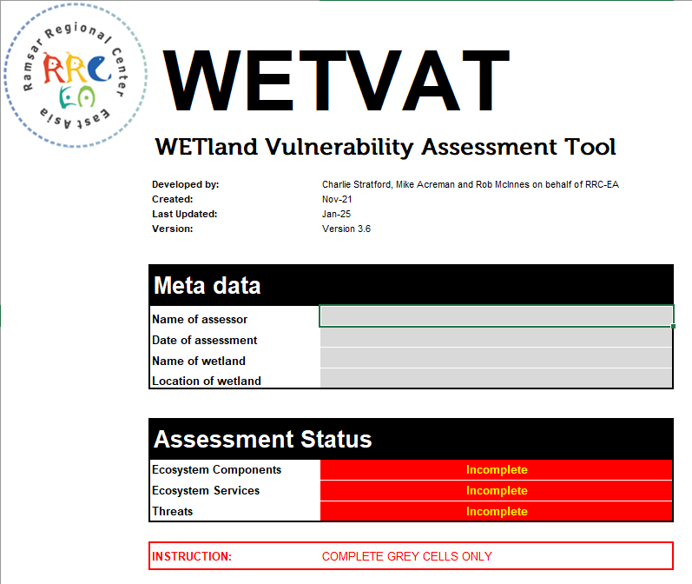

Figure 2. Worksheet 2: Ecosystem components
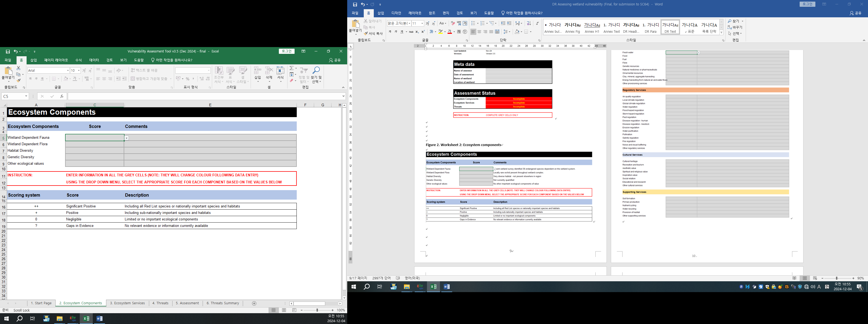

Figure 3. Worksheet 3: Ecosystem services
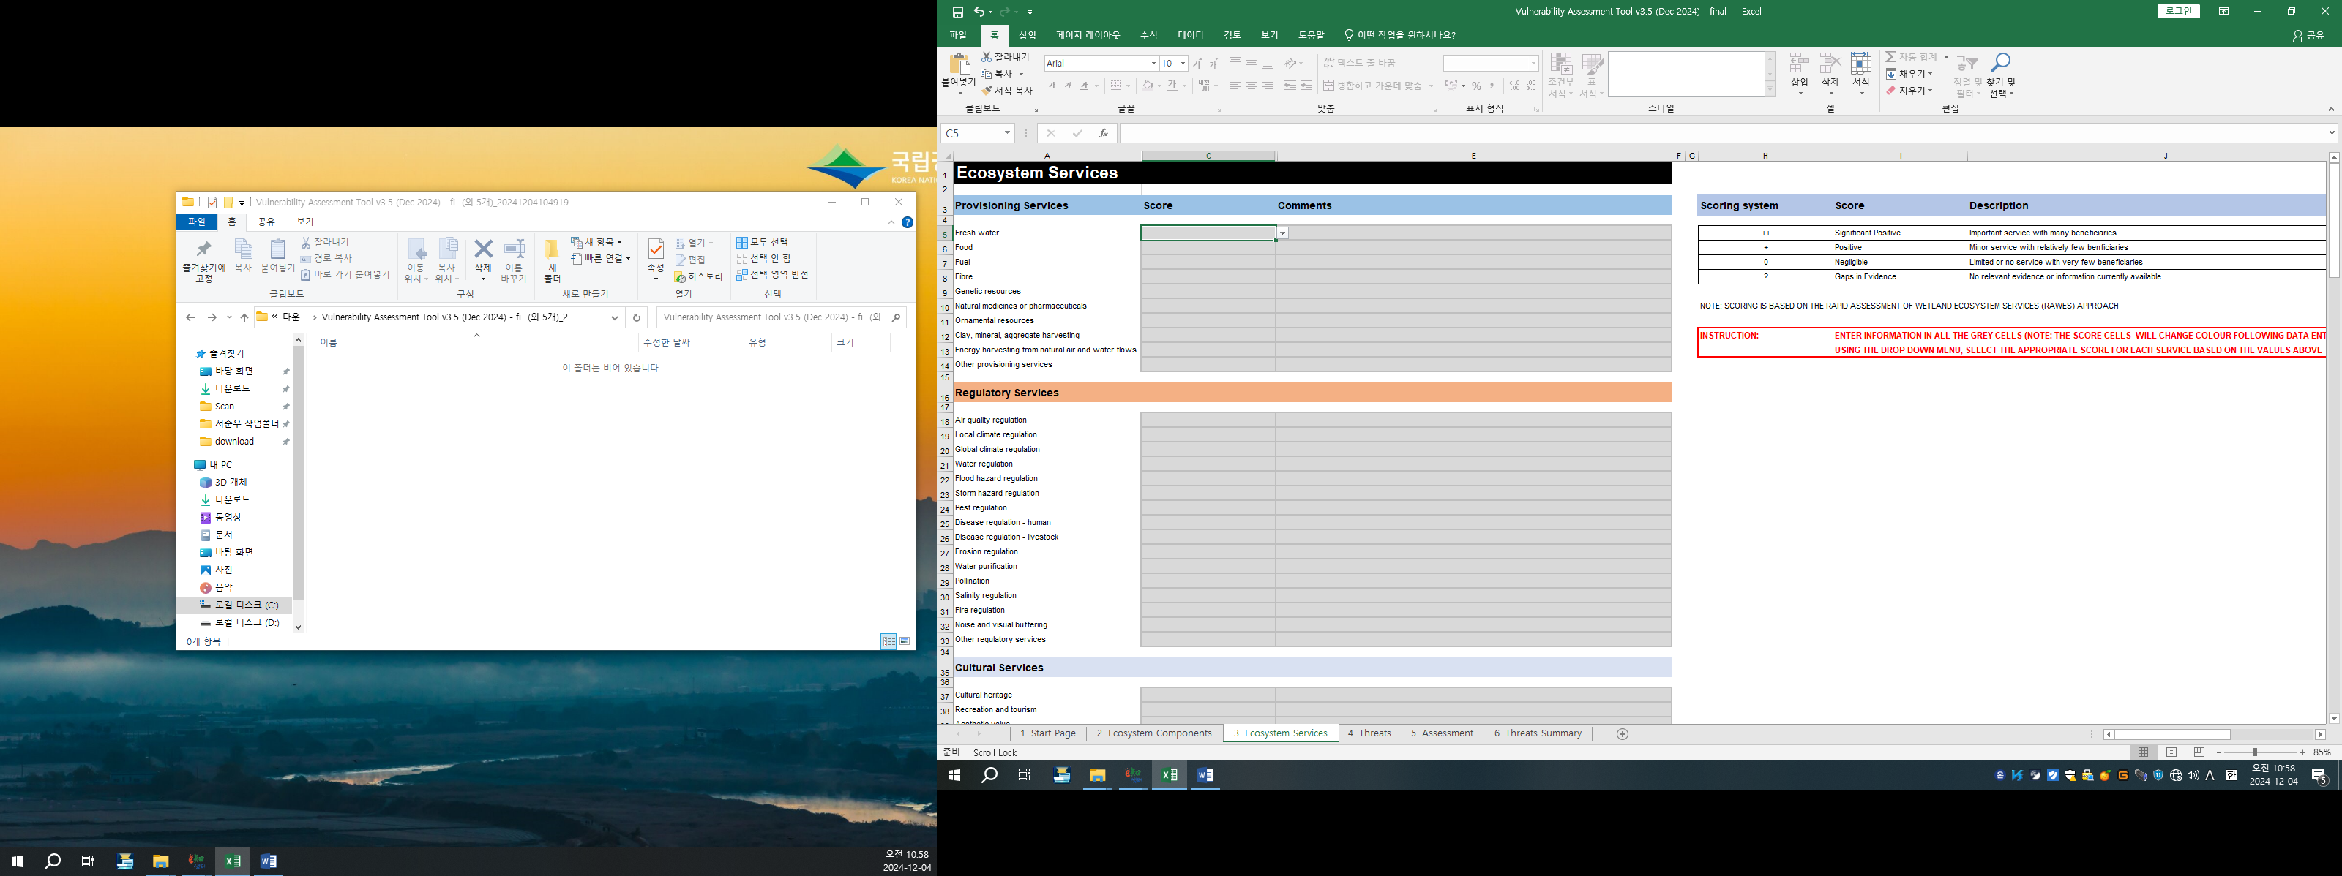
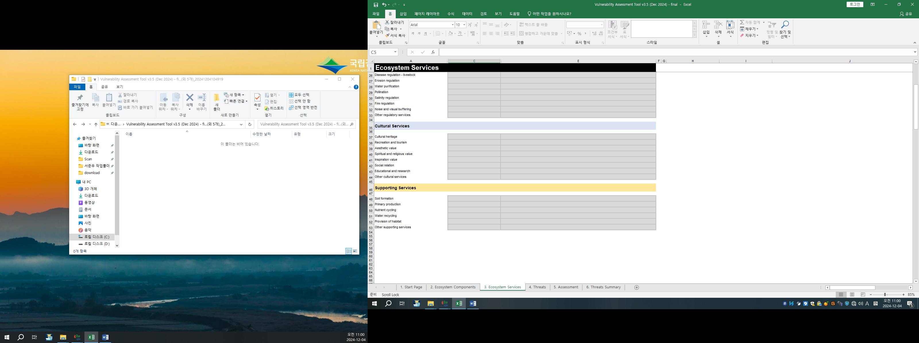

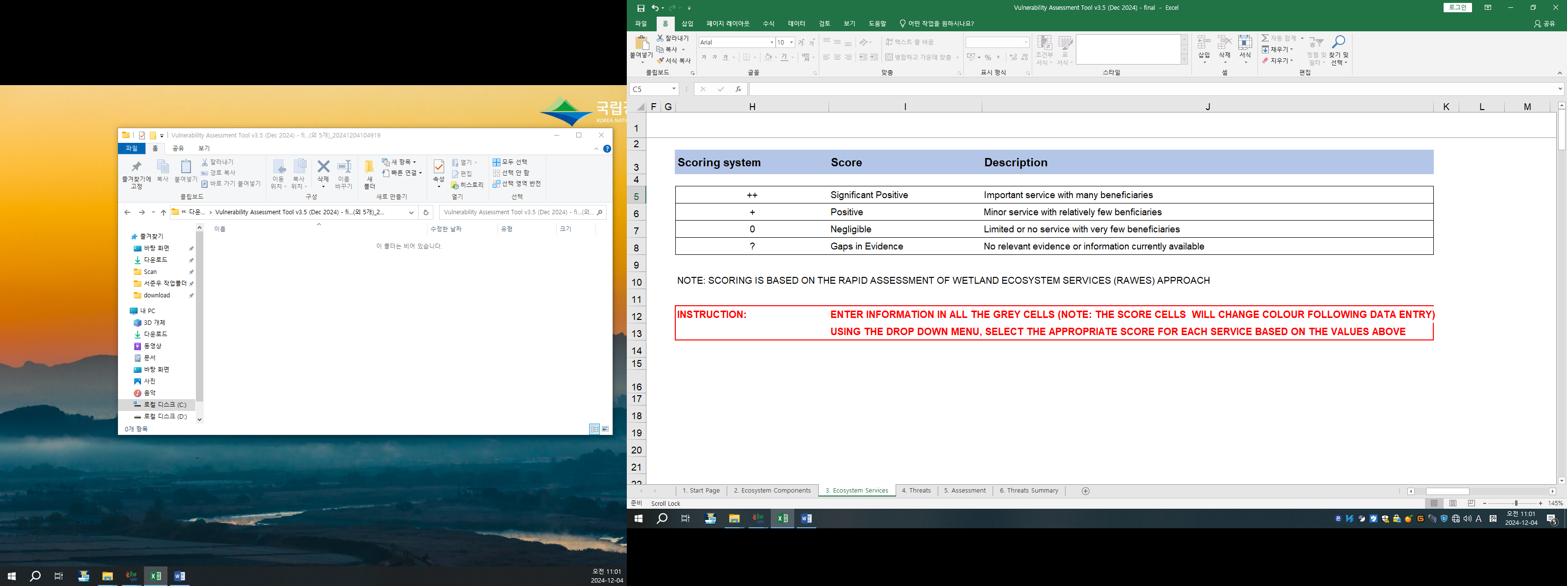
Figure 4. Worksheet 4: Threats
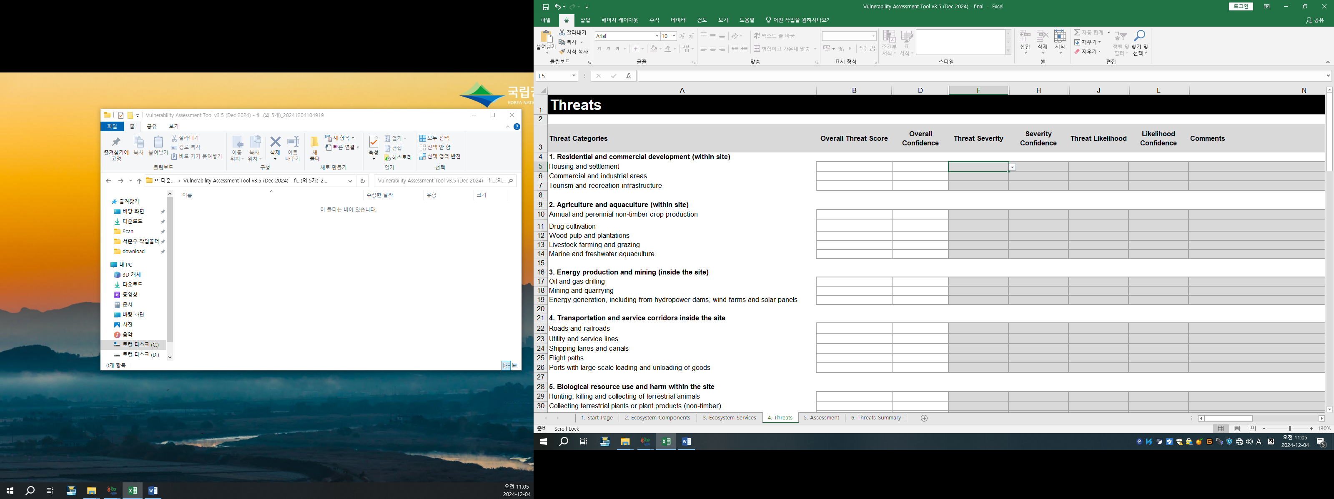
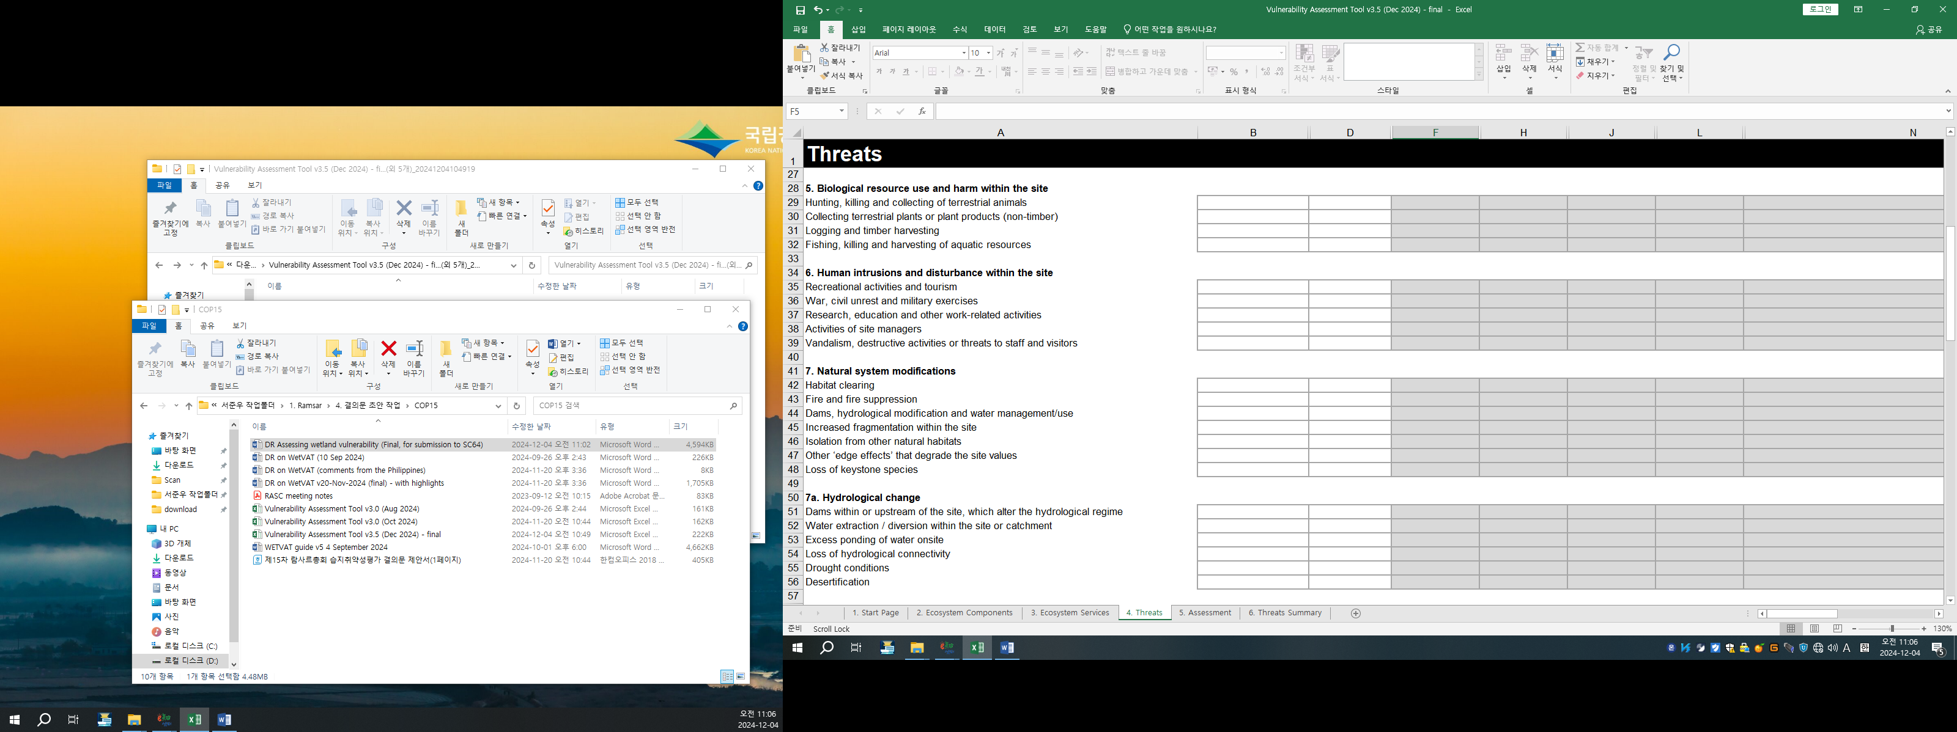
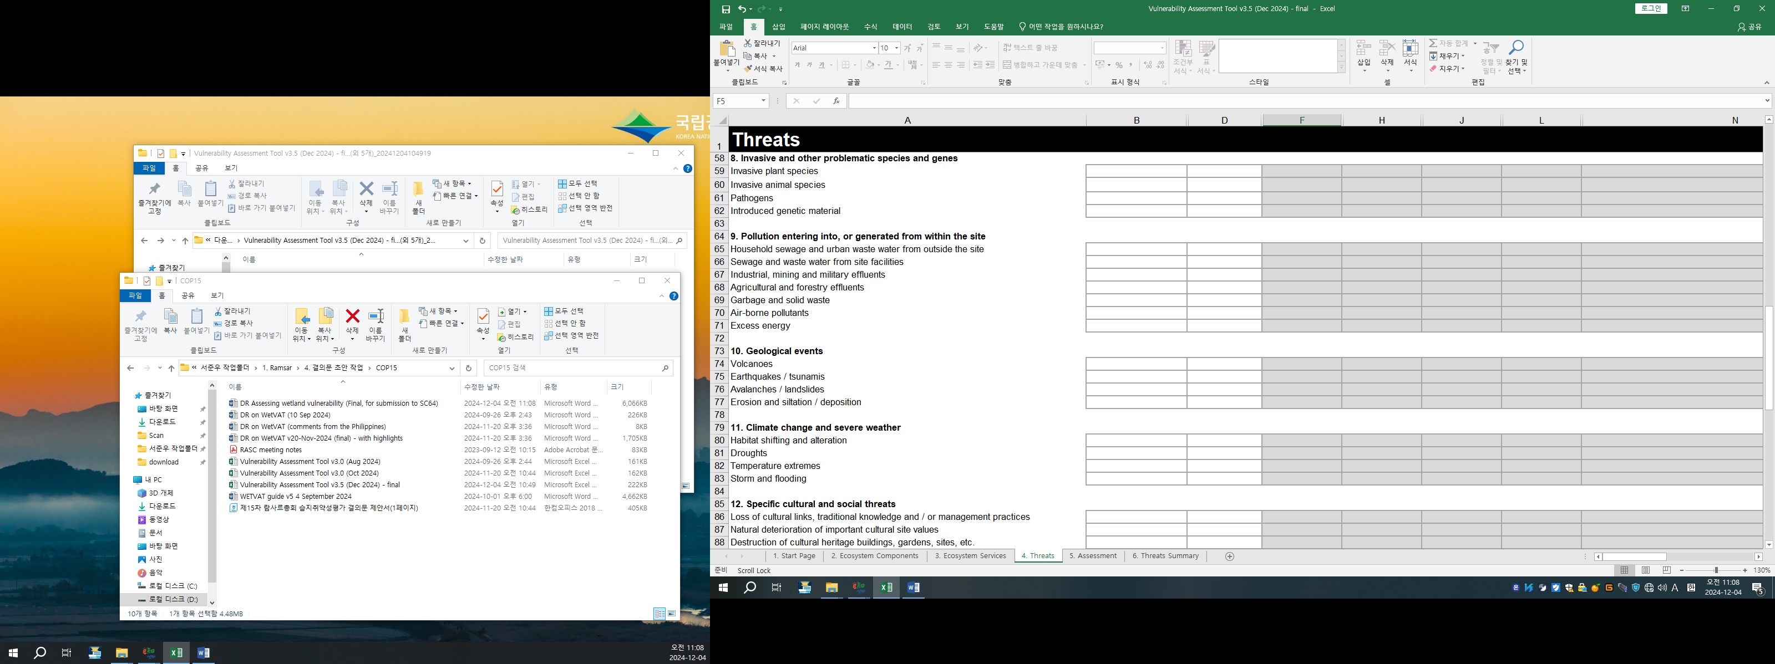

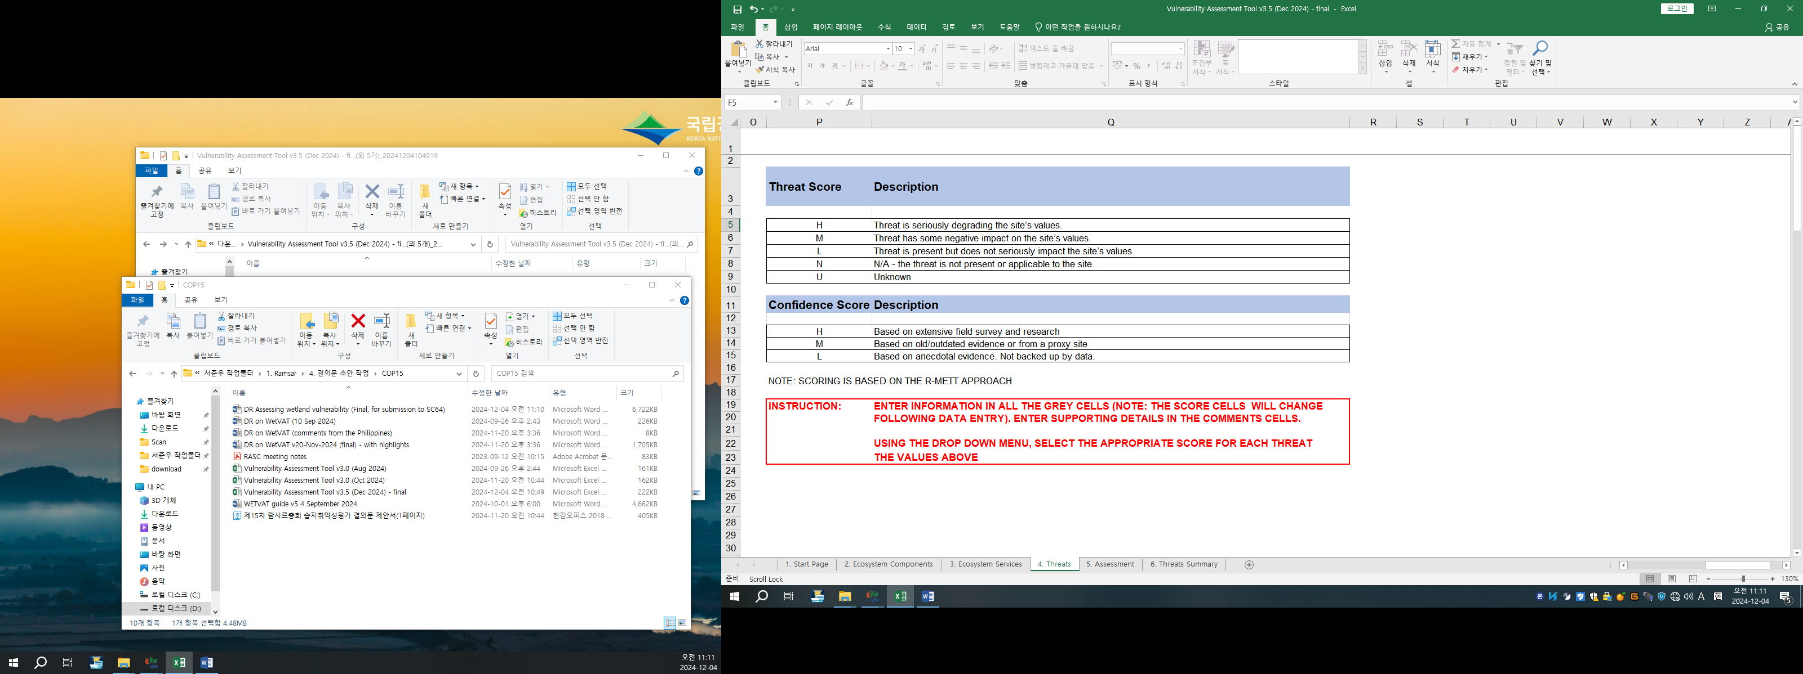
Figure 5. Worksheet 5 X-Ref (cross-referencing).

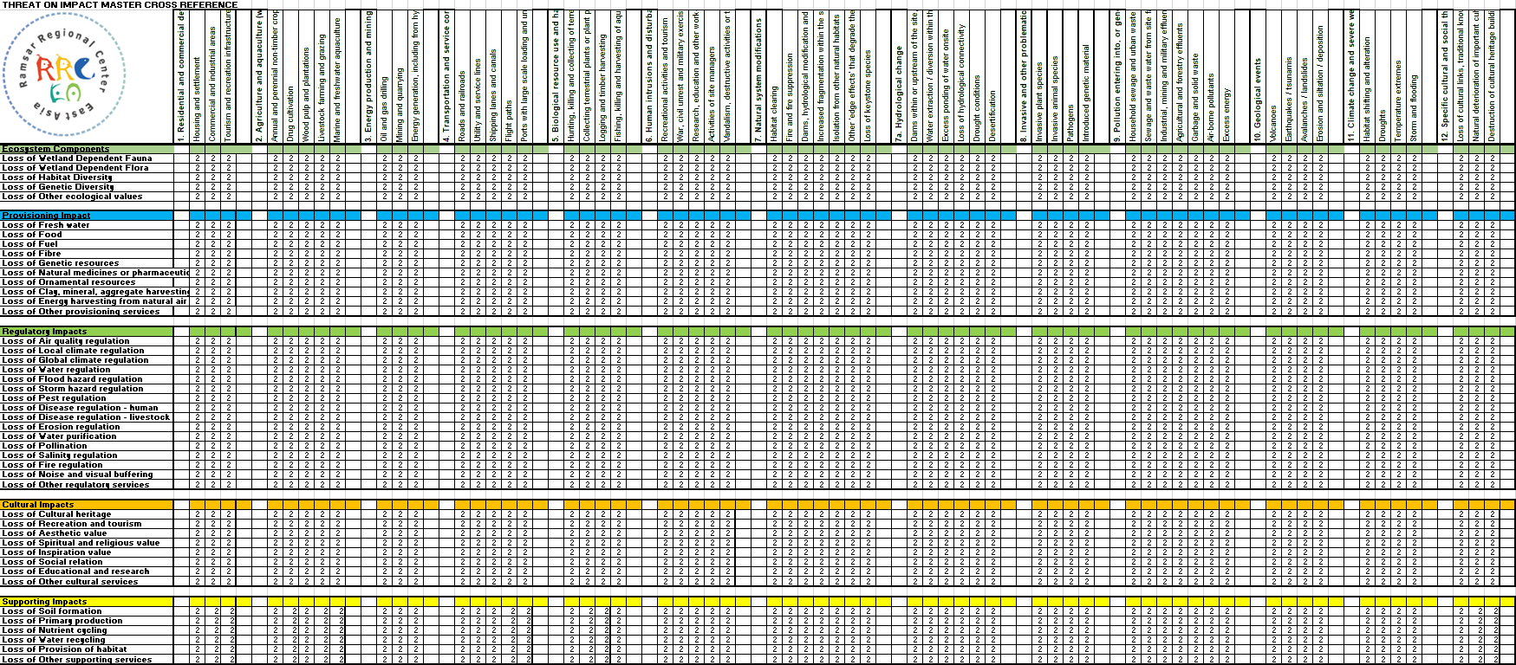

Figure 5. Worksheet 5 X-Ref (cross-referencing) (continued).

Figure 6. Worksheet 6: Assessment
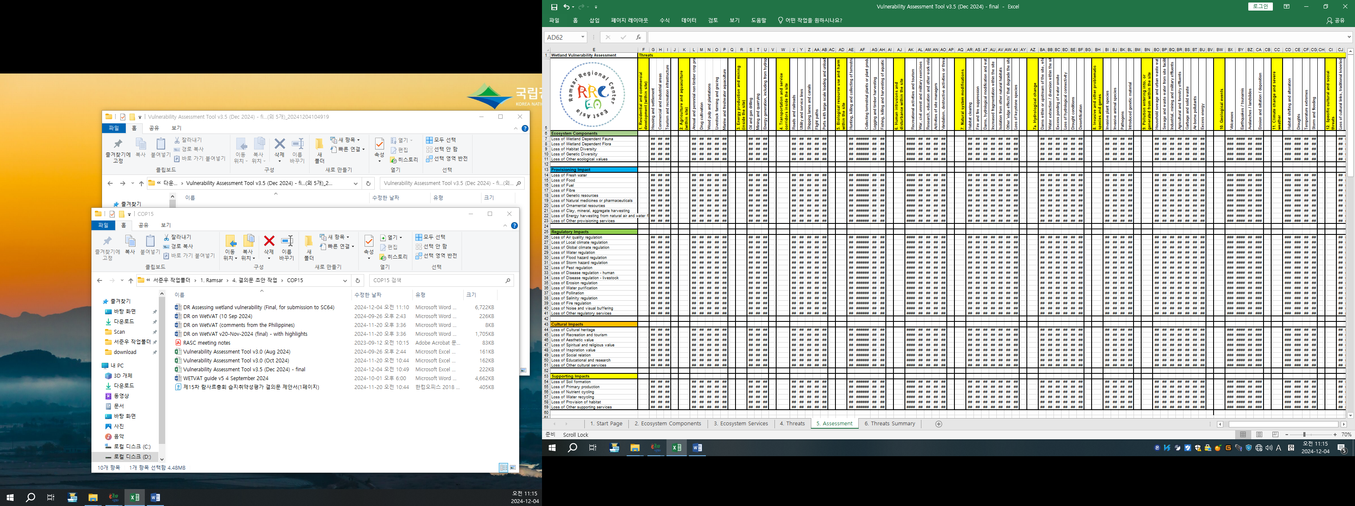

Figure 6. Worksheet 6: Assessment (continued)
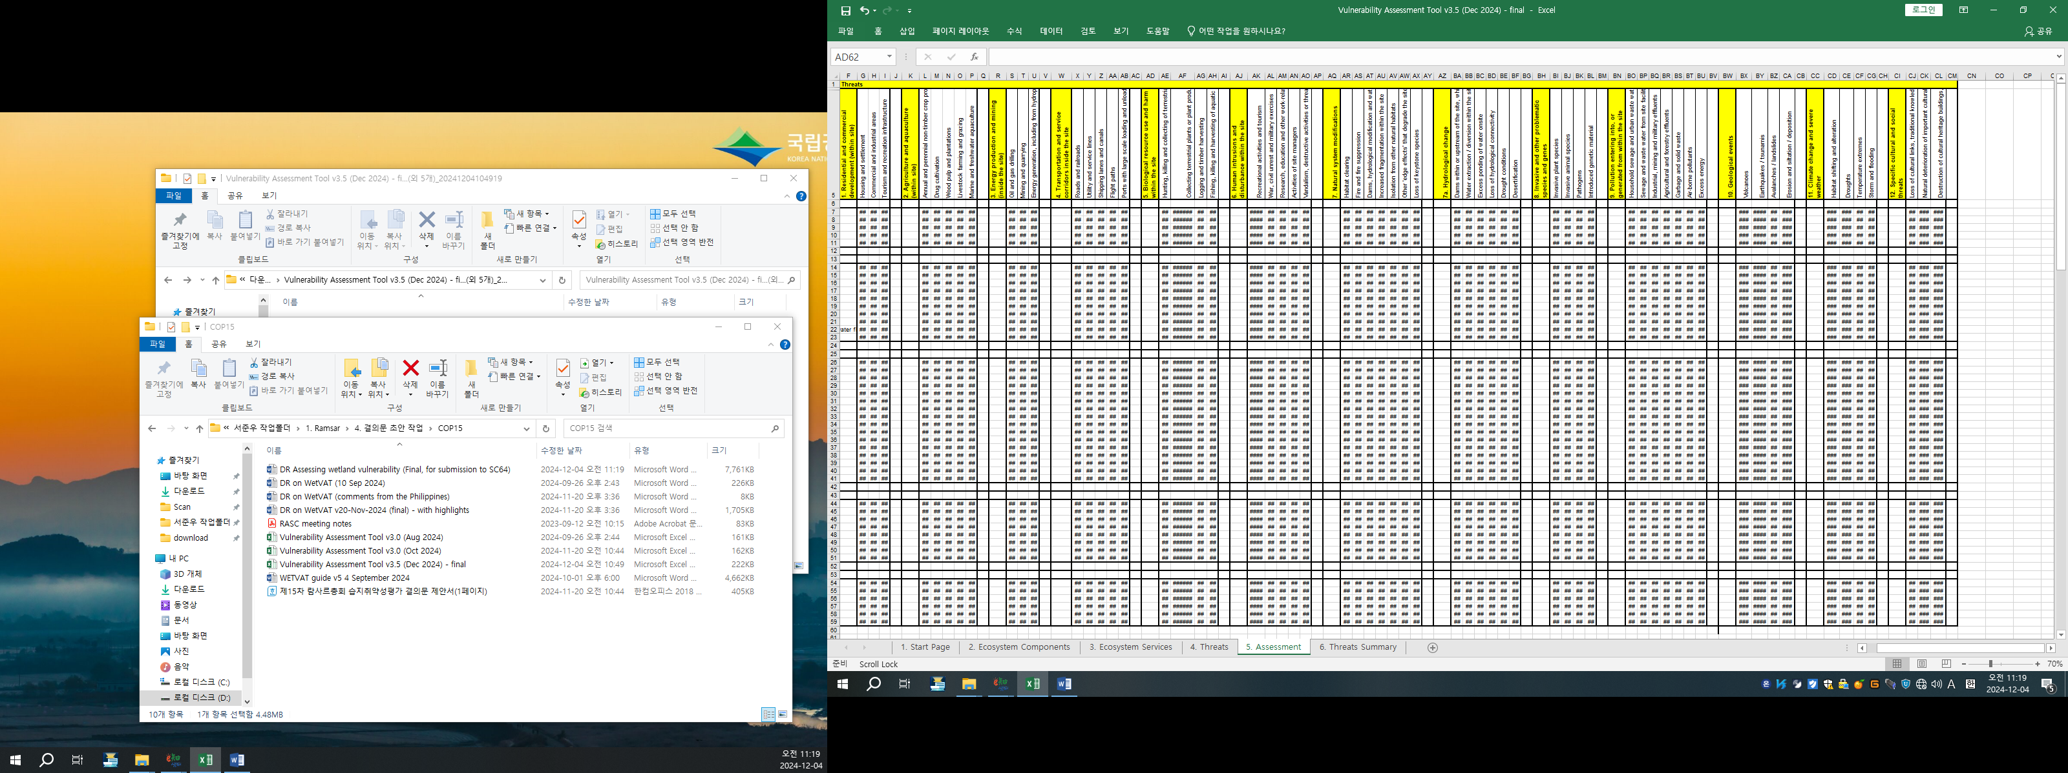

Figure 7. Worksheet 7: Summary
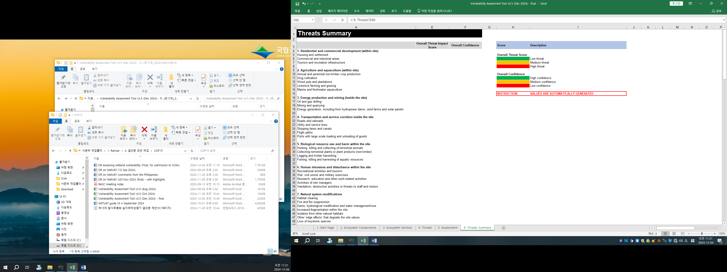
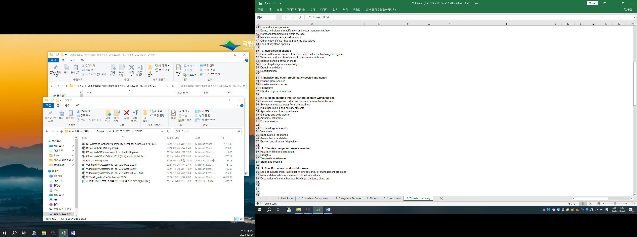

Figure 7. Worksheet 7: Summary (continued)

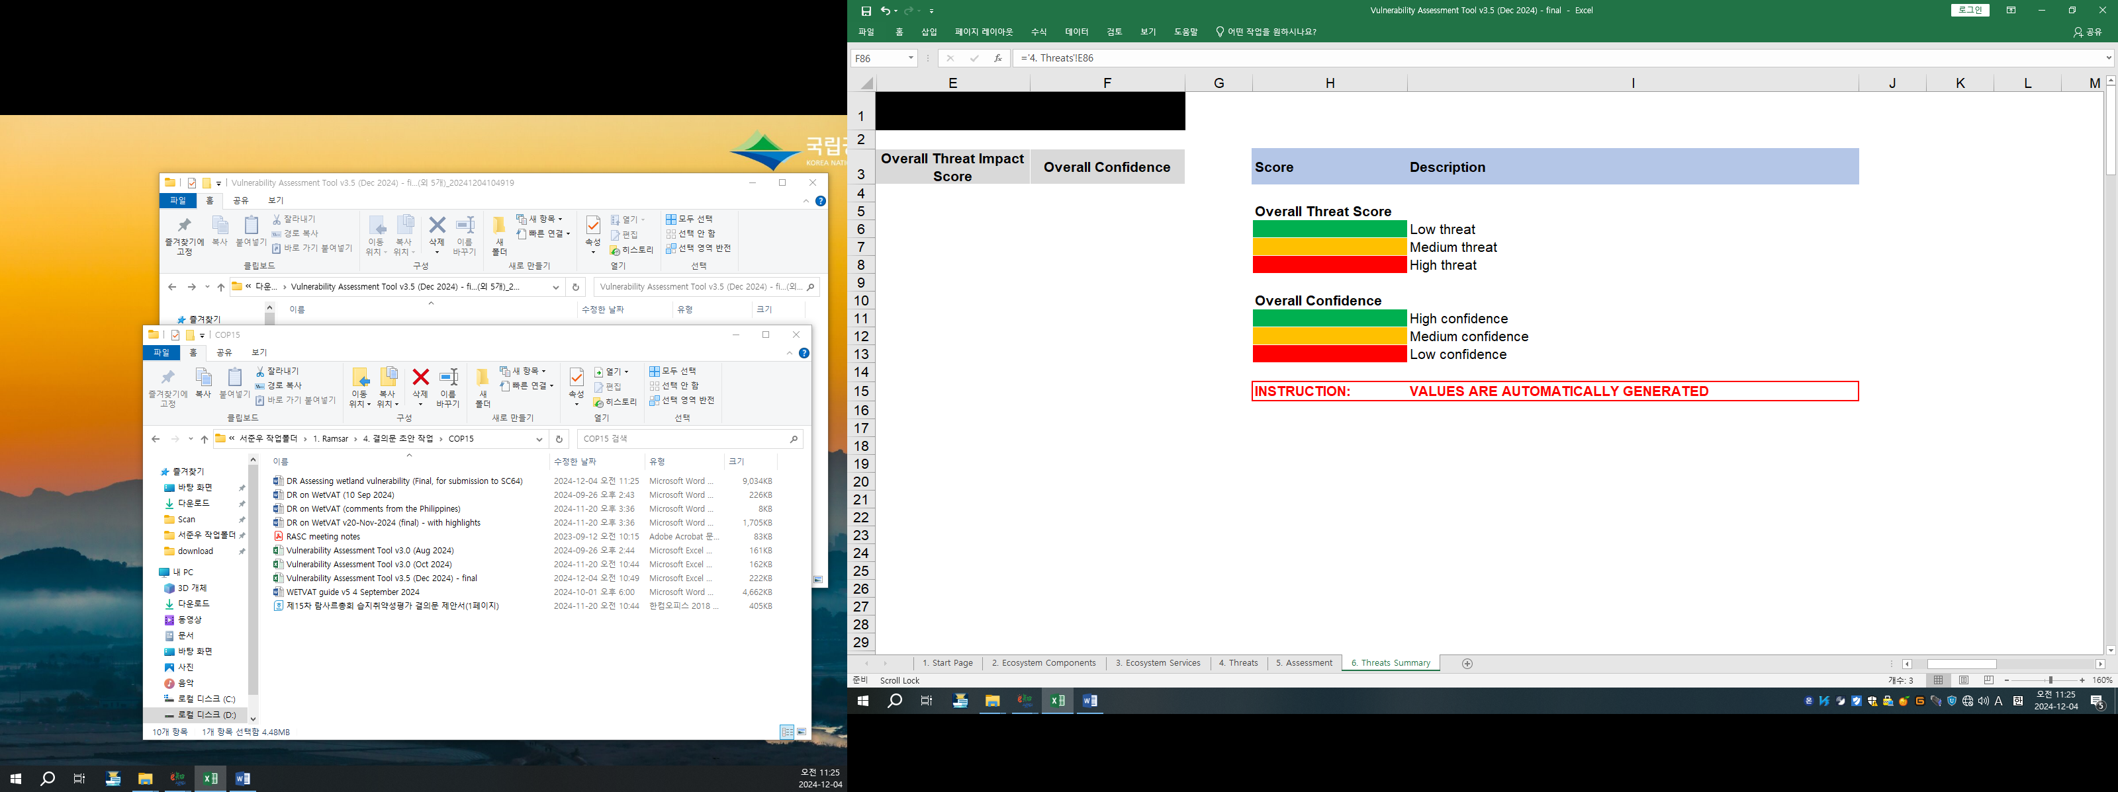

WWF, 2006. Conservation of high-altitude wetlands in the Himalayas. Report of the Fourth Regional Workshop. Capacity building for high altitude wetlands conservation and management. New Delhi, India, 27–29 June 2006.
ICIMOD, 2009. A manual for an inventory of Greater Himalayan wetlands. Kathmandu, Nepal: International Centre for Integrated Mountain Development (ICIMOD).
Stratford, C. J., Acreman, M. C., & Rees, H. G. 2011. A simple method for assessing the vulnerability of wetland ecosystem services. Hydrological Sciences Journal, 56(8), 1485-1500.
Stratford, C.J., Acreman, M.C., Rees, H.G. and Shilpakar, R., 2008. A vulnerability assessment method for wetlands in the Himalayan region. Report to the Asia Pro-Eco Programme of the European Commission.
Resolution XIII.17: Rapidly assessing wetland ecosystem services.
Resolution XII.15: Evaluation of the management and conservation effectiveness of Ramsar Sites.
Resolution XIV.16 Integrating wetland protection, conservation, restoration, sustainable use and management into national sustainable development strategies.
Gitay, H., Finlayson, C.M. and Davidson, N.C., 2011. A framework for assessing the vulnerability of wetlands to climate change. Gland, Switzerland: Ramsar Convention Secretariat, and Montreal, Canada: Secretariat of the Convention on Biological Diversity, Ramsar Technical Report no. 5 / CBD Technical Series no. 57. ISBN 92-9225-361-1 (print); 92-9225-362-X (web).

