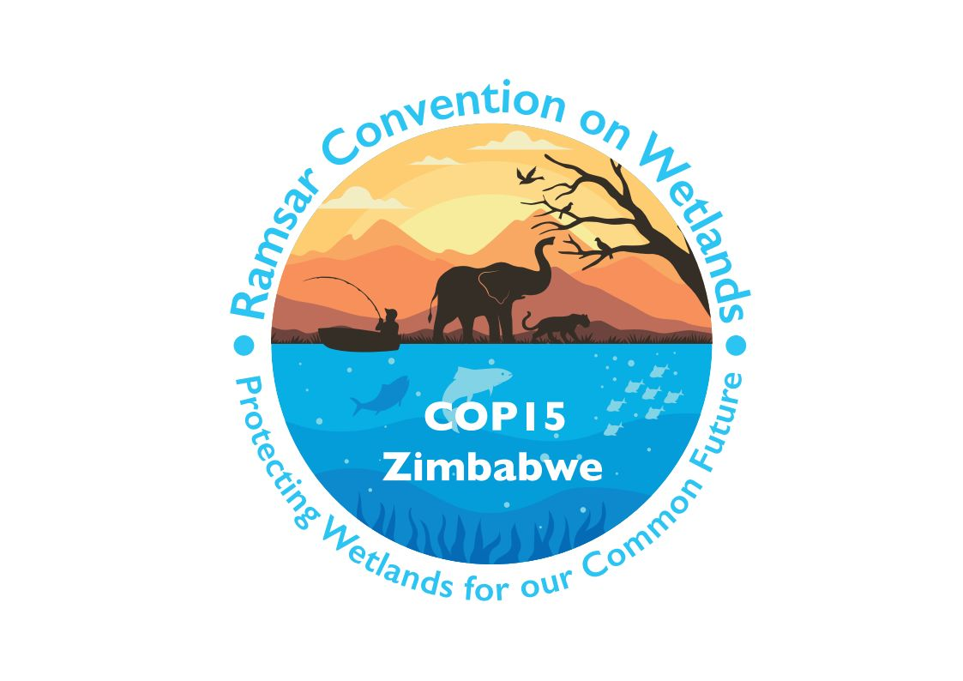

15th meeting of the Conference of the Contracting Parties

to the Convention on Wetlands

“Protecting wetlands for our common future”

Victoria Falls, Zimbabwe, 23-31 July 2025

COP15 Doc.3.2

Provisional working programme

Wednesday 23 July 2025

08:00 – 19:00 Registration (continues each day until 31 July)

09:00 – 12:00 Regional meetings

12:00 – 14:00 Lunch break

14:00 – 16:00 Regional meetings

16:30 – 18:30 65th meeting of the Standing Committee (subsequently to meet as the Conference Bureau)

18:45 – 20:15 Meeting of the Ramsar Regional Initiatives

Thursday 24 July 2025

08:00 – 19:00 Registration (continued)

10:00 – 11:00 1. Opening of the meeting

Opening ceremony
Welcome video on wetlands
National anthem
Flag handover ceremony

1.1 Opening statements

11:00 – 13:00 High-level ministerial segment
H.E. opening statement
Ministerial statements

13:00 – 15:00 Lunch break

15:00 – 18:00 20. Wetland City Accreditation

20.1 Presentation of certificates

15:00 – 18:00 Regional meetings

18:30 – 20:30 Welcome reception by the host country

Friday 25 July 2025

08:00 – 19:00 Registration (continued)

08:00 – 08:45 Meeting of the Conference Bureau

09:00 – 09:55 Regional meetings

10:00 – 13:00 Plenary session

2. Election of the President and Vice-Presidents and remarks by the President

3. Adoption of the provisional agenda and working programme

3.1 Provisional agenda

3.2 Provisional working programme

4. Adoption of the Rules of Procedure

5. Appointment of the Credentials Committee and any other committees

6. Admission of observers

7. Report of the Chair of the Standing Committee

8. Report of the Secretary General on the implementation of the Convention

8.1 Global implementation

8.2 Work of the Secretariat

13:00 – 15:00 Lunch break

15:00 – 18:00 Plenary session

9. Report of the Secretariat pursuant to Article 8.2 on the List of Wetlands of International Importance

10. Report of the Chair of the CEPA Oversight Panel on implementation of the CEPA Programme 2016-2024

11. Report of the Chair of the Scientific and Technical Review Panel (STRP)

12. Report of the Secretariat on the Ramsar Regional Initiatives

13. Report of the Secretariat on enhancing decision-making procedures and maintaining effective operation of the Convention during exceptional circumstances

14. Report of the Secretariat on assessment of progress on wetland restoration

15. Report of the Secretariat on opportunities to further strengthen the Convention’s contribution to the 2030 Sustainable Development Agenda and Sustainable Development Goals

16. Report of the Secretariat on the implementation of Resolution XIV.20

17. Report of the Secretariat on administrative and financial implications of draft resolutions

18. Financial report for 2023-2025 of the Chair of the Subgroup on Finance of the Standing Committee, and proposed budget for the 2026-2028 triennium

20. Wetland City Accreditation

20.2 Report of the Independent Advisory Committee on the implementation progress and financing of the Wetland City Accreditation

Saturday 26 July 2025

08:00 – 19:00 Registration (continued)

08:00 – 08:45 Meeting of the Conference Bureau

09:00 – 09:55 Regional meetings

10:00 – 13:00 Plenary session

22. Consolidation of existing Resolutions

22.1. Consolidated Resolution on assessment of wetland values and services

22.2 Consolidated Resolution on water, water-related and water-management matters

22.3 Consolidated Resolution on inventories

23. Consideration of the draft resolutions and recommendations submitted by Contracting Parties and the Standing Committee

13:00 – 15:00 Lunch break

15:00 – 18:00 Plenary session

23. Consideration of the draft resolutions and recommendations submitted by Contracting Parties and the Standing Committee (continued)

Sunday 27 July 2025

08:00 – 19:00 Registration (continued)

08:00 – 08:45 Meeting of the Conference Bureau

09:00 – 09:55 Regional meetings

10:00 – 13:00 Plenary session

23. Consideration of the draft resolutions and recommendations submitted by Contracting Parties and the Standing Committee (continued)

13:00 – 15:00 Lunch break

15:00 – 18:00 Plenary session

23. Consideration of the draft resolutions and recommendations submitted by Contracting Parties and the Standing Committee (continued)

Monday 28 July 2025

08:00 – 19:00 Registration (continued)

08:00 – 08:45 Meeting of the Conference Bureau

09:00 – 09:55 Regional meetings

10:00 – 13:00 Plenary session

23. Consideration of the draft resolutions and recommendations submitted by Contracting Parties and the Standing Committee (continued)

13:00 – 15:00 Lunch break

15:00 – 17:00 Plenary session

19. Election of Contracting Parties to the Standing Committee for 2025-2028

23. Consideration of the draft resolutions and recommendations submitted by Contracting Parties and the Standing Committee (continued)

17:00 – 18:00 21. Presentation of the Ramsar Wetland Conservation Award winners

Tuesday 29 July 2025

08:00 – 08:45 Meeting of the Conference Bureau (if needed)

Field visits

Wednesday 30 July 2025

08:00 – 19:00 Registration (continued)

08:00 – 08:45 Meeting of the Conference Bureau

09:00 – 09:55 Regional meetings

10:00 – 13:00 Plenary session

23. Consideration of the draft resolutions and recommendations submitted by Contracting Parties and the Standing Committee (continued)

13:00 – 15:00 Lunch break

15:00 – 18:00 Plenary session

23. Consideration of the draft resolutions and recommendations submitted by Contracting Parties and the Standing Committee (continued)

Thursday 31 July 2025

08:00 – 15:00 Registration (continued)

08:30 – 08:45 Meeting of the Conference Bureau
(with Standing Committee members 2025-2028 as observers)

09:00 – 09:55 Regional meetings

10:00 – 13:00 Plenary session

24. Report of the Credentials Committee

23. Consideration of the draft resolutions and recommendations submitted by Contracting Parties and the Standing Committee (continued)

13:00 – 15:00 Lunch break

15:00 – 17:00 Plenary session

25. Date and venue of the next ordinary meeting of the Conference of the Contracting Parties

26. Any other business

27. Adoption of the report of the 15th meeting of the Conference of the Contracting Parties

28. Close of the meeting

17:30 – 18:30 66th meeting of the Standing Committee (incoming members to elect officers, subgroup and working group members, and agree the date and venue of the first full Standing Committee meeting)

