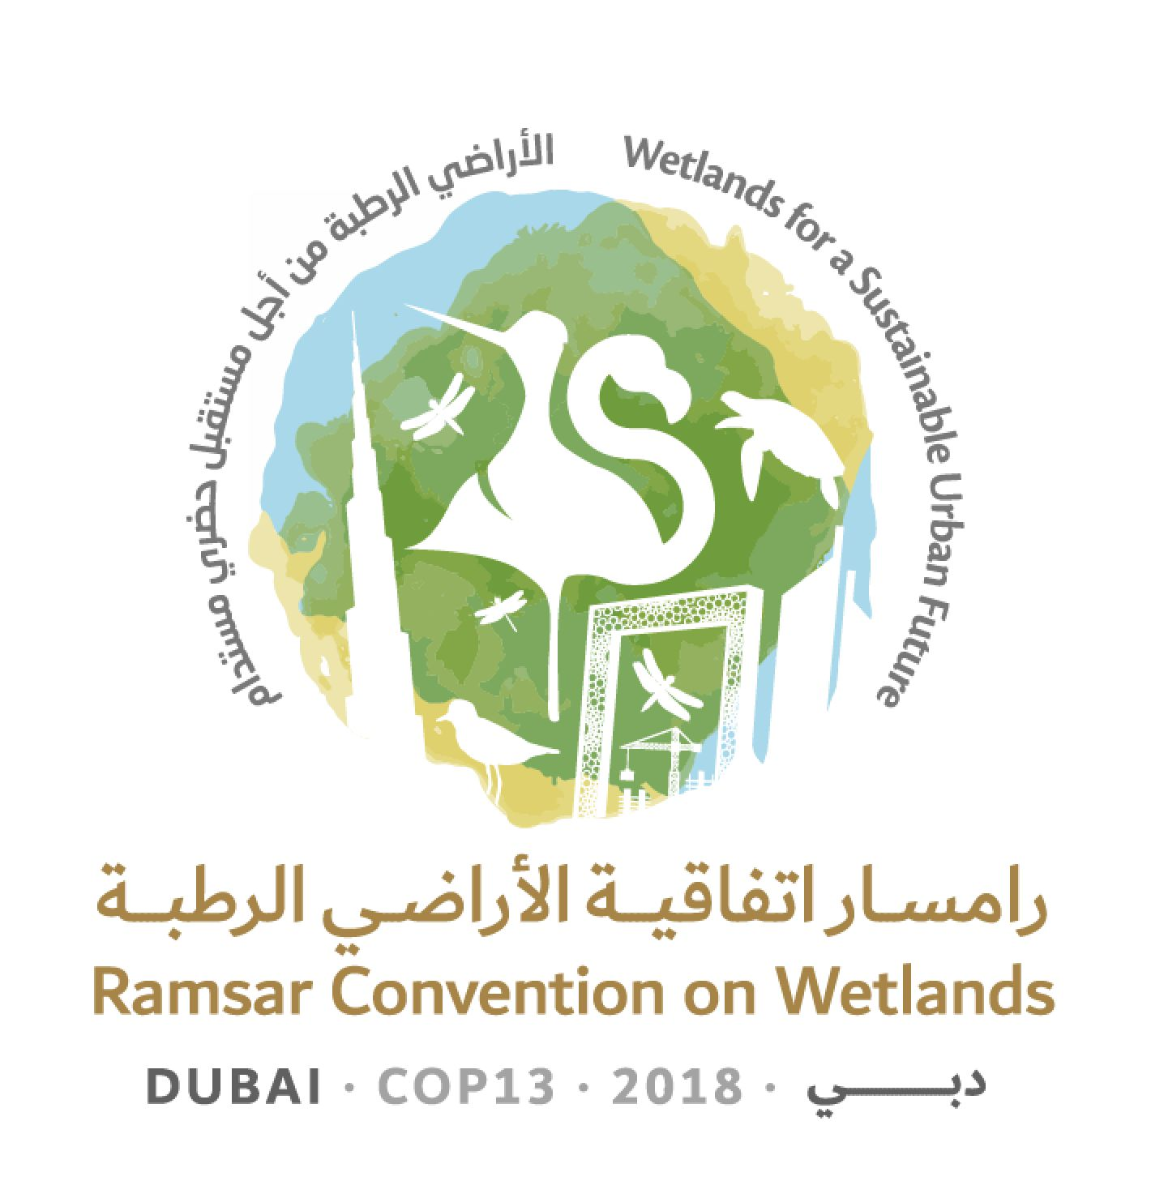
13th Meeting of the Conference of the Contracting Parties

to the Ramsar Convention on Wetlands

“Wetlands for a Sustainable Urban Future”

Dubai, United Arab Emirates, 21-29 October 2018

Ramsar COP13 Doc.17

Secretariat’s report on administrative and financial implications
of draft resolutions

1. Table 1 below identifies the projected administrative and financial implications of substantive agenda items for COP13, compiled by the Secretariat in accordance with Rule 14 of the Rules of Procedure.

Table 1: Administrative and financial implications of draft resolutions
Document | Draft resolution | Activities / tasks required | Staff days | Non-core funds (CHF)
18.1 | Enhancing the effectiveness of the Ramsar Convention | No significant activities/tasks required. | 0 | 0
18.2 | Improving the efficiency of structures and processes of the Convention | Travel and meeting support for two Open Ended Working Group meetings. Meeting support for Conference Bureau. Meeting support for Finance Committee and Science & Policy Interface. | 0 | 1,660,000
18.3 | Responsibilities, roles and composition of the Standing Committee and regional categorization of countries under the Convention | No significant activities/tasks required. | 0 | 0
18.4 | Language strategy for the Convention | STRP products in English, French and Spanish. Translation of key documents and texts. Interpretation. | 40 | 530,000
18.5 | Financial and budgetary matters | No significant activities/tasks required. | 0 | 0
18.6 | Review of the fourth Strategic Plan of the Ramsar Convention | Consultant to support working group. Face-to-face meeting for working group. | 0 | 45,000
18.7 | Enhancing the Convention's implementation, visibility and synergies with other multilateral environmental agreements and other international institutions | Completion of wetland inventories and wetland extent to report on Indicator 6.6.1. Invite external speakers to support Contracting Parties. | 0 | 165,000
18.8 | Ramsar Regional Initiatives 2019 - 2021 and their operational framework | Analysis of annual reports and preparation of a summary assessment. Participate in governance of RRIs. | 0 | 0
18.9 | World Wetlands Day | No significant activities/tasks required. | 0 | 0
18.10 | Status of sites on the List of Wetlands of International Importance | Input new Ramsar Sites and complete updates. Address Article 3.2 cases. | 100 | 0
18.11 | Ramsar Advisory Missions | Secure non-core funding for RAMs. | 0 | 225,000
18.12 | Future Implementation of STRP aspects of the Convention 2019 - 2021 | Provide support in preparation and distribution of STRP outputs (assumes a similar number of outputs as the current triennium including a future Global Wetland Outlook). |  | 300,000
18.13 | Guidance on identifying Wetlands of International Importance for global climate change regulation as an additional argument to existing Ramsar criteria | No significant activities/tasks required. | 0 | 0
18.14 | Restoration of degraded peatlands to mitigate and adapt to climate change and enhance biodiversity | Production of a Ramsar Techncial Report and Briefing Note. Follow up to Resolution VIII.17. | 0 | 45,000
18.15 | Promoting conservation, restoration and sustainable management of blue carbon ecosystems | Desk study of coastal blue carbon systems. | 0 | 165,000  (Cost included in Doc.18.7 above)
18.16 | Cultural values, indigenous peoples and local communities, and climate change mitigation and adaptation in wetlands | Secure case studies. Review and revise Guidelines for Rapid Cultural Inventories in Wetlands. Review and update Ramsar guidance on culture and wetlands. Support implementation of the resolution. | 40 | 0
18.17 | Sustainable urbanization, climate change and wetlands | Production of Ramsar Techncial Reports for the design and construction of urban and peri-urban Sites Production a Briefing Note. | 0 | 39,000
18.18 | Rapid assessment of wetland ecosystem services | Organize and host webinars. | 18 | 0
18.19 | Importance of wetlands for peace and security | No significant activities/tasks required. | 0 | 0
18.20 | Gender and wetlands | Development of a factsheet to support Contracting Parties in mainstreaming gender in the Strategic Plan. Gender training for all secretariat staff. Develop report on how the Convention can generate gender-related goals consistent with the UN Secretary-General’s system-wide strategy on gender parity. Support Parties in strengthening national statistics systems to improve reporting sex-disaggregated data and gender analysis. | 0 | 36,000
18.21 | Agriculture in wetlands | Compile case studies and best practices (consultant). Develop overview of wetland degradation since 1970. Provide advice to withdraw subsidies. | 0 | 20,000
18.22 | Promoting the conservation and wise use of intertidal wetlands and ecologically associated habitats | No significant activities/tasks required. | 0 | 0
18.23 | Conservation and management of small wetlands | Promote importance of small wetlands to Multilateral Environmental Agreements and High-level Political Forum. | 6 | 0
18.24 | Wetlands in West Asia | No significant activities/tasks required. | 0 | 0
18.25 | Wetlands in polar and subpolar regions | Raise awareness for polar wetlands. Develop synergies with other MEAs and Intergovernmental Organizations. | 0 | 0
18.26 | Enhanced conservation of sea turtle breeding, feeding and nursery areas and the designation of key areas as Ramsar Sites | Engage with the Inter-American Convention for the Protection and Conservation of Sea Turtles (IAC) and the IOSEA Marine Turtle MOU to futher sea turtle conservation in Ramsar Sites. Assist Parties in including sea turtle conservation in site management plans. | 6 | 0

2. The Conference of Contracting Parties is expected at COP13 to identify non-core funding needs for the next triennium and list them in order of priority. To assist the Parties in this effort, the Secretariat has reviewed the non-core funding priorities identified by the Parties at COP12 (see Resolution XII.1 Annex 3), the work plan for the current triennium and draft resolutions submitted to COP13, and suggests the non-core funding priorities listed at Table 2 for consideration.

Table 2: List of suggested non-core funding priorities
Activity | Three-year funding requirement (CHF)
World Wetlands Day | 250,000
Complete wetland inventories to report on indicator 6.6.1 | 165,000
Ramsar Advisory Missions | 225,000
COP14 and Pre-COP14 sponsorship for eligible delegates | 700,000
Support of Regional Initiatives | 150,000
Ramsar CEPA Programme | 200,000

Rule 14 Secretariat’s report on administrative and financial implications of agenda items The Secretariat shall report, within 24 hours of the opening of the meeting of the Conference of the Parties, on the projected administrative and financial implications of all substantive agenda items submitted to the meeting and before decisions on these items are taken by the Conference of the Parties.

