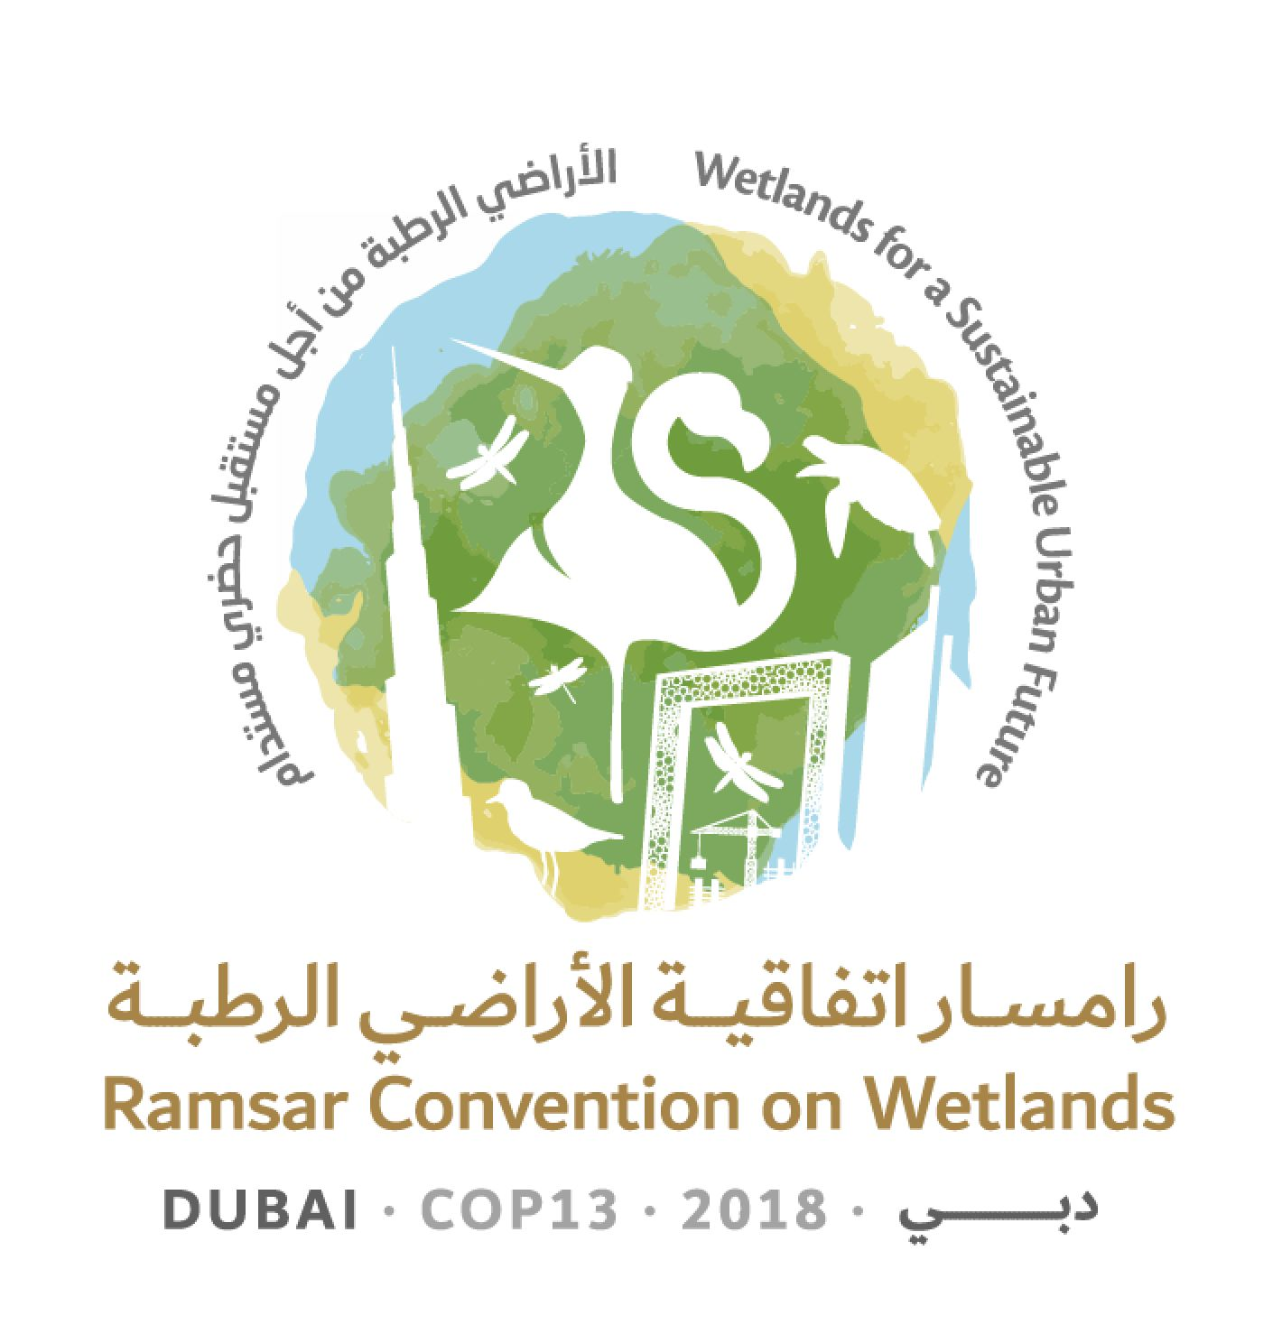
13th Meeting of the Conference of the Contracting Parties

to the Ramsar Convention on Wetlands

“Wetlands for a Sustainable Urban Future”

Dubai, United Arab Emirates, 21-29 October 2018

Ramsar COP13 Doc.18.26

Draft resolution on the enhanced [protection and management] [conservation] of sea turtle breeding, feeding and nursery areas
and the designation of key areas as Ramsar Sites

Submitted by France and Senegal

Note from the Secretariat

At its 54th meeting, following discussion and suggestions for amendments, the Standing Committee in Decision SC54-25 instructed the Secretariat to edit, finalize and publish the draft resolution contained in document SC54-Com.10 for consideration at COP13, subject to inclusion in square brackets of the amendments listed by France as not having consensus support, and removal of the attribution of amendments.

Introduction

1. In its Article 2 regarding the List of Ramsar Sites, the Ramsar Convention considers that the ecological functions of wetlands as habitats supporting a characteristic flora and fauna are fundamental. The choice of sites can be based on their international importance from a zoological point of view, as waterfowl habitat, but not exclusively. Sea turtles constitute a group that meets Criterion 2.

2. Moreover, Article 4.1 of the Convention also specifies that, for all wetlands, the Contracting Parties should promote the conservation of wetlands and waterfowl by establishing nature reserves, whether they are included in the List or not, and they should provide adequately for their wardening.

3. The Parties to the Convention have also already approved resolutions concerning marine turtles: Resolution VII.21 on Enhancing the conservation and wise use of intertidal wetlands, Resolution VIII.4 on Wetland issues in Integrated Coastal Zone Management (ICZM) and Resolution VIII.32 on Conservation, integrated management, and sustainable use of mangrove ecosystems and their resources.

3. The present [draft] resolution aims to urge the Parties on the one hand to reinforce conservation and management measures for wetlands presenting challenges for marine turtles and, on the other hand, to designate them as Ramsar Sites or reinforce their protection by other means.

Draft resolution XIII.xx

The enhanced [protection and management] [conservation] of sea turtle breeding, feeding and nursery areas and the designation of key areas as Ramsar Sites

1. RECALLING that the seven species of sea turtle (Dermochelyidae: Dermochelys coriacea; Cheloniidae: Chelonia mydas, Caretta caretta, Eretmochelys imbricata, Lepidochelys olivacea, Lepidochelys kempii and Natator depressa) have a conservation status ranging from vulnerable to critically endangered and ALSO RECALLING that in order to live and survive these species depend on the conservation of their breeding, feeding and nursery zones, which are marine and coastal areas;

2. CONSIDERING that, furthermore, all sites that are home to individuals belonging to the above-mentioned species meet Criterion 2 of the Convention for inclusion in the List of Wetlands of International Importance (Ramsar Sites), and that consequently, the Ramsar Convention should play a role as mobilizer by encouraging the Parties to strengthen their actions in favour of the wetlands that are essential to these species;

3. ALSO CONSIDERING that sea turtles are included in Appendix I of the Convention on International Trade in Endangered Species of Wild Fauna and Flora (CITES), Appendices I and II of the Convention on the Conservation of Migratory Species of Wild Animals (CMS), the Inter-American Convention for the Protection and Conservation of Sea Turtles (IAC), the Cartagena Convention for the Protection and Development of the Marine Environment in the Wider Caribbean Region, the Berne Convention on the Conservation of European Wildlife and Natural Habitats, the Barcelona Convention for the Protection of the Mediterranean Sea against Pollution, the Convention on Biological Diversity, and regional agreements (such as the Indian Ocean – South-East Asian (IOSEA) Marine Turtle Memorandum of Understanding and the Abidjan Memorandum of Understanding (MoU) concerning Conservation Measures for Marine Turtles of the Atlantic Coast of Africa), which encourage their respective Parties to provide better protection for sea turtles;

4. NOTING the existence of numerous tools and mechanisms with an ocean-wide scale, such as, for example covering the South Pacific and Western Pacific, the Secretariat of the Pacific Regional Environment Programme (SPREP), the Pacific Islands Regional Marine Species Conservation Action Plan, the Permanent Commission for the South Pacific (CPPS), and the Single Species Action Plan for the Loggerhead Turtle Caretta caretta in the South Pacific Ocean, adopted by the Conference of the Parties to CMS in Quito in November 2014 [replace with the Indian Ocean Southeast Asian Marine Turtle MOU (IOSEA)];

5. NOTING ALSO that some sea turtle subpopulations have increased in certain areas as a result of various conservation efforts;

6. CONCERNED that several regional populations of sea turtle are facing a high risk of extinction, and NOTING the degradation of their coastal habitats, the significant impact from fisheries bycatch, and also NOTING the excessively high mortality rates due to the taking of eggs, the destruction of adult females on nesting beaches by local human populations and the impact of [introduced predators] [exotic invasive species], in addition to predation and natural mortality of the eggs and hatchlings;

7. HIGHLIGHTING the fact that, during their life cycle, sea turtles use a wide variety of coastal habitats such as intertidal zones, estuaries, mangroves, rocks, seagrass beds and coral reefs;

8. CONSIDERING that marine and coastal feeding and nursery areas, in particular seagrass beds, coral reefs and mangroves, are often threatened physically and chemically by extractive, industrial and port activities and hotel infrastructure, as well as other human activities (including agriculture and the disposal of household and industrial effluents);

[9. RECOGNIZING the role of traditional owners, indigenous peoples and local communities in turtle conservation and management;]

10. CONSIDERING that the protection of nesting beaches and of marine and coastal feeding and nursery areas will allow the survival rate of adult female, newly hatched and immature turtles to increase;

11. NOTING that Resolution 12.25 of CMS on Promoting Conservation of Critical Intertidal and Other Coastal Habitats for Migratory Species adopted at the twelfth session of the Conference of the Parties to CMS (Manila, October 2017) urges the Parties to that Convention to conserve intertidal and coastal habitats for migratory species;

12. NOTING that 114 Ramsar Sites and 53 Contracting Parties already provide habitat for at least one species of sea turtle [(see the annexed table)];

13. RECOGNIZING that the Abidjan MoU adopted resolutions the application of which can help improve the conservation of sea turtles; and

14. RECALLING that an MoU has been signed between IAC and the Secretariat of the Ramsar Convention, with the goal of combining the efforts made under each of the Conventions, in order to build the capacities of the Parties to both Conventions to identify and strengthen the conservation and rational use of Ramsar Sites;

THE CONFERENCE OF THE CONTRACTING PARTIES

15. [URGES] [ENCOURAGES] the Contracting Parties whose coastlines contain sea turtle breeding areas, [important] nesting beaches, coastal and marine feeding and nursery areas, to identify index nesting and foraging sites and ensure the populations are monitored as precisely as possible, in order to improve knowledge of the distribution, numbers and state of health of each of the species involved;

16. [URGES] [ENCOURAGES] the Contracting Parties to strengthen the conservation and management of those identified index nesting and foraging sites, and notably if possible to designate them as Ramsar Sites, based on Criterion 2, and to strengthen this designation through the promulgation of the appropriate protective measures in accordance with their legislation, in particular through the creation of marine protected areas, as appropriate;

17. ENCOURAGES the Contracting Parties to develop and implement management plans for these sites, by integrating specific means for the protection or restoration of breeding, nesting, feeding and nursery habitats for the different species;

18. ENCOURAGES the Contracting Parties to consult each other, and work through existing regional agreements such as the the Indian Ocean – South-East Asian (IOSEA) Marine Turtle Memorandum of Understanding under the Convention on Migratory Species (CMS), the Abidjan Memorandum of Understanding concerning Conservation Measures for Marine Turtles of the Atlantic Coast of Africa, the Pacific Regional Environment Programme, the Inter-American Convention for the Protection and Conservation of Sea Turtles (IAC), and the Single Species Action Plan for the Loggerhead Turtle Caretta caretta in the South Pacific Ocean, within the framework of the CMS and of the Barcelona Convention for the Protection of the Mediterranean Sea against Pollution, to protect habitats in networks allowing for greater safety for sea turtles during their life cycle and in their movements;

19. STRESSES the urgent need to take, whenever possible, the measures required to reduce the lighting and the erosion of the beaches used for breeding and to fight against the impact of [predators introduced to] [exotic invasive species on] these sites, and to develop good practices to raise the awareness of the inhabitants of coastal zones;

[20. RECOMMENDS that the Contracting Parties, research institutes and organizations devoted to the protection of coastal and marine biodiversity set up integrated conservation programmes, which can call on responsible and regulated ecotourism, and include support for the training of guides and the launching of village community aid programmes, in order to increase respect for immature and adult turtles, their nests and their habitats, which can generate greater and more sustainable financial resources than poaching and the exploitation of dead turtle by-products (such as meat, fat and shells);]

[21. CALLS ON international organizations to establish regional cooperation, collaborating with all stakeholders, notably in the context of Ramsar Regional Initiatives, to create an effective programme in key habitats for the sea turtle’s terrestrial and coastal cycles to monitor the conservation of sea turtle habitats at all stages of the animals’ life cycle: eggs, hatchlings, juveniles and adults of both sexes;]

22. ENCOURAGES Contracting Parties to review their Ramsar Site management plans to seek to ensure that they include sea turtle conservation actions, as appropriate; and

23. REQUESTS the Secretariat to work with the Secretariats of the IAC and the IOSEA MoU to further sea turtle conservation in Ramsar Sites and ALSO REQUESTS that, where possible, and subject to the availability of resources, these Secretariats work with Contracting Parties to include sea turtle conservation actions in their Ramsar Site management plans.

[Annex 1

Existing Ramsar Sites with coastal and marine sea turtle habitats]

Jacques Fretey and Patrick Triplet, February 2018, updated after the 54th Meeting of the Standing Committee, April 2018.

Species involved (nesting beaches, nursery areas, feeding areas)*:
Lepidochelys olivacea = Lo (IUCN Red List status: Vulnerable)
Lepidochelys kempii = Lk (IUCN Red List status: Critically Endangered)
Chelonia mydas = Cm (IUCN Red List status: Endangered)
Chelonia agassizii or C. mydas agassizii = Ca (IUCN Red List status: Endangered)
Caretta caretta = Cc (IUCN Red List status: Endangered)
Eretmochelys imbricata = Ei (IUCN Red List status: Critically Endangered)
Dermochelys coriacea = Dc (IUCN Red List status: Vulnerable)
Natator depressus = Nd (IUCN Red List status: Data deficient)

In red: Site considered to be a hotspot of regional or international interest for the species
*Note: Depending on the description of the Site; there may be errors in the identification of species or lack of knowledge about existing habitats

- [Exhaustive list to be established by the secretariat]

North America – Central America Region
N° | Site number | Country | Name of Site | Species present
01 | 590 | USA | Pelican Island National Wildlife Refuge | Lk, Cm, Cc, Ei
02 | 1595 | Mexico | Corredor Costoro La Asamblea - San Francisquito | Ca, Cc, Ei, Dc, Lo
03 | 1778 | Mexico | Parque Nacional Cabo Pulmo | Ca, Cc, Ei, Dc, Lo
04 | 1349 | Mexico | Playa Tortuguera El Verde Camacho | Ca, Ei, Dc, Lo
05 | 1824 | Mexico | Sistema Lagunar Ceuta | Lo, Dc
06 | 1350 | Mexico | Playón Mexiquillo | Lo, Cm, Dc
07 | 1327 | Mexico | Playa Tortuguera Tierra Colorada | Dc, Lo
08 | 1821 | Mexico | Playa Barra de la Cruz | Dc, Cm, Ei, Lo
09 | 1326 | Mexico | Playa Tortuguero Rancho Nuevo | Lk, Ei, Cc, Cm
10 | 1348 | Mexico | Playa Tortuguera Chenkán | Cm, Ei
11 | 1764 | Mexico | Santuario Playa Boca de Apiza – El Chupadero – El Tecuanillo | Lo
12 | 1818 | Mexico | Laguna Chalacatepec | Lo
13 | 1795 | Mexico | Playa de Maruata | Lo, Dc, Ca
14 | 1823 | Mexico | Sistema Estuarino Puerto Arista | Ei, Ca, Lo, Dc
15 | 1448 | Mexico | Laguna Costera El Caimán | Cm/Ca ?
16 | 1345 | Mexico | Islas Marietas | Lo
17 | 1792 | Mexico | Estero Majahuas | Lo
18 | 1334 | Mexico | Reserva de la Biosfera Chamela - Cuixmala | Dc, Lo
19 | 1328 | Mexico | Reserva Estatal El Palmar | Ei
20 | 1360 | Mexico | Area de Protección de Flora y Fauna Yum Balam | Ei ?
21 | 1449 | Mexico | Parque Nacional Arrecifes de Cozumel | Cc, Ei, Cm
22 | 1323 | Mexico | Parque Nacional Isla Contoy | Ca, Cc, Ei, Dc
23 | 1777 | Mexico | Manglares de Nichutpté | Cm
24 | 1921 | Mexico | Manglares y Humedales del Norte de Isla Cozumel | Cc, Cm, Ei
25 | 1329 | Mexico | Sian Ka’an | Cm, Cc, Ei, Dc
26 | 2134 | Honduras | Sistema de Humedales de la Isla de Utila | Cm, Cc, Ei
27 | 2189 | Honduras | Sistema de Humelades Laguna de Zambucco | Dc, Ei
28 | 1135 | Nicaragua | Cayos Miskitos y Franja Costera Immediata | Cm, Ei
29 | 1586 | El Salvador | Complejo Bahía de Jiquilisco | Ca, Dc, Ei, Lo
30 | 2207 | El Salvador | Complejo Barra de Santiago | Ca, Dc, Ei, Lo
31 | 1907 | Panama | Humedal de Importancia Internacional Damani-Guariviara | Cc, Cm
32 | 1319 | Panama | Bahía de Panamá | Cc
33 | 783 | Costa Rica | Gandoca-Manzanillo | Cm, Dc, Ei

Insular Caribbean Region
N° | Site  number | Country | Name of Site | Species present
34 | 642 | France | Grand-Cul-de-Sac-Marin de la Guadeloupe | Ei
35 | 2029 | France | Zones humides et marines de Saint-Martin | Ei, Cm, Dc
36 | 1830 | France | Etang des Salines en Martinique | Ei
37 | 493 | United Kingdom | North, Middle and East Caicos Islands | Ei
38 | 2119 | Netherlands | Northwest Curaçao | Ei, Cc, Cm
39 | 2120 | Netherlands | Rif-Sint Marie | Dc, Ei
40 | 2270 | Netherlands | Mullet Pond, St Maarten | Dc, Cm, Ei
41 | 1496 | Trinidad and Tobago | Buccoo Reef – Bon Accord Lagoon Complex | Ei
42 | 1234 | Cuba | Ciénaga de Lanier y Sur de la Isla de la Juventud | Cm, Cc
43 | 1135 | Nicaragua | Cayos Miskitos y Franja Costera Immediata | Cm, Ei
44 | 1820 | Mexico | Parque Nacional Arrecife Alacranes | Ei ?
45 | 1768 | Mexico | Laguna Xola-ParamáDc | Dc, Lo, Ca
46 | 856 | Venezuela | Parce Nacional Archipiélago Los Roques | Ei Cm ?
47 | 2210 | Dominican Republic | Humedales de Jaragua | Ei, Cc, Cm, Dc
48 | 1454 | Jamaica | Palasadoes – Port Royal | Cm, Ei
49 | 1488 | Antigua and Barbuda | Codrington Lagoon | Dc, Ei
50 | 2034 | Grenada | Levera Wetland | Dc, Ei

Latin American Region
51 | Site  Number | Country | Name of Site | Species present
52 | 643 | France | Basse-Mana (réserve de l’Amana)* | Dc, Cm, Lo
53 | 1202 | Ecuador | Humedales del Sur de Isabela | Ca
54 | 2259 | Brazil | Atol das Rocas Biological Reserve | Cm, Cc, Ei
55 | 1902 | Brazil | Abrolhos Marine National Park | Cc, Dc, Ei
56 | 2305 | Brazil | Guaraqueçaba Ecological Station | Cm
57 | 414 | Venezuela | Refugio de Fauna Silvestre de Cuare | Cm, Ei, Dc
58 | 290 | Uruguay | Bañados del Este y Franja Costera | Lo, Cm, Cc, Dc
59 | 885 | Argentina | Bahía de Samborombón | Cm, Cc, Dc
*First site to be designated as a Ramsar Site due to the importance of the terrestrial habitat for sea turtles ***

Africa Region
N° | Site  number | Country | Name of Site | Species present
60 | 250 | Mauritania | Parc national du Banc d’Arguin | Cm**, Cc
61 | 1044 | Mauritania | Chat Tboul | Cm, Cc
62 | 666 | Mauritania | Parc national du Diawling | Cm, Cc
63 | 288 | Senegal | Parc national du Delta du Saloum | Cm
64 | 1575 | Cabo Verde | Curral Velho | Cc
65 | 2198 | Guinea-Bissau | Archipel Bolama-Bijagós | Cm, Dc, Lo
66 | 572 | Guinea | Iles Tristao | Cm, Lo, Ei
67 | 618 | Guinea | Ile Blanche | Ei
68 | 1581 | Côte d’Ivoire | Complexe Sassandra-Dagbego | Dc, Lo
69 | 1310 | Equatorial Guinea | Río Ntem o Campo | Cm, Lo
70 | 1311 | Equatorial Guinea | Reserva Natural del Estuario del Muni | Cm, Lo
71 | 1656 | Gabon | Parc national de Pongara | Dc, Lo, Ei, Cm
72 | 352 | Gabon | Petit Loango | Dc, Cm, Ei
73 | 353 | Gabon | Setté Cama | Dc
74 | 1741 | Congo | Conkouati-Douli | Dc
75 | 788 | DRC | Parc marin des Mangroves | Lo
**Feeding area of international importance

Indian Ocean – Red Sea Region
N° | Site  number | Country | Name of Site | Species present
76 | 1887 | Seychelles | Aldabra Atoll | Ei, Cm
77 | 2073 | France | Ile Europa | Cm, Ei
78 | 2002 | France | Vasière des Badamiers - Mayotte | Ei, Cm
79 | 1077 | United Kingdom | Diego Garcia | Ei, Cm
80 | 1015 | Islamic Republic of Iran | Sheedvar Island | Ei, Cm
81 | 920 | Bahrain | Hawar Islands | Cc, Cm, Ei, Dc
82 | 2293 | United Arab Emirates | Bul Syayeef | Ei, Cm ?
83 | 2125 | United Arab Emirates | Aire protégée de mangroves et d’Alhafeya dans le Khor Kalba | Ei, Cm ?
84 | 2191 | United Arab Emirates | Sir Bu Nair Island Protected Area | Ei
85 | 1079 | Lebanon | Palm Islands Nature Reserve | Cc, Cm
86 | 1239 | Djibouti | Haramous-Loyada | Cc, Cm
87 | 1860 | Sudan | Suakin-Gulf of Agig | Ei, Cm
88 | 2082 | Kenya | Tana River Delta | Ei, Cm, Lo
89 | 1443 | United Republic of Tanzania | Rufiji-Mafia-Kilwa Marine Ramsar Site | Ei, Cm
90 | 344 | South Africa | Turtle Beaches – Coral Reefs of Tongaland | Cc, Dc
91 | 2303 | Madagascar | Iles Barren | Dc, Cc, Ei, Cm, Lo
92 | 2302 | Madagascar | Mangroves de Tsiribihina | Ei, Cm

South Pacific – Oceania Region
N° | Site  number | Country | Name of Site | Species present
93 | 1 | Australia | Cobourg Peninsula | Cm, Nd, Lo, Dc, Ei, Cc
94 | 632 | Australia | Bowling Green Bay | Cm, Nd
95 | 797 | Australia | Pulu Keeling National Park | Cm
96 | 1220 | Australia | Ashmore Reef Commonwealth Marine Reserve | Cm, Ei
97 | 480 | Australia | Eighty-mile Beach | Nd
98 | 479 | Australia | Roebuck Bay | Nd
99 | 204 | Australia | Kakadu National Park | Cm, Nd
100 | 1222 | Australia | Coral Sea Reserves | Cm, Ei
101 | 792 | Australia | Shoalwater and Corio Bays | Cm, Nd
102 | 992 | Australia | Great Sandy Strait | Cc
103 | 631 | Australia | Moreton Bay | Cc, Cm
104 | 1971 | USA | Palmyra Atoll National Wildlife Refuge | Ei, Cm
105 | 2143 | Kiribati | Nooto-North Tarawa | Cm
106 | 2072 | Marshall Islands | Namdrik Atoll | Cm
107 | 1834 | France | Lagon de Moorea – Polynésie française | Ei, Cm

Asia Region
N° | Site  number | Country | Name of Site | Species present
 | 1205 | India | Bhitarkanika Mangroves | Lo
108 | 2203 | Vietnam | Con Dao National Park | Dc, Ei
109 | 2152 | Thailand | Ko Kra Archipelago | Ei, Cm
110 | 1931 | Sri Lanka | Kumana Wetland Cluster | Cm, Lo, Cc
111 | 1910 | Sri Lanka | Vankalai Sanctuary | Cm, Lo, Cc
112 | 2280 | Myanmar | Meinmalha Kyun Wildlife Santuary | Ei
113 | 2062 | Japan | Yonahawan | Ei
114 | 1546 | Japan | Keramashoto Coral Reef | Ei, Cm, Cc
115 | 1559 | Japan | Yakushima Nagata-hama | Cc
116 | 2249 | China | Guangdong Nanpeng Archipelago Wetlands | Cc, Cm
117 | 1150 | China | Huidong Harbor Sea Turtle National Nature Reserve | Cm
118 | 2271 | Philippines | Negros Occidental Coastal Wetlands Conservation Area | Ei, Cm, Lo

Mediterranean Region
N° | Site  number | Country | Name of Site | Species present
119 | 2135 | Montenegro | Tivat Saline (Tivatska solila) | Cc
120 | 1961 | Algeria | Ile de Rachgoun (Wilaya de Aïn Temouchent) | Cc (Dc)
121 | 980 | Lebanon | Tyre Coast Nature Reserve | Cc, Cm
122 | 1290 | Albania | Butrint | Cc, Dc
123 | 1473 | Morocco | Cap des Trois Fourches | Cc
124 | 2012 | Tunisia | Iles Kerkennah | Cc, Cm, Dc
125 | 1704 | Tunisia | Iles Kneiss avec leurs zones intertidales | Cc
126 | 62 | Greece | Messolongi Lagoons | Cc, Cm
Annexe 2

Technical cover note on the draft resolution

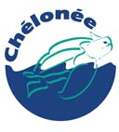 TECHNICAL NOTE FOR THE PRESENTATION OF THE DRAFT RESOLUTION

On the enhanced protection and management of sea turtle breeding, feeding and nursery areas and the designation of key areas as Ramsar Sites

According to the specialised systematists, a total of 7 or 8 species of sea turtle are recognised as belonging to the families Cheloniidae and Dermochelyidae. All of them (except Natator depressus whose populations are insufficiently known) have conservation statuses in the IUCN Red List ranging from “Vulnerable” to “Critically Endangered”.

When Professor Archie Carr from the University of Florida issued a warning to the United States and the scientific community in the mid 1950s, announcing a decline in the world sea turtle populations, the anthropogenic reasons for this situation appeared to be simple to overcome. The slaughter of female turtles on nesting beaches and the poaching of eggs from their nests appeared to be the human activities that were almost entirely responsible for the decline. Mortimer’s (1995) diagrams then explained very thoroughly how this decline occurred, as a result of delayed sexual maturity.

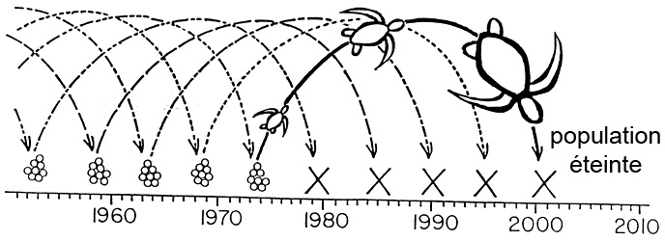
population extinct

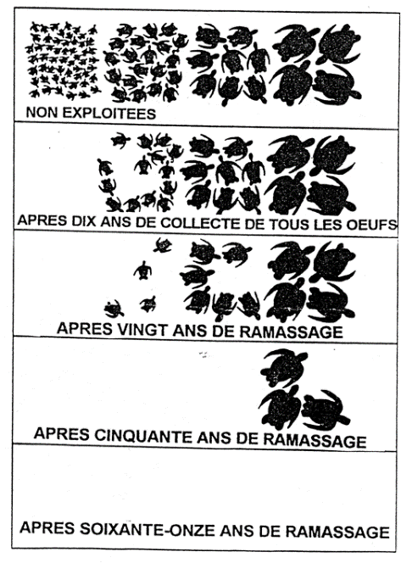  NO EXPLOITATION  EGGS TAKEN FOR TEN YEARS  EGGS TAKEN FOR SIXTY ONE YEARS  EGGS TAKEN FOR FIFTY YEARS  EGGS TAKEN FOR TWENTY YEARS | Scientific studies revealed clearly that under natural conditions, sea turtles, despite significant natural predation in the first years of their life, have a very long life span and great capacity for breeding. In the 1970s, on a large number of nesting beaches projects were launched that associated research, the identification of female turtles, the monitoring of nests and the raising of villagers’ awareness. It takes a long time to obtain the results of conservation campaigns because, for a species like Chelonia mydas, we have to wait around fifty years for the turtles from protected nests to breed.  There continue to be several black spots where turtles are killed and poached, especially in West Africa.
The overexploitation of adults for their meat, fat and shells that has been carried out for centuries, and the total destruction of all their nests on many beaches, have led to a considerable decline in sea turtle populations since the 20th century. Gradually, new anthropogenic threats have appeared, such as the degradation and development of nesting beaches and the removal of sand, the physical and chemical pollution of coastal waters, by-catches in fishing gear, the entanglement of turtles in ghost nets, the predation of eggs and baby turtles by introduced or invasive animals (rats, mongooses, ants, beetles, etc.), pigs or stray dogs, the disturbance of females on nesting beaches by lights or uncontrolled tourism, coastline artificialisation, etc.

In the past, when a villager killed a turtle to feed their family, it was no more serious for the turtle population concerned than the natural predation of a turtle from the same population by a killer whale, for example. With the opening up of villages that had formerly existed as self-sufficient units, the desire to buy manufactured products meant the inhabitants needed money and thus had to obtain it somehow. Trade, and indeed the cross-border trafficking of products derived from sea turtles was a rapid way of making money. However, it led to an increase in the harvesting of these animals’ natural populations. The few attempts that have been carried out at turtle ranching and farming have only increased the harvesting and commercial demand, and thus poaching.

Coastal erosion affects many nesting beaches. Natural erosion, in tropical environments, is sometimes greatly worsened by anthropogenic developments such as groynes, riprap and other infrastructures, which lead to changes in coastal currents, and even the creation of ports for industrial minerals. Additional threats will include heavy shipping traffic.

In the future, global warming will constitute a new threat, and we can already imagine what repercussions this will have on the reproduction of sea turtles. Sea level rise will destroy nesting beaches, especially in island environments. Due to temperature-dependent sex determination during embryonic development, the rise in the temperature of the substrate will lead to the feminisation of turtle populations.

Irrespective of the species, the life cycle always requires mating areas, either very near the coast or offshore, and the beaches where the females go to dig a nest and lay their eggs will be abandoned without the eggs being incubated.

A period known as the sea turtles’ “lost years” is also required, when newly hatched turtles swim away from the coast and then return to a coastal nursery area.

Depending on the species and the regional population, the adults either stay in one place or else carry out long migrations between feeding and nesting sites. The better the female’s health and the richer her diet, the more frequently she will lay eggs and the more eggs she will lay. Directly related to their food and age, sea turtles are to a greater or lesser extent dependent on rocky coastal areas, coral reefs, seagrass meadows, estuaries and mangroves, etc.

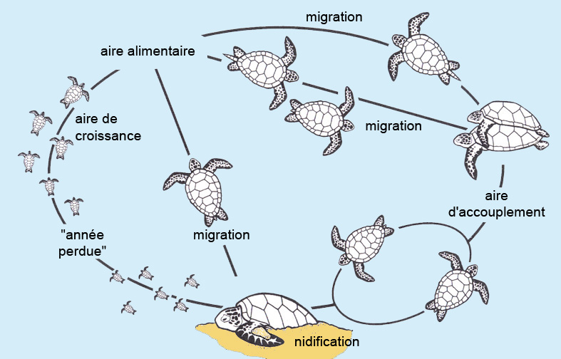
migration
migration
migration
feeding area
mating area
“lost year”
nursery area
nesting

The Convention on the Conservation of Migratory Species of Wild Animals (also referred to using the abbreviation CMS or the Bonn Convention) aims to conserve terrestrial, marine and avian migratory species throughout their range. The CMS has a unique role to play in drawing attention to the 76 endangered species currently listed in Appendix I. All species of sea turtle, except Natator depressus, are included in Appendix I of CMS. Appendix II contains migratory species, including sea turtles, which require or would benefit from international cooperation agreements concluded by CMS for their conservation and management. These agreements may range from legally binding treaties to less formal instruments such as memoranda of understanding. The Bonn Convention, with multi-species regional instruments such as the Memorandum of Understanding concerning Conservation Measures for Marine Turtles of the Atlantic Coast of Africa (Abidjan Memorandum of Understanding) and the Memorandum of Understanding on the Conservation and Management of Marine Turtles and their Habitats in the Indian Ocean and South-East Asia (IOSEA) has became the reference convention for these species.

Over one hundred Ramsar sites are already directly affected by sea turtle habitats.

The shores of the Basse-Mana wetland in French Guiana were the first to be classified as a Ramsar site (number 643) due to being of international importance for the nesting of one sea turtle species (D. coriacea), as well as being of importance for waterfowl. This Ramsar classification helped speed up the procedures for creating a national nature reserve, and thus improve the conservation of these exceptional habitats and stop the killing of the turtles and the poaching of their eggs.

The draft resolution aims to urge the Parties concerned to develop protective measures as well as management plans for the breeding, feeding and nursery habitats, and to designate as Ramsar sites the habitats presenting the greatest challenges for these species.

Jacques Fretey
Senior Advisor IUCN/SSC Marine Turtle Specialist Group
Scientific coordinator of the Abidjan Memorandum UNEP/CMS
President of Chélonée

