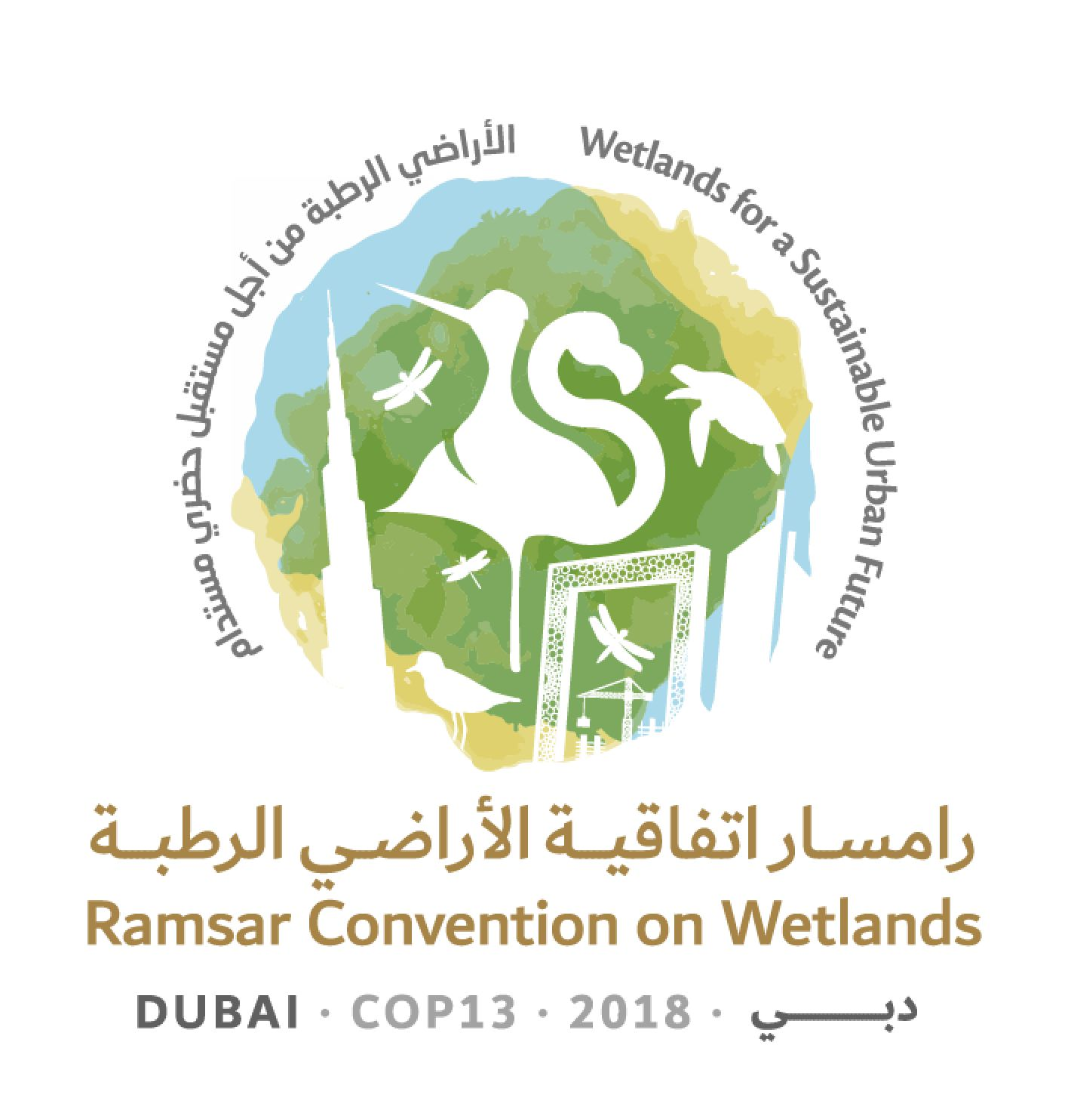
13th Meeting of the Conference of the Contracting Parties

to the Ramsar Convention on Wetlands

“Wetlands for a Sustainable Urban Future”

Dubai, United Arab Emirates, 21-29 October 2018

Ramsar COP13 Doc.3.2 Rev.1

Provisional working programme

Sunday 21 October 2018

08:30 – 12:30, 14:00 – 18:00 Registration of delegates (continues each day to 29 October)

10:00 – 13:00 55th Meeting of the Standing Committee

14:00 – 18:00 Regional meetings
(including discussions on Contracting Parties to be proposed for election to the Standing Committee, under agenda item 16)

18:15-21:00 Meetings of Regional Initiatives

Monday 22 October 2018

08:30 – 12:30, 14:00 – 18:00 Registration (continued)

09:00 – 12:00 Regional meetings

12:00 – 13:30 Special event “UN Ocean Conference Community of Ocean Action on Mangroves: Progress and opportunities”

14:00 – 16:00 Regional meetings

17:00 – 19:00 Opening ceremony and welcoming statements

1. Opening of the Meeting

2. General statements and keynote addresses

Ramsar Awards ceremony

19:00 – 21:30 Welcome reception

Tuesday 23 October 2018

07:45 – 09:45 Regional meetings

08:30 – 12:30, 14:00 – 18:00 Registration (continued)

08:30 – 09:45 Meeting of the Conference Bureau

10:00 – 13:00 Plenary Session

5. Election of the President and Vice-Presidents and remarks by the President

3.1 Adoption of the provisional agenda and working programme: Provisional agenda

3.2 Adoption of the provisional agenda and working programme: Provisional working programme

4.1 Adoption of the Rules of Procedure: Provisional Rules of Procedure

4.2 Adoption of the Rules of Procedure: Proposed amendments to the Rules of Procedure

6. Appointment of the Credentials Committee and any other committees

7. Admission of observers

8. Report of the Chair of the Standing Committee

11.1 Report of the Secretary General on the implementation of the Convention: Global implementation

11.2 Report of the Secretary General on the implementation of the Convention: Work of the Secretariat

13:00 – 15:00 Lunch break

15:00 – 17:45 Plenary Session

10. Report on implementation of the CEPA Programme 2016-2018 and recommendations on future directions

9. Report of the Chair of the Scientific and Technical Review Panel (STRP)

12. Report of the Secretary General pursuant to Article 8.2 on the List of Wetlands of International Importance

13. Issues arising from Resolutions and Recommendations of previous meetings of the Conference of the Contracting Parties

14. Financial report for 2016-2018 by the Chair of the Subgroup on Finance of the Standing Committee, and proposed budget for the 2019-2021 triennium

17. Secretariat’s report on administrative and financial implications of draft resolutions

18. Consideration of the draft resolutions and recommendations submitted by Contracting Parties and the Standing Committee
(see running order in Annex 1)

17:45 – 18:15 Presentation of the Global Wetland Outlook

Wednesday 24 October 2018

08:00 – 09:00 Meeting of the Conference Bureau

08:30 – 12:30, 14:00 – 18:00 Registration (continued)

09.00 – 09.55 Regional meetings

10:00 – 13:00 Plenary Session

18. Consideration of the draft resolutions and recommendations submitted by Contracting Parties and the Standing Committee
(see running order in Annex 1)

13:00 – 15:00 Lunch break

15:00 – 18:00 Plenary Session

18. Consideration of the draft resolutions and recommendations submitted by Contracting Parties and the Standing Committee (continued)
(see running order in Annex 1)

Thursday 25 October 2018

08:00 – 09:00 Meeting of the Conference Bureau

08:30 – 12:30, 14:00 – 18:00 Registration (continued)

09:00 – 09:55 Regional meetings

10:00 – 13:00 Plenary Session

18. Consideration of the draft resolutions and recommendations submitted by Contracting Parties and the Standing Committee (continued)
(see running order in Annex 1)

15.1 Wetland City Accreditation: Report of the Standing Committee

13:00 – 15:00 Lunch break

15:00 – 18:00 Plenary Session

15.2 Wetland City Accreditation: Presentation of certificates

18. Consideration of the draft resolutions and recommendations submitted by Contracting Parties and the Standing Committee (continued)
(see running order in Annex 1)

Friday 26 October 2018

08:00 – 09:00 Meeting of the Conference Bureau

08:30 – 12:30, 14:00 – 18:00 Registration (continued)

09:00 – 09:55 Regional meetings

10:00 – 13:00 Plenary Session

16. Election of Contracting Parties to the Standing Committee 2019-2021

18. Consideration of the draft resolutions and recommendations submitted by Contracting Parties and the Standing Committee (continued)
(see running order in Annex 1)

13:00 – 15:00 Lunch break

15:00 – 18:00 Plenary Session

18. Consideration of the draft resolutions and recommendations submitted by Contracting Parties and the Standing Committee (continued)
(see running order in Annex 1)

18:30 – 20:00 Preparatory meeting of the appointees to the incoming Standing Committee 2019-2021

Saturday 27 October 2018

09:00 – 10:00 Meeting of the Conference Bureau (if needed)

Free time

Sunday 28 October 2018

08:00 – 09:00 Meeting of the Conference Bureau

08:30 – 12:30, 14:00 – 18:00 Registration (continued)

09:00 – 09:55 Regional meetings

10:00 – 13:00 Plenary Session

19. Report of the Credentials Committee

20. Report on the discussions, conclusions and recommendations in the preceding sessions

13:00 – 15:00 Lunch break

15:00 – 18:00 Plenary Session

21. Adoption of Conference resolutions and recommendations

Monday 29 October 2018

08:30 – 12:30, 14:00 – 18:00 Registration (continued)

08:30 – 09:45 Meeting of the Conference Bureau
(with Standing Committee 2019-2021 appointees as observers)

10:00 – 13:00 Plenary Session

21. Adoption of Conference resolutions and recommendations (continued)

13:00 – 15:00 Lunch break

15:00 – 18:00 Plenary Session

22. Date and venue of the next ordinary meeting of the Conference of the Contracting Parties

23. Any other business

24. Adoption of the report of the 13th Meeting of the Conference of the Contracting Parties

25. Close of the meeting

18:30 – 19:30 56th Meeting of the Standing Committee (incoming members to elect officers and subgroup members, and agree the date and venue of the first full meeting)

Annex 1
Running order for consideration of draft resolutions
18.5 | Draft resolution on financial and budgetary matters
18.9 | Draft resolution on World Wetlands Day
18.1 | Draft resolution on enhancing the effectiveness of the Ramsar Convention
18.2 | Draft resolution on improving the efficiency of structures and processes of the Convention
18.3 | Draft resolution on the responsibilities, roles and composition of the Standing Committee and regional categorization of countries under the Convention
18.4 | Draft resolution on language strategy for the Convention
18.19 | Draft resolution on the importance of wetlands for peace and security
18.6 | Draft resolution on review of the fourth Strategic Plan of the Ramsar Convention
18.7 | Draft resolution on enhancing the Convention’s implementation, visibility and synergies with other multilateral environmental agreements and other international institutions
18.25 | Draft resolution on wetlands in polar and subpolar regions
18.8 | Draft resolution on Ramsar Regional Initiatives 2019-2021 and their Operational Framework
18.10 | Draft resolution on the status of Sites on the List of Wetlands of International Importance
18.26 | Draft resolution on the enhanced conservation of sea turtle breeding, feeding and nursery areas and the designation of key areas as Ramsar Sites
18.11 | Draft resolution on Ramsar Advisory Missions
18.12 | Draft resolution on future implementation of scientific and technical aspects of the Convention for 2019-2021
18.13 | Draft resolution on guidance on identifying Wetlands of International Importance (Ramsar Sites) for global climate change regulation as an additional argument to existing Ramsar criteria
18.14 | Draft resolution on restoration of degraded peatlands to mitigate and adapt to climate change and enhance biodiversity
18.15 | Draft resolution on promoting conservation, restoration and sustainable management of coastal blue carbon ecosystems
18.16 | Draft resolution on cultural values, indigenous peoples and local communities, and climate change mitigation and adaptation in wetlands
18.17 | Draft resolution on sustainable urbanization, climate change and wetlands
18.18 | Draft resolution on the rapid assessment of wetland ecosystem services
18.20 | Draft resolution on gender and wetlands
18.21 | Draft resolution on agriculture in wetlands
18.22 | Draft resolution on promoting the conservation and wise use of intertidal wetlands and ecologically associated habitats
18.23 | Draft resolution on conservation and management of small wetlands
18.24 | Draft resolution on wetlands in West Asia

