Pre-COP13 Asia Regional Meeting
Ramsar Convention on Wetlands
Date: 26 February – 2 March 2018
Venue: Carolina Beach Resort & Spa, Chilaw, Sri Lanka
Host: Ministry of Sustainable Development and Wildlife, Sri Lanka
Organizers: Secretariat of the Ramsar Convention on Wetlands and the Ministry of Sustainable Development and Wildlife, Sri Lanka

Background Information
In preparation for the 13th Meeting of the Conference of the Contracting Parties to the Ramsar Convention on Wetlands which will be held in Dubai, the United Arab Emirates from 21 to 29 October 2018, a meeting for the Asian Contracting Parties will be organized in Chilaw, Sri Lanka from 26 February to 2 March 2018.
Representatives from Ramsar Contracting Parties in the Asia Region are expected to be present at the meeting. Observers, including non-Contracting Parties to the Convention, intergovernmental and non-governmental organizations, as well as wetland experts and other stakeholders, are also welcomed.
The aim of the meeting is for the Ramsar Secretariat to:
- Update the Asian Contracting Parties on activities of the Secretariat and bodies of the Convention since COP12 in 2015;
- Explain the background to the key Draft Resolutions that will be presented to COP13, so that Asian Contracting Parties can be better informed to discuss the Draft Resolutions;
and to allow the Asian Contracting Parties to:
- Exchange their experiences, especially in relation to the Draft Resolutions that will be presented to COP13;
Working language: English
Meeting Documents:
The Draft Resolutions (DRs) to be discussed at the pre-Cop13 meeting and which will be presented to the 54th Standing Committee meeting for approval before going forward to COP13, will be made available on the Ramsar website on
https://www.ramsar.org/event/54th-meeting-of-the-standing-committee (Agenda items 21, 23, 24 and 25)
Venue and Accommodation
The accommodation and meeting venue will be at the Carolina Beach Resort & Spa located in Chilaw, Sri Lanka.

Address:
Ambakandawila, Chilaw, Sri Lanka
Tel: +94 (0) 32 224 3110/32 224 3111
Email: info@carolinabeachhotel.lk
Website: http://www.carolinabeachhotel.lk/
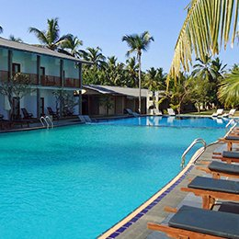 | 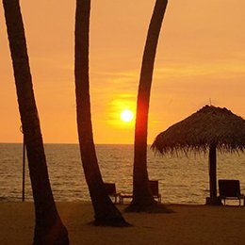
Carolina Beach Resort
Field Trip
You can choose from one of two field visits that will be organized on Wednesday 28 February. The first is to the wetlands in and around Colombo City where you will see the work that has been carried out to restore the urban wetlands as part of a World Bank project to reduce the risk of flooding, to cool and clean the air in the city, to provide space for recreation and education etc. [link]. A visit will also be made to the Beddagana Wetland Park.
The second visit is to the Wilpattu Ramsar Wetland Cluster which is made up by some 205 natural and human-made water bodies. A unique feature is the numerous 'villus' which are natural, sand-rimmed water basins ranging between 10 to 160 hectares that are filled with rainwater. The varying salt content of the villus provide habitat for a range of wildlife, including the endangered Asia Elephant Elephas maximus, the vulnerable Lesser Adjutant Leptoptilos javanicus and the vulnerable freshwater crocodile Crocodylus palustris.
Please bring along standard fieldtrip clothing and equipment for bird-watching and walking on these field trips, such as binocular, rainwear, camera, walking-boot/shoes, hat, drinking water, sun cream and insect repellent.
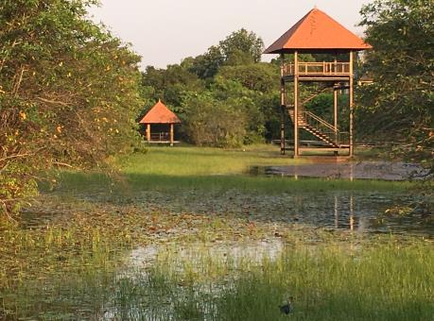 | 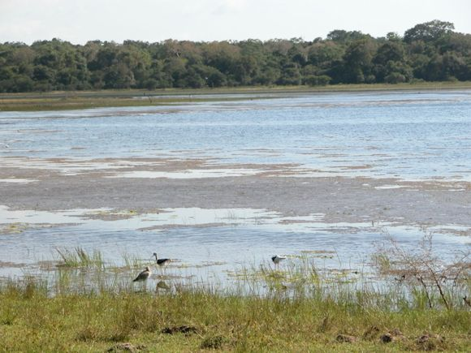
Beddagana Wetland Park | Wilpattu Ramsar Wetland Cluster

Visa for entry into Sri Lanka
Visa Application
All participants are required to get a visa for Sri Lanka before departure or on arrival. Visa for Sri Lanka can be processed through online with this link: https://www.eta.gov.lk/slvisa/visainfo/center.jsp?locale=en_US. However, please check with your nearest Sri Lankan embassy/consulate before departure to make sure of the process of visa application.
Visa can be obtained directly when you arrive at the Bandaranaike International Airport in Colombo. The maximum stay permitted with the visa is thirty (30) days, and may be extended up to 90 days from the date of arrival at the first instance and further 90 days at the second instance.
The general requirements for visa on arrival are:
- Original passport that must have at least six (6) months validity
- Round-trip airplane ticket
- One recent photograph (4x6cm)
Appropriate visa fee:
- Applicants from South Asian Association for Regional Cooperation (SAARC) Countries:
  - Business visa with Multiple Entry for 30 days: USD 30 (online) or USD 40 (on arrival) (you may be asked to demonstrate that you have sufficient funds for your stay)
- All other countries:
  - Business visa with Multiple Entry for 30 days: USD 40 (online) or USD 50 (on arrival) (you may be asked to show supporting documents such as the invitation letter from the organizers and host and also the letter from your Ministry nominating you to participate in this meeting)
For more details, please refer to
- The Sri Lankan Embassy in your country
- Ministry of Foreign Affairs in Sri Lanka
- More information about the online applications (https://www.eta.gov.lk/slvisa/visainfo/center.jsp?locale=en_US)

Transfer from airport to the Carolina Beach Resort & Spa
Transport from airport to hotel:
The Department of Wildlife Conservation (DWC), Sri Lanka will provide transportation service for all the participants. Please kindly note that tickets for buses or taxis to attend the venue will not be reimbursed. Please contact Mrs. Gishani Rajapaksha (gishanikrajapaksha@gmail.com; +94714465504) and Mr. Yai Akoijam (asia.oceania@ramsar.org; +41 77 960 4769) to advise your planned arrival time and arrange transportation.

General Information
Location
Sri Lanka, officially the Democratic Socialist Republic of Sri Lanka, is an island country in South Asia, located southeast of India and northeast of the Maldives. The island is home to many cultures, languages and ethnicities.

The majority of the population is from the Sinhalese ethnicity, while a large minority of Tamils have also played an influential role in the island's history; Christians in both groups are recent converts who have kept the traditional culture. Moors, Burghers, Malays, Chinese, and the aboriginal Vedda are also established groups on the island. The country’s administrative and commercial capitals are Sri Jayawardenepura Kotte and Colombo respectively. Sri Lanka covers an area of 65,610 sq. km.
Religion
Sri Lanka is a multi-religious country with Buddhism comprising 70 percent of the population, with the Theravada school being predominant. Buddhism was introduced to Sri Lanka in the 2nd century BCE by Venerable Mahinda. Other religions in Sri Lanka are Hinduism, Islam, Christianity and Zoroastrianism.
Currency
Sri Lankan Rupee (LKR) is the official tender in Sri Lanka divided into 100 cents. The airport is a convenient place to change your money as there are many bank desks there that are open 24/7 and you get a good rate too.
Electricity System
Electrical outlets in Sri Lanka are mainly associated with 2 types of plugs (types D and G). Plug type D has three round pins in a triangular pattern and plug type G has three rectangular pins in a triangular pattern. Sri Lanka operates on a 230V supply voltage and 50Hz.
Internet Access
The meeting venue has free Wi-Fi connection available for all participants lodging at the hotel in the meeting halls as well as their rooms.
Climate
The climate is tropical and warm, due to the moderating effects of ocean winds. Mean temperatures range from 17 °C (62.6 °F) in the central highlands, where frost may occur for several days in the winter, to a maximum of 33 °C (91.4 °F) in other low-altitude areas. Average yearly temperatures range from 28 °C (82.4 °F) to nearly 31 °C (87.8 °F). Day and night temperatures may vary by 14 °C (25.2 °F) to 18 °C (32.4 °F).
Time Zone
Sri Lanka Standard Time (SLST) is the time zone for Sri Lanka. It is 5 hours and 30 minutes ahead of GMT/UTC (UTC+05:30).
Health Issues
Being a tropical city, as a precaution, it is recommended that you drink bottled water at all times from one of the many quality brands available. Water from tap, even in the best of hotels, should be avoided for drinking unless it is boiled for several minutes.

Insurance
The organizers cannot be held liable for any case of damage, accident, injury, sickness, theft, etc. during your travel to and from, and stay in Sri Lanka. We strongly recommend that you make an arrangement of travel insurance by yourself.
Secretariat Services
All documents for the meeting will be provided to each participant. Request for documents, photocopying, distribution should be made through the officers of the Department of Wildlife Conservation, Sri Lanka.
Photocopying and other secretariat services will be made available to participants. Stationery will be distributed to delegates during the meetings. Any additional requirement can be obtained from the information desk.

Contacts in Chilaw, Sri Lanka
In case of emergency, please call one of the numbers below:
- Police Emergency Hotline ☎ 118/119.
- Ambulance / Fire & rescue. ☎ 110.
- Tourist Police. ☎ 011-2421052.
- Police Emergency. ☎ 011-2433333.
- Emergency Police Mobile Squad ☎ 011-5717171
- Government Information Center. ☎ 1919.
- Report Crimes ☎ 011-2691500
- Fire & Ambulance Service ☎ 011-2422222
For general enquiries during your stay in Chilaw and field trip, please contact:

Mr. Manjula Amararathna
Deputy Director
Department of Wildlife Conservation
Tel: +94 11 287 1531/+94 11 288 8585
Mobile: +94 71 442 8858
E-mail: manjulaamararathna@yahoo.com

Mrs. Gishani Rajapaksha
Development Officer
Department of Wildlife Conservation
Tel: +94 11 2888 585
Mobile: +94 71 446 5504
E-mail: gishanikrajapaksha@gmail.com
For enquiries about meeting arrangements and schedule, please contact

Dr. Lew Young
Senior Adviser for Asia-Oceania
Secretariat of the Ramsar Convention on Wetlands
Tel: +41 22 999 0177
Mobile: +41 79 290 2625
E-mail: young@ramsar.org

Mr. Yaiphaba M. Akoijam
Assistant Adviser for Asia-Oceania,
Secretariat of the Ramsar Convention on Wetlands
Tel: +41 22 999 0138
Mobile: +41 77 960 4769
E-mail: asia.oceania@ramsar.org

For enquiries regarding the hotel, please contact:
Ms. Sandy Wanniarachchi
Carolinaa Beach Resort & Spa
Tel: +94 (0) 32 224 3110 | +94 (0) 32 224 3111
Mobile phone: +94 77 736 1010
Email: marketing@carolinabeachhotel.lk

