CONVENTION ON WETLANDS (Ramsar, Iran, 1971)
48th Meeting of the Standing Committee
Gland, Switzerland, 24– 28 January 2015

DOC. SC48-30

Draft Resolution: Call to action to ensure and protect the water requirements of wetlands for the present and the future

Submitted by Mexico

Action requested. This draft Resolution was sent to the Secretariat by Mexico on 30 September according to the rules of procedure. The Standing Committee is requested to consider the attached draft Resolution for transmission to COP12.

Resolution XII.__

Call to action to ensure and protect the water requirements of wetlands for the present and the future

- NOTING the Preamble of the Convention, which recognizes the fundamental ecological functions of wetlands as regulators of water regimes and as habitats supporting a characteristic fauna and flora, especially waterfowl;

- RECOGNIZING that wetlands provide a wide range of ecosystem services, which contribute to human well-being and the state of the environment, and that consequently their conservation and wise use are fundamental in order to continue to offer these services, and moreover that wetlands are both a source and consumer of water;

- BEARING IN MIND that the report The Economics of Ecosystem and Biodiversity for Water and Wetlands highlights the urgent need to focus on wetlands as natural solutions to the global water crisis. SIMILARLY, it urges a major shift in our attitudes to wetlands, to recognize both their value in delivering water, raw materials and food which are essential for life, and the crucial role they play in maintaining people’s livelihoods and the sustainability of the world’s economies;

- NOTING Decision X/28 of the Convention of Biological Diversity (CBD) on Inland waters biodiversity, and, in particular, AWARE of the concern regarding major anthropogenic changes that are ongoing in the Earth’s water cycle on global, regional and local scales, due to the direct use of water and land-use change; that the limits of sustainability of both surface water and groundwater resources have already been reached or surpassed in many regions; that these trends are becoming more pronounced in some areas through climate change; and that the water-related stresses on biodiversity and ecosystem changes are rapidly escalating;

- RECALLING the Changwon Declaration on human well-being and wetlands (Resolution X.3), which recognizes explicitly that the increasing demands for, and over-use of, water jeopardize human well-being as well as the environment, and that there is often not enough water to meet our direct human needs or to maintain the wetlands we require, and ALSO RECALLING the issues of fundamental importance for the future of the Convention indicated in Resolution X.1, which identifies the lack of water resources for wetlands and the increasing demand for water extraction as the main factors that generate continuous change and lead to the deterioration and disappearance of wetlands and their services;

- AWARE of Resolution XI.10 that revealed concern on a regional and global scale over the increase in public works, and in particular hydroelectric power generation projects, which by modifying water flow and the transportation of sediments, interrupt connectivity and create barriers that prevent species migrating, as well as having a negative impact on the ecological characteristics of wetlands, in particular on species and ecosystems, and on their potential to produce a wide range of ecosystem services, on their biodiversity and on the quantity and quality of the water;

- CONSIDERING Resolution VIII.34, which URGES the Contracting Parties to ensure that management plans for Ramsar Sites and other wetlands are developed within wider integrated management approaches, which duly acknowledge the need for the appropriate implementation of practices and policies that are compatible with wetland conservation and sustainable use goals;

- ALSO CONSIDERING Resolution VI.23 and Resolution VIII.1, which explicitly recognize that wetland ecosystems require a certain volume of water in order to maintain their ecological characteristics and establish guidelines for the process of allocating and managing water resources to this end, and ALSO AWARE of Resolution VIII.40, which recognizes that maintenance of the ecological integrity of most wetlands, especially those located in arid or semi-arid zones, is closely linked to the supply of groundwater;

- HIGHLIGHTING the fact that ensuring the availability of the water required by wetlands will promote both their biodiversity and the sustainable use of their components, in addition to meeting the targets of the CBD’s Strategic Plan for Biodiversity 2011-2020 (Aichi Targets). STRESSING, in particular, that knowing wetlands’ water requirements will favour the integration of biodiversity values into development planning processes and strategies, contribute to the sustainable management of water in agricultural areas, and maintain the impacts of the use of natural resources within ecological limits in order to guarantee biodiversity conservation;

- RECOGNIZING that the allocation and protection of the water requirements of wetlands will help improve the integrated management of water resources (Resolution VII.18), and in particular river basins, by harmonizing water-use and land-use strategies, maintaining the renewal of the water cycle and the link existing between ground and surface water, both enabling their management, and helping to establish adaptation conditions that allow climate variability to be mitigated;

- RECALLING that Resolution X.24 on Climate change and wetlands (2008) recognizes the potentially serious impacts of climate change for ensuring the continued conservation and wise use of wetlands. Similarly, it calls on the Contracting Parties to manage their wetlands in such a way as to increase their resilience to climate change and extreme climatic events, and to ensure that in their climate change responses, such implementation does not lead to serious damage to the ecological character of wetlands;

- NOTING Resolution VII.7 on Guidelines for reviewing laws and institutions to promote conservation and the wise use of wetlands, which URGES each Contracting Party to review its laws and institutions to ensure they are aimed not only at the wise use of wetlands and eliminating obstacles to conservation, but also at adopting measures that can serve as positive incentives for the effective implementation of the wise use obligation, such as the allocation of water to wetlands;

- ALSO RECOGNIZING the need among the Contracting Parties to replicate successful examples of the determination, allocation and protection of wetlands' water requirements in order to maintain their ecological functions, prevent conflict over water resources, improve the resilience of wetlands to climate change, and to safeguard the ecosystem services that wetlands offer society;

- NOTING Resolution IX.3 on the Engagement of the Ramsar Convention on Wetlands in ongoing multilateral processes dealing with water, which AFFIRMS that the conservation and wise use of wetlands is critical for the provision of water for people and nature, and that wetlands are a source, as well as a user, of water, as well as supplying a range of other ecosystem benefits/services;

- AWARE of the role water will have to play in the Post-2015 Development Agenda, as well as the so-called “Post-2015 Global Goal for Water”, which include targets for improving the sustainable use and development of water resources and the conservation of wetland ecosystems, in order to promote decisions and actions that take into account both human and environmental water requirements, as well as the need to increase the long-term viability of natural supply systems;

- RECALLING THAT the need to guarantee a volume of water is established in the local laws of several of the world's nations, and is thus currently emerging as an international principle in the areas of environmental and water legislation;

- ECHOING the Changwon Declaration’s call to action, which presents an overview of the priority action steps that together show how to deliver some of the world’s most critical environmental and sustainability goals, including the wise management and protection of our wetlands – always ensuring that the latter have enough water for them to continue to be the source of the quantity and quality of water we need for food production, drinking water and sanitation;

THE CONFERENCE OF THE CONTRACTING PARTIES

- RECOGNIZES AND REITERATES that the lack of water in wetlands is a far-reaching global problem with serious consequences for ecosystems and people’s livelihoods, in particular those of vulnerable, marginal communities that depend on wetlands, and that this problem has not yet been solved, but that on the contrary it will increase in the future due to the growing demand for water and the effects of climate change;

- WELCOMES the process carried out in Mexico for the creation of water reserves for wetlands, described in the annex to this Resolution, and URGES the Contracting Parties to use this model, identifying the opportunities to act preventatively, and adapting it as necessary in order to address national and regional conditions and circumstances, within the framework of existing regional initiatives and commitments and within the context of sustainable development;

- CALLS UPON the Contracting Parties, other pertinent governments and organizations, to increase their efforts in order to guarantee the allocation of the water required by wetlands, in particular identifying opportunities to anticipate the negative impacts of projects and infrastructures related to the use of water on wetlands, their biodiversity and the services they provide;

- ASKS the Ramsar Convention’s Secretariat, the Scientific and Technical Review Panel, the International Organization Partners and the interested Contracting Parties to draw up a Global action plan to guarantee the water required by wetlands, which considers:

- Integration with other global initiatives, in particular on the contribution of wetlands to the Sustainable Development Goals (SDGs);
- Assessment of the global situation regarding wetland water requirements;
- Application of strategies and tools for the determination and allocation of water to wetlands on a regional or national scale;
- A programme for monitoring the water conditions of wetlands;
- International cooperation for the creation of research networks and specialized regional centres and for institutional capacity building;
- Communication, education and raising public awareness about the need to consider ecological flows in the sustainable use of natural resources, as well as the benefits for the environment and human health that these wetlands offer.

Annex

WATER IS REQUIRED FOR THE CONSERVATION AND WISE USE OF WETLANDS

- The Convention’s mission is “the conservation and wise use of all wetlands” understood in general terms as “the maintenance of their ecological character”, which involves conserving interactions between the various individual processes, functions, attributes and values of the ecosystems.

- From an ecological perspective, there is no doubt that the processes that govern wetlands (including the recycling of nutrients, productivity, succession processes, competition between species, etc.) are to a large extent controlled by their water regime. Without a doubt, it can be said that Convention’s key mission is to guarantee the conservation or restoration of water regimes in accordance with the maintenance of the biological, chemical and physical components characteristic of each wetland.

- The Convention’s definition of wetlands encompasses a large number and wide variety of ecosystems across the globe, since it includes “areas of marsh, fen, peatland or water, whether natural or artificial, permanent or temporary, with water that is static or flowing, fresh, brackish or salt, including areas of marine water the depth of which at low tide does not exceed six metres”.

- Naturally, with its respective location and characteristics, each wetland has its own individual water regime, variable over time but with variability patterns and ranges that condition its evolution. The conservation of the water regimes characteristic of each wetland thus becomes of key importance for their conservation and wise use, something that the COP itself has recognized. Thus, for example, Resolution VIII.33 protects the maintenance of the specific hydrological functioning upon which temporary pools depend, including their dependence on permanent surface waters, in order to ensure the sustainable management of the temporary pools.

- The importance of the natural water regime as a benchmark for the conservation of wetlands has been highlighted in several Resolutions. The Annex to Resolution VIII.1 indicates that, “to maintain the natural ecological character of a wetland, it is necessary to allocate water as closely as possible to the natural regime". In the guidelines for Contracting Parties for the integration of conservation and wise use of wetlands into river basin management (Resolution X.19), it is also recommended that the precautionary principle be used to maintain the natural state as closely as possible in situations where available information on the environmental water requirements of wetlands is inadequate.

- Despite the fact that the natural water regime constitutes a benchmark for conservation and wise use, it is important to bear in mind that the Convention aims at listing natural or semi-natural wetlands. Thus, the Ramsar wetlands encompass a wide range of ecosystems and management approaches, from extremely natural areas where the aim is to protect their ecological integrity, to semi-natural or artificial wetlands whose conservation is integrated into traditional lifestyles. Along these lines, it should be pointed out that wetlands' water requirements are not all identical, and we should be aware of this in order to maintain their individual ecological character. In general terms, wetlands listed due to the fact they are very natural, should have natural or almost natural water regimes, whilst semi-natural or artificial wetlands may have regimes that involve the sustainable extraction of resources.

SEVERAL CHALLENGES FOR GUARANTEEING THAT WETLANDS HAVE ALL THE WATER THEY NEED

- According to the Status Report on the Application of Integrated Approaches to Water Resources Management, over 75% of the countries studied considered that “Water for environment” was a priority in their respective countries, whilst only 5% of the countries considered that this issue was “not a problem”.

- Water use trends and concern about water issues contrast with the major challenges involved in ensuring ecosystems have all the water they require. In this respect, there are at least four major factors that allow us to visualize these great challenges:

a. Most wetlands have no water monitoring system to assess changes in their functioning.

- The monitoring of water resources and their use is an enormous challenge, especially given the renewable character and the general complexity of knowledge about the water cycle. This great challenge contrasts with the fact that our knowledge of water resources and the use of water is probably diminishing due to the decrease in the availability of data on national water services (Figure 1). A similar situation occurs with the monitoring of groundwater, despite its importance for the world’s supply of fresh water and the maintenance of ecosystems.

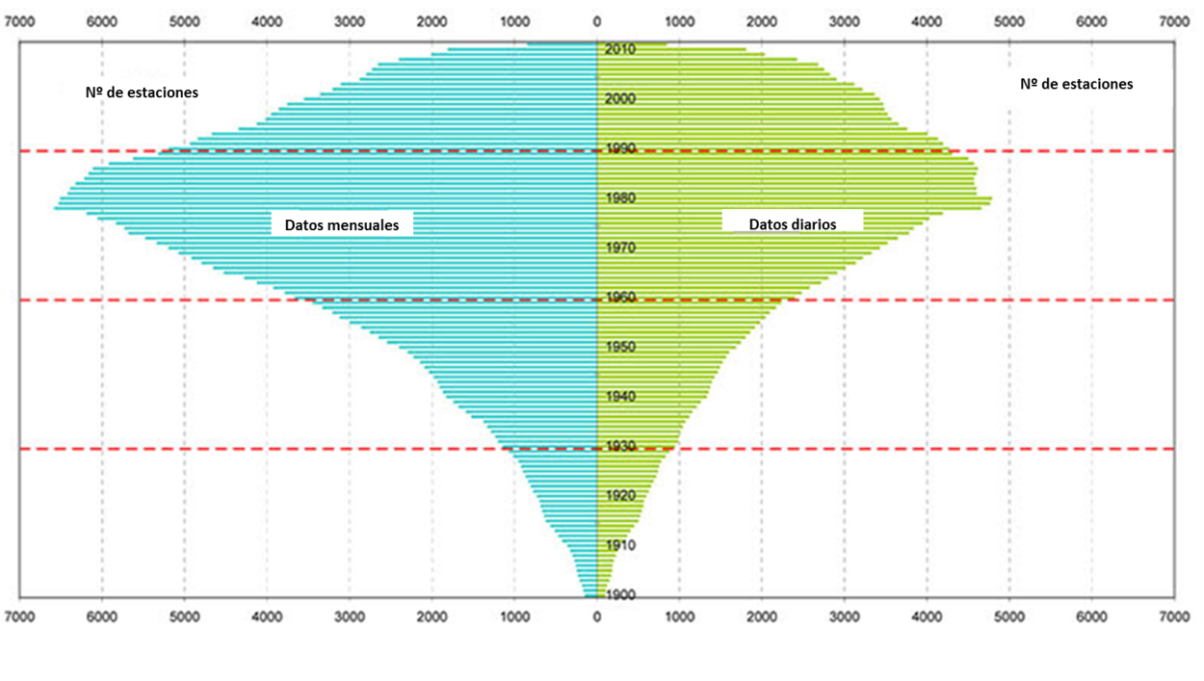
Nº de estaciones = Number of stations
Datos mensuales = Monthly data Datos diarios = Daily data

Figure 1. Availability of historical discharge data in the Global Runoff Data Centre (GRDC) database at the German Federal Hydrology Institute, Koblenz, Germany, 2012. Source: GRDC available at http://grdc.bafg.de

- According to the UN Status Report of the Application of Integrated Approaches to Water Resources Management (2012), only 22.5% of all countries studied have fully implemented a monitoring programme on the use of water, and around 30% have not begun to implement one. Due to a lack of data on water monitoring in wetlands (flow, groundwater levels, extraction, etc.) and the abstractions that affect them, it is impossible to know whether wetlands have all the water they require. One particular challenge is the maintenance of a regular comparable database for monitoring changes and trends in the different water parameters (flow, groundwater levels, etc.) over time.

b. The scientific methods for determining the water needs of wetlands are very limited, bearing in mind the broad range of both Ramsar wetlands and biological groups requiring water.

- Most methods for calculating environmental flow focus basically on flowing water ecosystems (rivers), whilst these systems only represent 10% of all Ramsar wetlands (see Figure 2). Moreover, in many cases the methods used to calculate the water requirements of the ecosystems have been designed to determine river types, and are not suitable for other regions (for example the habitat simulation models frequently used in some countries are extremely limited in the case of large tropical rivers).
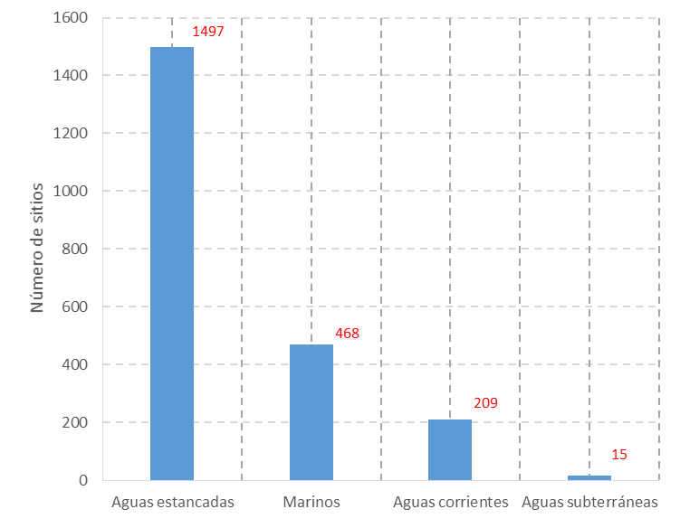

Número de sitios = Number of sites

Aguas estancadas = Static water
Marinos = Marine
Aguas corrientes = Flowing water
Aguas subterráneas = Groundwater

Figure 2. Wetland types in accordance with their general water characteristics. Source: Ramsar Sites Information Service (RSIS) available at: http://ramsar.wetlands.org/

- Moreover, most methods used to calculate environmental flow are fundamentally based on the water requirements of fish, and in many cases only the species of greatest economic interest. However, there are other biological groups that justify the designation of wetlands as sites of international importance. For example, 92% of the sites have been added to the Ramsar List because of the birds that use these wetlands. One major challenge is to increase scientific knowledge in order to obtain more detailed information about the water requirements of different types of Ramsar Sites and all the species that justify their designation.

c. For most of the Contracting Parties, the legal frameworks do not recognize explicitly the need to allocate water to wetlands and/or provide the legal mechanisms to do so effectively

- As recognized by the Annex to Resolution VIII.1, in order to make decisions on the water allocations for wetland ecosystems, an enabling policy environment is required, supported both by adequate and appropriate legal tools, which clarify the legal situation of water and water resources, and by a framework for assessing the merits of different allocation options.

- The legal allocation of water resources to wetlands requires far-reaching reforms for many countries, with changes in both environmental and water policies, legislation and planning. For some countries this is complicated by the fact that water resources are the responsibility of lower administrative levels such as the state, province or municipality. In these cases, it is essential that the countries identify alternatives to rectify this situation and to be able to plan for water allocation/demand processes.

- According to the Status Report on the Application of Integrated Approaches to Water Resources Management (2012), 45.4% of the countries surveyed implement to some extent programmes for the allocation of water resources, which take environmental considerations into account. However, only 12.3% have fully completed this type of programme. Moreover, in the countries that have introduced environmental flow programmes, there is little information on how successful they have been, since there are no clear assessment criteria.

d. The Contracting Parties are still a long way from adopting the Integrated Water Resources Management tools. These are the very tools that can allow for the proper integration of wetland water requirements into resource management.

- Strategy 1.7 of the Ramsar Strategic Plan 2009-2015 consists of ensuring “that policies and implementation of Integrated Water Resources Management (IWRM), applying an ecosystem-based approach, are included in the planning activities in all Contracting Parties and in their decision-making processes, particularly concerning groundwater management, catchment/river basin management”, and includes the Key Result Area 1.7ii (planned for 2015), which states: “All Parties, in their water governance and management, to be managing wetlands as natural water infrastructure integral to water resource management at the scale of river basins”.

- Resolution X.19 highlighted the fact that in the longer term it is not sufficient to integrate wetland management objectives into land use management plans. In turn, land and water resource management plans need to be integrated to ensure that these plans reflect common, agreed management objectives for the wetlands in a river basin. The aim should be to match water resources strategies with land use strategies, so that these can be implemented jointly to support the maintenance of healthy, functional wetlands that provide a range of benefits for people (including water supply).

- According to the results of the survey on the application of IWRM, clear progress has been made in the adoption of integrated approaches to water resources on a global scale. Water resource management programmes (including allocation systems, groundwater management, environmental impact assessment, demand control, etc.) are being applied in 84% of the countries with the highest Human Development Index, though only in around 40% of the other countries. This same survey reveals that 50% of the countries have implemented neither an integrated water resources management plan at a national or federal level nor any equivalent strategic plan.

NEED FOR GLOBAL ACTION AND ITS STRATEGIC GUIDELINES

- According to the United Nations 5th World Water Development Report (WWDR), global water demand (in terms of water withdrawals) is projected to increase by some 55% by 2050. As a result, freshwater availability will come under increasing strain over this period, with 40% of the global population projected to be living in areas of severe water stress by 2050. There is also clear evidence that groundwater supplies are diminishing, with an estimated 20% of the world’s aquifers being over-exploited, some critically so.

- The enormity of this challenge calls for urgent coordinated global action, in preparation for the growing pressure for this resource, in order to guarantee the water required by wetlands, including strategic guidelines on:

• Legal and institutional frameworks. To develop legal and institutional tools that are in line with the urgent need to ensure the water requirements of the ecosystems and capable of anticipating the growing demand for this resource
• Monitoring. To generate basic information to support the making and supervision of decisions with regard to wetlands.
• Tools. To support the knowledge and development of tools for calculating and allocating the water required by ecosystems and suitable for its rapid use.
• Education, awareness raising and capacity building. To promote the importance of the allocation of water to wetlands through education, the public media and capacity building.

- A series of actions on these strategic areas could create the right environment for taking urgent action and generating the changes required to promote sustainable development compatible with water, fulfil basic human activities and guarantee the protection of wetlands.

INITIATIVES UNDERTAKEN BY THE MEXICAN GOVERNMENT TO GUARANTEE THE WATER REQUIRED BY WETLANDS

- Mexico has been a Contracting Party of the Ramsar Convention since 1986, and to date has 142 sites designated as Wetlands of International Importance, which cover a total area of 8.4 million hectares, making it the contracting country with the second highest number of designated Ramsar sites in the world. In Mexico, the management of wetlands is the responsibility of the Ministry of the Environment and Natural Resources (Secretaría de Medio Ambiente y Recursos Naturales, SEMARNAT) and its decentralized bodies: the National Commission of Protected Natural Areas (Comisión Nacional de Áreas Naturales Protegidas, CONAP), focal point for the Ramsar Convention and the body that coordinates the execution of actions involved in complying with the Convention’s commitments; and the National Water Commission (Comisión Nacional del Agua, CONAGUA) the federal body responsible for the administration of Mexico's water resources.

- In Mexico, the allocation of water for the environment has been recognized since the publication of the National Water Law (Ley de Aguas Nacionales, LAN) in 1992. However, it was not until recently that two national initiatives were undertaken that represent major progress in guaranteeing the water resources required by wetlands: the publication of the “Mexican law for the determination of environmental flow” and the “National Water Reserve Programme” (Programa Nacional de Reservas de Agua, PNRA).

The Mexican Environmental Flow Standard

- With the publication of the LAN, the Mexican water administration took on the challenge of building the water concession administration system, which is based on establishing the water balance in each river basin or administrative unit, and granting concessions to each water user, recognizing in advance the various documents issued by the competent authority, authorizing the use of water. In this process, the requirement for allocating water to the environment was postponed, since it was claimed that insufficient information on water requirements was available, and that there was uncertainty over the application of scientifically appropriate and economically accessible methodologies for determining a reliable ecological flow. As a result, in many of the country’s basins, water concessions have been granted for 100% or more of the measured or estimated mean annual runoff, and without considering water allocated to the environment. This situation has constituted one of the causes of the severe over-use of water resources in 8 out of 13 hydrological regions in which 75% of the country’s gross domestic product is produced.

- Concern over this situation led to a long participatary process aimed at establishing the means of calculating the water requirements of ecosystems. The process was enhanced by the practical experiences of World Wildlife Fund (WWF) in association with the Gonzalo Río Arronte Foundation, which allowed the bases and methods for calculating environmental flows to be established, an action essential for protecting the country's water security. The Mexican Environmental Flow Standard was approved in 2012, establishing the methodologies for determining environmental flow, as a means of regulating the exploitation, use and conservation of water to protect ecosystems and favour sustainable development.

- The importance of this tool consists of integrating the ecological, social and economic significance into the determination of the flow in the following terms.

• It establishes the scientific bases that should guide all environmental flow proposals. It is explicitly recognized that a variable water regime is necessary (beyond minimum flows), with different components (low flows, flood regime, etc.) responsible for the ecosystem dynamics. Some of the basics mentioned explicitly as guiding principles are the paradigm of the natural flow regime and the biological condition gradient.
• It recognizes that there are very diverse situations in the country where we need to find a balance between the pressure caused by the extraction of water and the conservation of environmental conditions. This leads to the establishment of environmental objectives, which allow environmental flows to be adjusted in accordance with the ecological importance of the sites and the pressure created by water use.
• It integrates social assessment of water in the environment and ensures its availability for consumption by and the well-being of rural communities.
• It establishes a hierarchical condition for the application of methodologies in accordance with pressure due to water use, and a reference framework for the assessment of large projects, such as hydroelectric power generation, within the scope of environmental impact assessment.

The National Water Reserve Programme

- The National Water Reserve Programme (Programa Nacional de Reservas de Agua, PNRA) is an initiative undertaken by CONAGUA in collaboration with the WWF-Gonzalo Río Arronte Foundation Alliance and supported by the Inter-American Development Bank, and one in which academic institutions and civil society organizations participated actively.

- The PNRA’s objective is to establish water reserves for the environment legally, so that this volume of water is excluded from the total amount liable to be allocated in concessions. The water reserve is a legal figure provided for by the LAN, for the conservation or restoration of vital ecosystems. The Programme’s additional objectives include proving the benefits of water reserves as a tool to guarantee the functionality of the water cycle and its environmental services, and its application as a means of adapting to climate change and creating the capacities in the country for the determination, implementation and monitoring of environmental flows.

- In Mexico, the main obstacle hindering the implementation of an environmental flow proposal is the lack of water; in other words when what remains after the water concessions already granted is zero or when it does not comply with the requirements corresponding to the ecological importance of the area. The still-developing institutional capacities for determining environmental flow with sufficient ecological and economic support constitute another obstacle. In order to remove these obstacles, work was carried out to identify those river basins with sufficient water and of clear environmental importance, in order to develop the necessary capacities and learning for dealing with more complex river basins. Thus, 189 of the country’s 731 river basins were identified as potential water reserves. The PNRA’s initial strategy focused on these 189 river basins, which were not subject to a great deal of pressure from water use and benefited from the presence of protected natural areas, Ramsar sites, or another officially recognized ecological value (Figure 3).
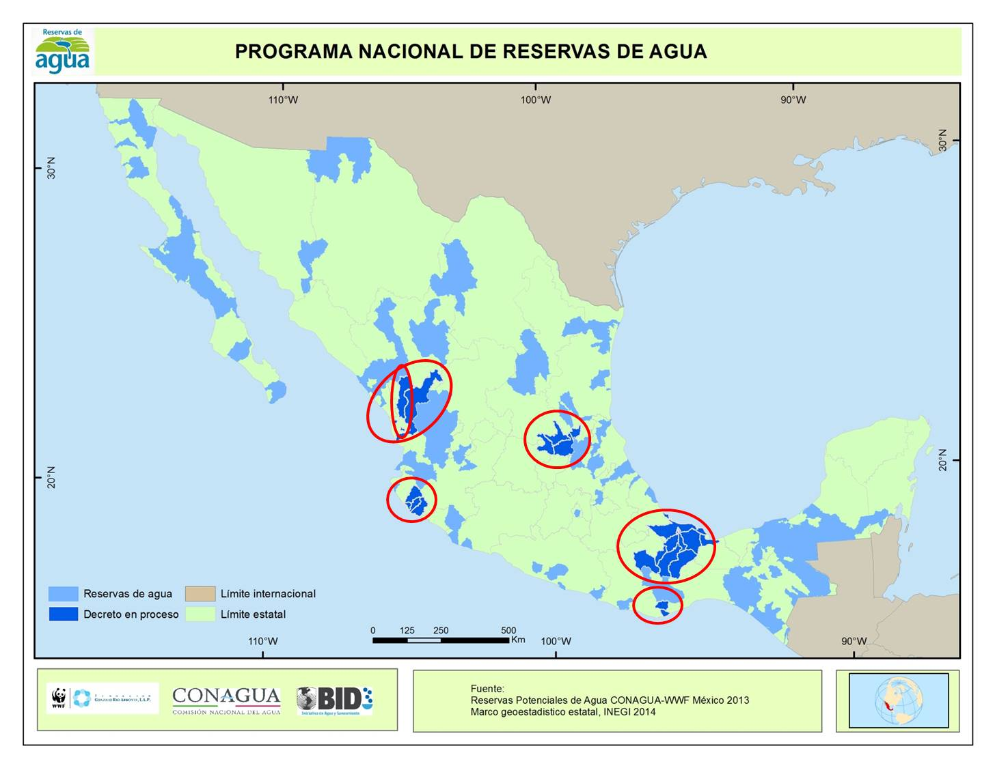

PROGRAMA NACIONAL DE RESERVAS DE AGUA = NATIONAL WATER RESERVE PROGRAMME

Reservas de agua = Water reserves

Decreto en proceso =
Decree underway

Límite internacional = International border

Límite estatal = State border

Fuente = Source

Figure 3. Potential water reserves and pilot working zones

- The aim of the first phase of the Programme is to ensure that by 2018 reserve decrees have been issued for the 189 river basins identified as priority. The direct benefits of the PNRA for the whole country include guaranteeing the water required by 97 protected natural areas, 55 Ramsar sites and over 78,500 km2 of zones that enjoyed no official protection and had hydrological conditions that were unaltered or virtually unaltered. These figures reveal the great strategic value of the integrated management of water resources, and water reserves, for biodiversity protection in Mexico, and its potential for integrating water and land-use management policies.

- In a second phase, based on this experience, there are plans to tackle the allocation of water to the river basins with highest pressure, in which the remaining 87 Ramsar wetlands are located, and where the strategy will be to determine the water requirements as environmental flow and to proceed to rescue the volumes earmarked for other uses.

- Studies started in six pilot working areas (Figure 3) present the following scope and results:

• They include 43 river basins with a total surface area of 92,000 km2 (4.5% of the national territory) in which the longitudinal, vertical and lateral connectivity will be maintained for 4,500 km of main water channels, 31 aquifers, 17 Protected Natural Areas and 13 Ramsar Sites.
• On average, the reserve water volume represents 53% of the mean annual runoff, and in total amounts to 49,000 Hm3 per annum, which represents around 11% of the mean annual national runoff.
• In terms of their biological significance, these water reserves will guarantee the water requirements of 546 species that enjoy some kind of protection category, and 99 of these species will be used directly in the analyses to determine environmental flows.
• The capacity of 58 institutions will be strengthened, including government agencies, academic institutions and civil society organizations, and a total of 138 experts will participate in the development of studies and proposals on environmental flow.

- On 15 September 2014, the first reserve decree was signed by the President of Mexico, including 11 river basins in the river San Pedro Mezquital hydrologic subregion, which supplies water to the Marismas Nacionales Biosphere Reserve and Ramsar Site. This decree establishes the reserves for the environment, domestic and urban public use, and the generation of electricity for public use, for the next 50 years. It sets out the conditions for authorizing these uses and to guarantee that they act in a complementary and synergistic manner.

Recommendations and lessons learned

- Mexico’s creation and consolidation of its own IWRM, and in particular the process of ensuring water is available for the environment and wetlands, has given rise to a series of experiences leading to the following recommendations.

- To date, the PNRA as a Mexican strategy for guaranteeing the water required by wetlands has made it possible:

• To understand the validity of different methodologies for determining environmental flow and to develop a reference framework for their application on a national level.
• To establish a gradual capacity-building process for each of Mexico’s regions.
• To act immediately in those river basins where the water regime is currently conserved in its natural state, or with few changes, and where the establishment of an environmental flow does not create conflict.
• To understand that the real impact of environmental flow on water availability for other uses is minimized by water commitments with users downstream, due to adjustments in the operation of infrastructure, or to the synergy with reserves for domestic use and energy generation.
• To establish a reference framework for the objective discussion of projects that alter the water regime, in particular hydroelectric projects.

- In regions unaffected by development or in those where development is just starting, it is very important to take preventative action in order to avoid future conflict over demands for this resource, in particular disputes between potential users over water allocated to the environment. Many of these sites coincide with regions of great ecological value, due to their biodiversity and the environmental services they provide. This is a great opportunity for establishing sustainable limits for water extraction, for conserving biodiversity and its services and guaranteeing water security conditions in the future.

- The permanence of water in the environment ensures the supply of services of use to IWRM, such as the replenishing of aquifers, the fertility of flood plains and agricultural land, the conservation of the hydraulic capacities of water channels, the improvement in water quality, etc. The IWRM has great potential for biodiversity conservation if it internalizes these services.

- Water reserves have turned out to serve as a measure for adaptation to climate variability. The percentage of the mean annual runoff which a reserve represents buffers the impacts, helps manage the risks of climate uncertainty and creates conditions of resilience.

- For developing countries, the challenge of the implementation of environmental flows is not a matter of capacities, but instead one of water security, of the future and the safeguarding of the national heritage.

- In the development of this initiative, the creation of a relationship of trust between government, civil society and academia has been decisive. Civil society organizations are IWRM's ally in the recognition of the needs for allocating water for the environment, and thus in the strengthening of the management.

Replaced by Resolution X.19
According to definition of Annex A of Resolution IX.1
Poff N.L., J.D. Allan, M.B. Bain, J.R. Karr, K.L. Prestegaard, B. Richter, R. Sparks and J. Stromberg. 1997. The natural flow regime: a new paradigm for riverine conservation and restoration. BioScience 47:769-784.
Davies S.P. and Jackson S.K. 2006. The Biological Condition Gradient: A Descriptive Model for Interpreting Change in Aquatic Ecosystems. Ecological Applications: Vol. 16, No. 4 pp. 1251–1266.

