CONVENTION ON WETLANDS (Ramsar, Iran, 1971)

53rd Meeting of the Standing Committee

Gland, Switzerland, 29 May – 2 June 2017

**SC53-20**

[**Ramsar financial matters 2016**](http://www.ramsar.org/cda/en/ramsar-documents-standing-40th-meeting-of-the-22812/main/ramsar/1-31-41%5e22812_4000_0__)

**Actions requested:**

The Standing Committee is invited to:

1. note the preliminary core budget results for 2016;
2. approve the proposals for the 2016 surplus and reserve fund;
3. consider the proposal to start the use of designated reserves for exceptional annual core budget surpluses;
4. note the non-core budget and voluntary contributions for 2017;
5. note the preliminary 2016 balance sheet;
6. note the agreement to delay the 2016 Financial Statement audit until June 2017;
7. review the attached 2016 draft financial statements as of 31 December 2016;
8. confirm the 2018 core budget as approved at COP12; and
9. note that a review of old non-core balances fromprojects is underway.

1. Attached at Annex 1 are the 2016 preliminary financial statements (in the required Swiss reporting format) as of 31 December 2016.
2. Attached at Annex 2 is a summary of the approved 2016 core budget (as per decision SC51-22 with agreed changes to the COP12-approved budget), preliminary income and expenditure as at 31 December 2016. These are presented in the Ramsar reporting format.

**Background**

1. The new Secretary General has identified a number of issues of concern regarding the management of the Secretariat finances and submitted a report to the Executive Team in 2016, which includes an Action Plan to address the issues identified. This Action Plan is currently being implemented.
2. The subsequent unexpected departure of the Finance Officer, on 2 November 2016, created a gap in capacity for the Finance Department. An interim solution is in place until the newly recruited Finance Officer starts on 15 May 2017.
3. Owing to these circumstances and the ongoing correction of issues identified, the Secretariat has included preliminary rather than final financial figures in the present document. This was agreed by the Finance Sub-group on 2 March 2017.

**2016 results – core budget**

1. The 2016 preliminary core budget summary attached at Annex 2 shows the approved budget, actual income and expenditure, and the variance between actuals and budget.
2. At the end of 2016, there was a preliminary core budget surplus of CHF 338,000. Table 1 below provides a summary.

*Table 1: 2016 preliminary core budget surplus summary (‘000 CHF, includes possible rounding differences)*

|  |  |  |  |
| --- | --- | --- | --- |
| **Cost Centre** |  |  | **Comments** |
| Income |  | (30) | Income Tax (53)k, Interest Income 23k |
| Senior Management |  | 73 | Salary and Benefits |
| Partnership Coordinator |  | 64 | Salary and Benefits |
| Regional Advice and Support |  | 81 | Salary and Benefits 61k, Travel 20k |
| Communications |  | 104 | Salary and Benefits 86k |
| Administration |  | 141 | Salary and Benefits 85k, Staff hiring and |
|  |  |  | departure costs 48k |
| Other |  | 21 |  |
| ***Subtotal*** |  | ***454*** | *Surplus before provisions* |
|  |  |  |  |
| **KMISC, Provisions and Other** |  |  |  |
| Accruals | (169) |  |  |
| Provisions and exchange loss | 24 |  |  |
| Legal and Professional Services | 29 |  |  |
| ***Subtotal*** |  | (116) | *Provisions and Other* |
| **Total** |  | **338** | *Overall surplus* |

1. The following points are highlighted for the Standing Committee’s information:
   1. Income was generally as budgeted except for income tax, which was CHF 53,000 under budget and only partially offset by an increase in interest income of CHF 23,000. The reduction of income tax was due to staffing gaps during the year.

* 1. Overall salary costs were CHF 377,000 under budget (12% under budget). This was due to the delayed filling of vacant positions (the Secretary General, Head of Partnerships, Head of Communications and Finance Officer).
  2. No IUCN-imposed cost-of-living increases have come into effect since 2011.
  3. K.MISC, Provisions and Other were over budget, mainly as a result of preliminary accruals of CHF 169,000. These accruals are being reconciled to identify which budget lines they should be charged to and to confirm the total amount.
  4. Allocations of CHF 277,000 were made from the core budget to non-core projects related to Ramsar Regional Initiatives, RSIS and website redevelopment, and STRP implementation. These transfers have been carried out during the last years without clear reporting. The Secretary General included the need to review this practice in her report of October 2016 to the Executive Team. The total allocations for 2014 and 2015 are included in the “Transfer between core and projects” line of the audited income statements. Table 2 below provides a summary of allocations from the core budget from 2014 to 2016. A proposed new approach is outlined below at paragraph 12.

*Table 2: Allocations from the core budget to non-core projects 2014 – 2016 (‘000 CHF, includes possible rounding differences)*

|  |  |  |  |
| --- | --- | --- | --- |
| **Description** | **2014** | **2015** | **2016** |
| Regional Initiatives | 120 | 107 | 120 |
| RSIS redevelopment | 90 | 80 | 47 |
| Web redevelopment | 30 | 60 | 70 |
| STRP implementation | 30 | 40 | 40 |
| **Total** | **270[1]** | **287[2]** | **277** |

**Proposal for the 2016 surplus and reserve fund**

1. At its 51st meeting (SC51, 2015), the Standing Committee decided in decision SC51-22 to set aside CHF 278,000 in item K of the 2016 budget for reserve fund provisions. After setting aside this amount, the preliminary overall core surplus was CHF 338,000 at the end of 2016.
2. The Secretariat proposes to allocate CHF 112,000 of the 2016 surplus to replenish the reserve fund to the target maximum level of 15% of the annual core budget in line with Resolution XII.1.
3. The Secretariat also proposes to set up a designated reserve for the remaining balance of the 2016 surplus (CHF 226,000) and is in the process of preparing proposals for allocation of this preliminary excess reserve. These will cover areas such as additional staffing needs approved by the Executive Team (part time Accounting Assistant, under discussion with IUCN, and a Legal Advisor on Convention matters to be retained through a contract of services), covering staffing gaps and building capacities and skills to ensure effective operations of the Secretariat. These proposals will be presented at SC53.

**Proposal for 2017 to start the use of designated reserves for exceptional annual core budget surpluses**

1. The Secretariat proposes to discontinue the practice of making allocations from core to non-core projects, to enhance efficiencies in the execution of the budget and to put in place a clear and transparent mechanism for exceptional circumstances when there are core budget surpluses that need to be used for specific purposes after the end of the year. IUCN has discontinued the practice of making allocations from core to non-core projects and now uses designated reserves for core budget surpluses. The Secretariat is also in the process of checking the practices followed by other Conventions for core budget surpluses and will provide further information at SC53.

**2016 results: non-core budget and voluntary contributions**

1. The United States of America made voluntary contributions totalling CHF 1,142,233 (USD 1,150,000) in 2016: CHF 1,065,799 for the Secretariat core budget and CHF 76,434 for non-core projects through the Wetlands for the Future Fund.
2. Voluntary contributions of CHF 13,000 were received in 2016 from Contracting Parties in the Africa region, relating to 2016 and previous years. Resolution X.2, paragraph 23 stipulates that these contributions must be specifically earmarked for African Regional Initiatives.
3. An additional CHF 703,00 of voluntary non-core contributions were received in 2016. These contributions are outlined in Table 3 below.

*Table 3: Additional voluntary non-core contributions received in 2016 (‘000 CHF, includes possible rounding differences)*

|  |  |  |
| --- | --- | --- |
| **Donor** | **Amount** | **Comments** |
| Danone | 271 |  |
| Switzerland (FOEN) | 120 |  |
| MAVA | 124 |  |
| Japan (NEF) | 92 |  |
| Canada | 28 | COP12 delegate support |
| Norway | 36 |  |
| WWF International | 22 |  |
| Hans Seidel Foundation | 5 |  |
| Other adjustments | 5 |  |
| **Total** | **703[3]** |  |

1. In addition, Star Alliance provided flight tickets with a total value of CHF 19,000 (EUR 18,000).
2. The Secretariat would like to express its sincere appreciation to Contracting Parties and donors for voluntary contributions to non-core activities of the Convention.

1. The budget approved at COP12 anticipated voluntary non-core contributions of CHF 4.2 million over the triennium to fund the priority activities for 2016-2018 (see Annex 5). It should be noted that the former position of Head of Partnerships was vacant during 2016 and a revised position of Head of Resource Mobilization and Outreach is currently being recruited.

**2016 balance sheet**

1. Annex 1 shows the preliminary balance sheet as at 31 December 2016. The Secretariat had an overall Swiss-franc-equivalent cash balance of CHF 4,569,000, with 48% held in Swiss francs, 24% in US dollars, 17% in euros and 11% in Norwegian krone.

1. When taken together, the cash contributions and accounts receivable were sufficient to cover all of the Secretariat’s obligations at the end of 2016.
2. The level of outstanding Contracting Party contributions diminished in 2016. For further discussion on this issue, please see Document SC53-21.

**Delay of the 2016 Financial Statement audit**

1. On 2 March 2017 the Subgroup on Finance agreed with the Secretary General’s request to delay the 2016 Financial Statement audit until June 2017 and present preliminary figures at SC53 for the following reasons:

* to address and correct issues highlighted in the 2015 PwC Management Letter;
* to resolve the backlog caused by the departure of the Finance Officer;
* to complete the ongoing clean-up of accounts as outlined in the Action Plan and update reported to the Executive Team; and
* to allow the new Finance Officer to be involved in the audit process (a candidate has been selected and is due to start work on 15 May 2017).

1. The auditors PwC have indicated that it is better to delay the audit and for the Ramsar Secretariat to be ready, rather than to repeat the delays in preparation and financial statement changes experienced during the 2015 audit.

**Core budget for 2017**

1. Attached at Annex 3 is the COP12-approved core budget for 2017, which was confirmed by Decision SC52-30.
2. The Secretary General does not propose any major changes to the core budget for 2017. However, she may make adjustments to enable the effective management of the Secretariat to deliver on the refocused Work Plan and to respond to the Contracting Parties requests (for example adjustments of travel expenses between departments).

**Confirmation of the 2018 core budget**

1. As noted in Document SC53-21 on *Update on Outstanding Annual Contributions*, the Secretariat is no longer in a financial situation that would necessitate an austerity budget for 2018, and the Executive Team thus agreed on 23 February 2017 to maintain the 2018 budget approved at COP12. The Standing Committee is invited to confirm the 2018 budget as approved at COP12 and attached at Annex 4.

**Review of old non-core projects**

1. The Secretariat is in the process of reviewing old balances from non-core projects. This issue was identified in the Secretary General’s report presented to the Executive Team in October 2016. On 23 February 2017, the Executive Team agreed with the approach to go back a maximum of ten years in this review. An update of the status and findings of the review will be presented at SC53.
2. A major component of this review includes the issue of a considerable balance of old projects that had been closed and included in the “Admin” non-core project balance. The balance is being analysed and broken down into groupings so that decisions can be made regarding funds that may need to be reported to donors for decision on their use and remaining funds that could be available for use with approval from the Executive Team or Standing Committee as appropriate. An update will be provided at SC53.

**Annexes**

1. Preliminary financial statements as of 31 December 2016 (Swiss reporting format) 7
2. Preliminary 2016 core results, with SC51 changes to COP12 approved budget, actuals and variance from approved budget 10
3. COP12-approved 2017 budget 11
4. COP12-approved 2018 budget 12
5. Non-core budget from 2016-2018 triennium (Annex 3 of Resolution XII.1) 13

**Annex 1**

**Preliminary financial statements as of 31 December 2016 (Swiss reporting format) (includes possible rounding differences)**

|  |  |  |  |  |  |  |
| --- | --- | --- | --- | --- | --- | --- |
| **BALANCE SHEET AS OF 31 DECEMBER** | |  |  |  |  |  |
|  |  |  |  |  |  |  |
| *in thousands of Swiss Francs (CHF '000s)* | **Notes** | **Preliminary 2016** | |  | **2015** | |
| **ASSETS** |  |  |  |  |  |  |
| **Current assets** |  |  |  |  |  |  |
| Cash and short term bank deposits |  | 4,569 |  |  | 4,652 |  |
| Contracting Party Receivables (net) | 6 | 620 |  |  | 658 |  |
| Other account receivables | 7 | 131 |  |  | 88 |  |
| **Total current assets** |  | **5,320** |  |  | **5,398** |  |
|  |  |  |  |  |  |  |
| **Fixed assets (net)** |  |  |  |  |  |  |
| Office Furniture and Computer Equipment at cost |  | 84 |  |  | 82 |  |
| Less: Accumulated Depreciation | 9 | (63) |  |  | (48) |  |
| **Total non-current assets** |  | **21** |  |  | **34** |  |
|  |  |  |  |  |  |  |
| **TOTAL ASSETS** |  | **5,341** |  |  | **5,432** |  |
|  |  |  |  |  |  |  |
| **LIABILITIES AND FUND BALANCES** |  |  |  |  |  |  |
| **Current liabilities** |  |  |  |  |  |  |
| Amount owed to IUCN |  | 264 |  |  | 775 |  |
| Other Payables | 8 | 753 |  |  | 630 |  |
| Accrued liabilities |  | 435 |  |  | 293 |  |
| **Total current liabilities** |  | **1,453** |  |  | **1,698** |  |
|  |  |  |  |  |  |  |
| **Provisions** |  |  |  |  |  |  |
| Staff repatriation | 5 | 124 |  |  | 124 |  |
| Staff leave | 5 | 100 |  |  | 165 |  |
| Staff termination | 5 | 89 |  |  | 227 |  |
| **Total provisions** |  | **313** |  |  | **516** |  |
|  |  |  |  |  |  |  |
| **Fund and Reserves** |  |  |  |  |  |  |
| Unrestricted reserve fund | 11 | 988 |  |  | 372 |  |
| Restricted Projects | 12 | 2,587 |  |  | 2,846 |  |
| **Total fund and reserves** |  | **3,575** |  |  | **3,218** |  |
|  |  |  |  |  |  |  |
| **TOTAL LIABILITIES AND FUND BALANCES** |  | **5,341** |  |  | **5,432** |  |
|  |  |  |  |  |  |  |



**Annex 1, Appendix A: Projects Financed by Restricted Funds, 1 January to 31 December 2016 (‘000 CHF, includes possible rounding differences)**



**Annex 2**

**Preliminary 2016 core results, with SC51 changes to COP12 approved budget, actuals and variance from approved budget (includes possible rounding differences)**

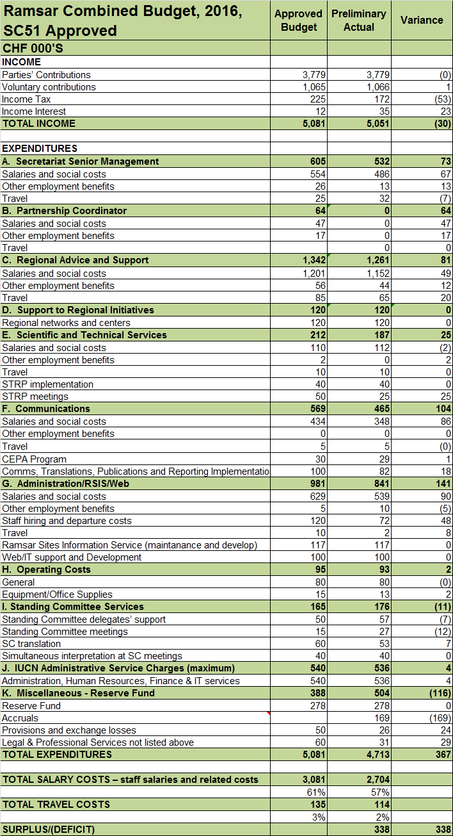

**Annex 3**

**COP12-approved 2017 budget, CHF 000s**

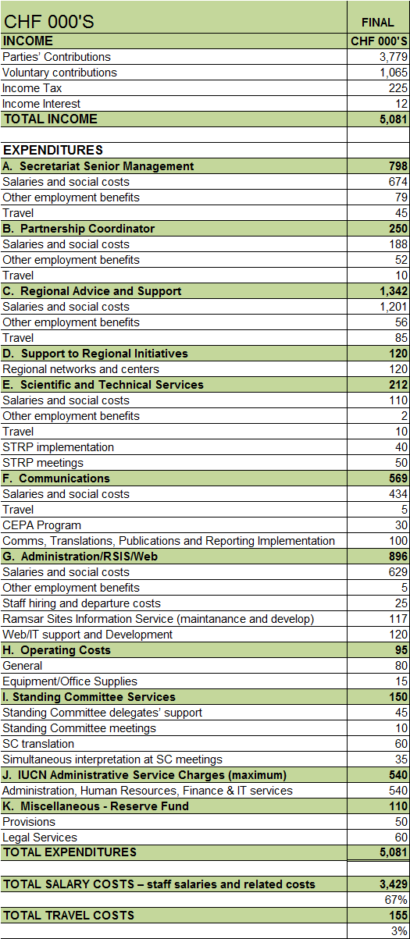

**Annex 4**

**COP12-approved 2018 budget, CHF 000s**



**Annex 5**

**2016-2018 budgeted non-core expenditures (Annex 3 of Resolution XII.1)**



1. Amount reported as “Total transfer between core and projects” in the Ramsar 2014 audited income statement.
2. Amount reported as “Total transfer between core and projects” in the Ramsar 2015 audited income statement.
3. Voluntary cash contributions amount for 2016 before deducting CHF 80 k for the return to Uruguay of prior year contributions for COP12 funding.