THE CONVENTION ON WETLANDS
59th Meeting of the Standing Committee
Gland, Switzerland, 21-25 June 2021

SC59 Doc.24.1

Draft resolution on Guidance on protection, management and restoration of Mediterranean wetlands as Nature-based solutions to address environmental and climate changes

Submitted by Albania

Secretariat cover note:
The DR recalls Resolutions relevant for the Mediterranean region including Resolutions XI.14 on climate change and XIII.14 on Blue Carbon, and refers to other relevant multilateral environmental processes. The Secretariat invited the STRP to review the technical annex on Mediterranean wetlands (knowledge, extent, pressures, roles related to carbon, management and restoration), and to inform the Standing Committee.

Draft resolution on Guidance on protection, management and restoration
of Mediterranean wetlands as Nature-based solutions to address
environmental and climate changes

Summary introduction for the Standing Committee

The Mediterranean Basin is a global biodiversity hotspot but also one of the most vulnerable regions in the world to the impacts of global warming. Protection, management and restoration of Mediterranean wetlands represent an effective nature-based solution to maintain and enhance crucial functions of Mediterranean ecosystem services such as ensuring carbon sequestration, sound water resources management, disaster risk reduction, food security and human well-being, and biodiversity conservation. As such, it meets international policy commitments and priorities made by the Mediterranean Contracting Parties under the Ramsar Convention, the CBD, the Paris Agreement on climate change, being compliant with the UN decade for the restoration of ecosystems as well as the EU Green Deal. The draft resolution urges Mediterranean Contracting Parties to introduce and adopt appropriate policies and measures to conserve, sustainably manage and restore wetlands as long term and most cost-effective NbS through promoting ecosystem-based and integrated sustainable water management of the whole connected watersheds while putting in place financial incentives to support the efforts of local stakeholders. Moreover, the resolution recommends the Mediterranean Contracting Parties to support the MedWet Initiative to develop Mediterranean-wide knowledge base on the conservation status and the carbon fluxes of wetlands as a base to assess progress and prioritise restoration actions, to organise exchanges of good practices and lessons learnt from existing successful wetland restoration projects as NbS and wetlands restoration capacity building for wetlands managers and other stakeholders.

Paragraph | Action | Cost (CHF)
12. REQUESTS the Ramsar Secretariat to foster further synergies and better coordinate policies with other relevant regional and international frameworks… | Secretariat to coordinate collaboration with other international frameworks, consultant to prepare a policy roadmap (10 days) | 5,000
13. FURTHER requests the Ramsar Secretariat to establish an appropriate platform for cooperation among regional initiatives on the role of wetlands as NbS… | Consultant to establish an appropriate platform for cooperation among regional initiatives on the role of wetlands as NbS (30 days) | 15,000

Draft Resolution XIV.xx

Protection, management and restoration of Mediterranean wetlands as Nature-based solutions to address environmental and climate changes

1. RECALLING
a. Resolution XI.14 on Climate change and wetlands: implications for the Ramsar Convention on Wetlands, which urges Contracting Parties to maintain or improve the ecological character of wetlands to promote the ability of wetlands to contribute to nature-based climate change adaptation;
b. Resolution XIII.14 on Promoting conservation, restoration and sustainable management of coastal blue-carbon ecosystems, highlighting the value of wetlands as natural carbon sinks
c. Resolution XII.13 on Wetlands and disaster risk reduction which welcomes initiatives that support the conservation and restoration of coastal wetlands and encourages engagement in such activities;
d. the Ramsar Strategic Plan 2016-2024 highlighting the important ecosystem services that wetlands provide, to contribute to food security, healthy living, water quality and supply, water security, disasters risk reduction, adaptation to climate change and biodiversity;

2. RECOGNISING
a. the Paris Agreement under the UN Framework Convention on Climate Change (UNFCCC), as well as the outcome of the 25th UNFCCC Conference of the Parties;
b. the framework for defining Nature-based Solutions (NbS) adopted at the World Conservation Congress in 2016 by Resolution 6.069 and the IUCN Global Nature based Solutions adopted in 2020 (WCC-2020-Res-060);
c. the entry into force of the UN Decade for the restoration of ecosystems 2021-2030;
d. the process for the preparation of the post-2020 global biodiversity framework adopted by the conference of the parties to the convention on biological diversity (CBD/COP/DEC/14/34);
e. that the EU Green Deal and its post 2020 Biodiversity strategy, includes a strong EU restoration plan to reverse the degradation of land and sea ecosystems and thereby increase nature resilience to climate change, and that substantial financial support will be dedicated to restoration actions, both within the EU and for neighbouring countries;

3. AWARE that
a. the Mediterranean Basin is a global biodiversity hotspot, with its wetlands, in particular, hosting more than a third of all species, but also one of the regions of the world most vulnerable to climate change, with effects on ecosystems, the economy, and human well-being that are significantly higher than the global average;
b. 52% of coastal and marine vertebrate populations have been lost since 1993, and that 36% of wetland-dependent species are threatened with extinction, which places Mediterranean wetland ecosystems among the most vulnerable ecosystems in the world;
c. 48% of Mediterranean wetlands have been lost since 1970 and that the areal extent of coastal wetlands has shrunk by 10% in the last decade, compromising their capacities to provide critical goods and services;

4. CONCERNED
a. about the fact that the Mediterranean Basin is warming 20% faster than the rest of the world with a drop of 15% in the availability of freshwater by 2040 as well as an increase in the intensity and frequency of extreme weather events like floods, heatwaves and droughts;
b. that the societal challenges NbS aim to address (food security, climate change, water security, human health, disaster risks, economic and social development) are particularly acute in the Mediterranean Basin due to the historical relationship between humans and nature, but also due to recent strong demographic developments, tremendous pressure on scarce water resources, the concentration of economic activities and urbanisation in coastal regions, and dependence on climate sensitive agriculture;

5. NOTING
a. that well-preserved wetlands are a prerequisite for biodiversity to thrive in the coming decades and adapt to and mitigate the new conditions imposed by climate change as it has been demonstrated for Mediterranean water bird populations;
b. the key role played by Mediterranean wetlands in providing crucial ecosystem services and their potential role as NbS, and aware of the need to protect and restore wetlands;
c. that the Mediterranean Wetlands Initiative (MedWet) has successfully contributed to the conservation and wise use of Mediterranean wetlands for the last 30 years and will continue to do so;

THE CONFERENCE OF CONTRACTING PARTIES

6. AFFIRMS the significant value of wetlands conservation and restoration as Nature-based Solutions for facing societal challenges, especially climate-change mitigation and adaptation, water and food security, risk reduction and health;

7. URGES the Contracting Parties in and around the Mediterranean to
a. address simultaneously biodiversity loss, wetland degradation, water abstraction and scarcity and risks associated to climate change as urgent and to pursue policies and projects to conserve and restore wetlands in the coming years;
b. consider the conservation, sustainable management of wetlands and the restoration of degraded wetlands as long term and most cost-effective NbS when contemplating measures to regulate carbon emissions, to mitigate climate impacts, to secure sound water resources management as well as sustainable food production;
c. favour the conservation and the restoration of Mediterranean wetlands by promoting ambitious, ecosystem-based and integrated sustainable water management and hydro-morphological restoration measures of the whole connected watersheds;
d. put in place financial incentives to support the efforts of local stakeholders and their full involvement to sustainably manage, conserve and restore Mediterranean wetlands;

8. RECOMMENDS Mediterranean Contracting Parties to support the MedWet initiative, if resources are available, in promoting the following activities:
a. developing a Mediterranean-wide knowledge base on the wetland extent, based on a watershed and river basin approach, and their conservation status in the region as a regional reference base to assess progress and prioritise restoration actions;
b. calling for more research to provide a knowledge-base on carbon fluxes in wetlands including blue carbon and on targeted restoration efforts that would co-benefit biodiversity and climate change adaptation and mitigation;
c. identifying, upscaling and replicating existing successful wetland restoration projects based on a NbS approach in the Mediterranean to other sites designated as priority for restoration and organise exchanges of good practices and lessons learnt;
d. promoting wetlands restoration capacity building for wetland managers, practitioners, civil society, etc;

9. FURTHER recommends Mediterranean Contracting Parties to take NbS into account under the Ramsar convention to include them in their "nationally determined contributions" under the Paris Agreement on Climate Change, but also in all relevant sectoral policies as approved by the IUCN World Conservation Congress 2020 (WCC-2020-Res-031);

10. INVITES the European Commission funding instruments and other funding agencies to support the Contracting Parties and the MedWet Initiative to allocate enough resources to support the above-mentioned recommended activities;

11. CALLS ON governments, financial institutions, and private funders who are stakeholders in the Mediterranean Basin to mobilize NbS funding and systematically consider them as alternatives or complements to their financing of ‘grey’ infrastructure projects;

12. REQUESTS the Ramsar Secretariat to foster further synergies and better coordinate policies with other relevant regional and international frameworks such as the Barcelona Convention, the Union for the Mediterranean, the IUCN, and the European Union to financially support wetland restoration;

13. FURTHER requests the Ramsar Secretariat to establish an appropriate platform for cooperation among regional initiatives on the role of wetlands as NbS and aiming at providing scientific and technical support as well as easing the access to financial resources for affected countries.

Technical annex

- KNOWLEDGE ON MEDITERRANEAN WETLANDS’ TYPES AND EXTENT

There has been some recent progress in assessing wetland ecosystem condition in Europe to include part of the Mediterranean region. However, wetland assessment reports on inland and coastal wetlands have been produced separately due to scattered data availability for certain habitats needing further integration and limited to the Northern part of the Mediterranean and Turkey, whereas wetlands in Balkan countries have been assessed recently, with information gaps still persisting for the Eastern and Southern parts of the Mediterranean.

- Need for comprehensive wetland habitat reporting

The major habitat types hosted by the Euro-Mediterranean wetlands are varied and reported by countries in compliance with parallel policy frameworks and nomenclatures, depending on their association to the marine or coastal realms, which makes a comprehensive assessment of coastal and marine wetlands difficult to implement.

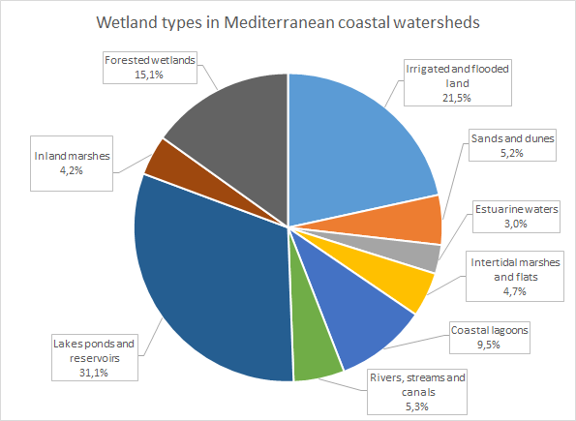 | Figure 1: Percentage of wetland habitat typology in the coastal watersheds draining in the northern part of the Mediterranean basin.

- Need for Southern/Eastern Mediterranean data

The boundaries of the current EU wetland study area are defined by the watersheds which drain into the Mediterranean Sea according to the HydroSHEDS dataset and the area and results presented herein are referred to as Euro-Mediterranean wetlands (Figure 2).
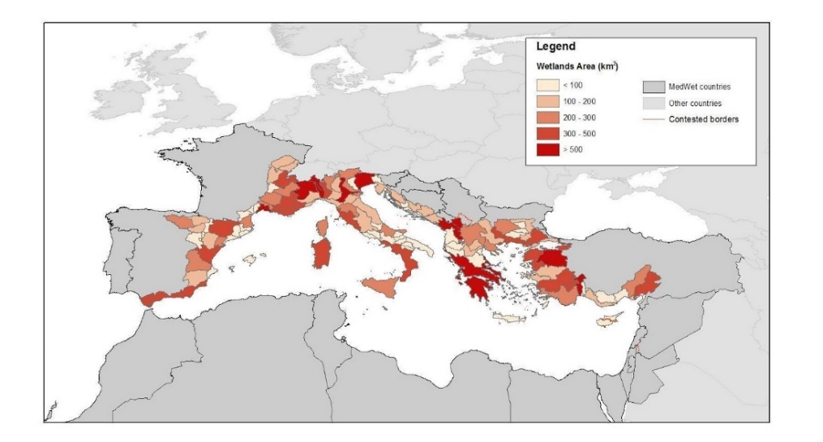 | Figure 2: The total area of the wetlands ecosystem delimited covers 27,823 km2 in the northern part of the basin for watersheds draining into the Mediterranean

This recent assessment, a first basis to understand the condition of European wetlands, needs to be complemented to achieve a Mediterranean-wide wetland ecosystem map and knowledge base, which is being addressed at present by a partnership of key Mediterranean institutions and co-financed by the EU Interreg Mediterranean programme.

- KNOWLEDGE ON THE CONDITION AND PRESSURES ON MEDITERRANEAN WETLAND HABITATS

- Need to decrease pressures to reverse declining and unfavourable trends for wetlands

At the pan-Mediterranean level (within a sample of more than 400 sites), the Mediterranean Wetlands Observatory has reported that natural wetland habitats have decreased by 48% since 1970 (MWO-2, 2018). At the same time, urbanisation increased by 294% and agricultural areas by 42%. Most of these losses were caused by urbanisation and agricultural expansion causing the transformation of natural wetlands into human-made wetlands, croplands, built-up areas and sea waters (respectively 47%, 46%, 5% and 2% of the conversions). These decreasing trends of natural wetland habitats, among other factors such as climate change, have negatively impacted the abundance of wetland-dependent species. The Living Planet Index, calculated for these species in the Mediterranean region (LPI-Med), shows a long-term decline since 1990 (-15%), mainly driven by negative trends of the “Amphibian, Reptiles and Mammals” group (-35%) and the “Fish” group (-34%).

Human demography growth is considered as one of the main drivers leading to natural wetlands loss and degradation. The MWO has reported that, in the Mediterranean region, it has increased by almost one-third since 1990 and is still on an upward trend. Coastal areas and especially coastal lagoons seem to be the most impacted (Figure 3).

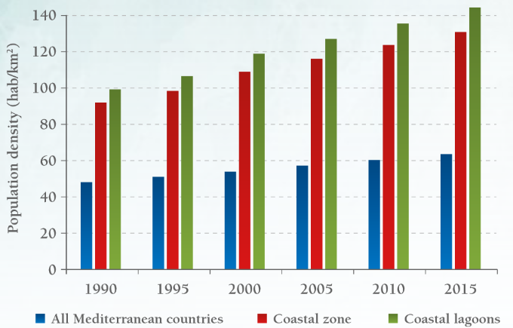 | Figure 3: Trend in average density of human populations around the Mediterranean Basin (CIESIN, 2016).

- As pressures are maintained high, unfavourable condition of wetland habitats and species is still dominant, despite slight good signs at local scale

The condition of habitat areas linked to coastal Euro-Mediterranean wetland habitats has been assessed from reported data of Art.17 of the Habitats directive for the period 2013-2018. The information on conservation conditions and trends of 8 habitats associated with the coastal wetlands ecosystem in the Mediterranean bio-geographical region is based on the four parameters representing different aspects of the habitat conditions namely: “Range”, “Area”, “Structure & Function”, “Future Prospects”. The indicator reflects the condition of the ecosystem associated with the habitats, showing the number of assessments reporting Favourable, Unfavourable Inadequate, Unfavourable-Bad and unknown status as evaluated at EU Member State level. The assessment of coastal Euro-Mediterranean wetland habitats provides evidence on the dire condition of these habitats where 69% of the assessed habitats show unfavourable conservation status with a high percentage of knowledge gaps (unknown), while only a small share (14%) of the assessed habitats show signs of effective conservation (14%).

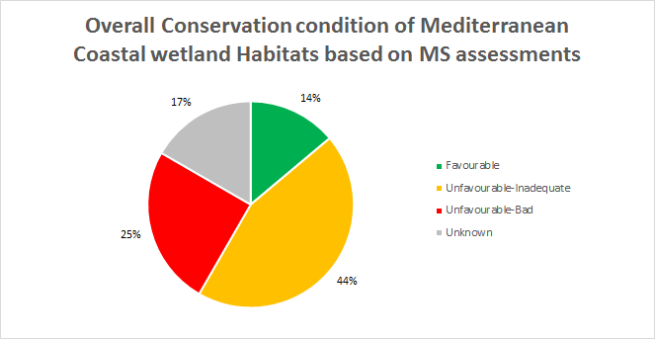 | Figure 4: Condition of the coastal wetlands ecosystem in the Mediterranean part of the EU27 domain: percentage of the assessments reporting Favourable status, Unfavourable Inadequate and Unfavourable-Bad status as evaluated at EU Member State level.

The conservation trends of coastal wetland habitats show alarming declining (30%) and stable trends (31%), which indicates that the condition of ecosystems under legal designation assessed as unfavourable (figure 4) presents worrying signs; in fact, improving trends are reported for only 5% of the reported assessments by EU Member States.
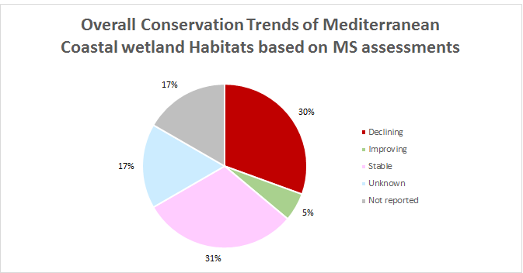 | Figure 5: Conservation trends of the coastal wetlands ecosystem in the Mediterranean part of the EU27 domain: percentage of the assessments reporting Improving, Unknown, Stable, Declining trend evaluated at MS level for the period 2013-2018.
Nonetheless, the global trend of the LPI-Med seems to be improving since the mid-2000s, mostly due to increases in waterbird populations especially in regions and countries where concrete conservation actions have been undertaken at local scale.

- More protection figures that are balanced across wetland habitat types and more effective implementation are required to re-establish wetland functions

The analysis on the level of protection of watershed wetlands according to the type of habitats shows unbalance, with certain habitat types like estuarine waters, coastal lagoons and intertidal marshes and flats on the Mediterranean northern shore having a higher percentage of protection, including the overlapping of several designations and lack of protection for irrigated and flooded lands.

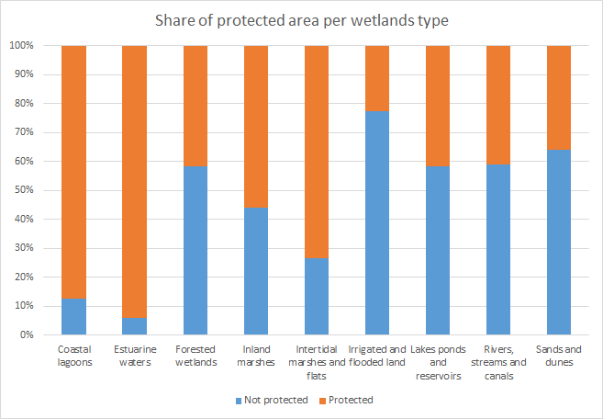 | Figure 6: Wetlands in watersheds draining from the northern part of the Mediterranean basin: percentage of protected areas (Natura2000 network and Nationally designated areas) for each habitat type

This assessment demonstrates that tangible improvements in the condition of Euro-Med wetlands and the reestablishment of their functions in providing key services such as water provision to ensure food security are far from being met by the current level of protection, which should include management, monitoring and restoration measures. Furthermore, an equivalent analysis to include non-EU regions is needed for the Mediterranean ecoregion to achieve a regional assessment.

- THE ROLE OF WETLANDS RELATED TO CARBON

Wetlands have demonstrated to be the most efficient long-term carbon stocks (figure 7) compared to other ecosystems. According to the current meta-analysis led by ETC-UMA (to be published in May 2021), wetlands have a high blue carbon sequestration potential when in a good environmental status and effectively managed, particularly seagrass meadows and salt marshes, and are a powerful tool to address the environmental and socio-economic challenges in the region. Degrading wetlands on the contrary become carbon emission sources, which prove that conservation, effective management and restoration of wetlands are effective low-cost nature-based solutions against the impacts of climate change, including water scarcity.

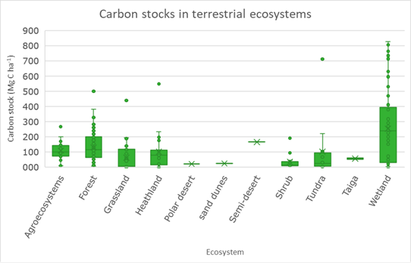 | Figure 7: Carbon stocks of terrestrial ecosystems (from Hendriks et al., 2020)

- EFFECTIVE MANAGEMENT AND RESTORATION PRIORITISATION

The multiple benefits of effective wetland management and restoration are highlighted through the various Mediterranean cases as shown below.

Improving water quality: Albufera, Spain
- Over 100ha marshlands restored.
- 10 years of management after the restoration.
- Significant improvement of water quality both inside the restored areas and their surroundings.
- Further impacts on biodiversity and socio-economic activities with 50,000 visits to the site.
- The economic valuation of the provision of ecosystem services in one of the areas after its restoration has been estimated at more than € 20 million.

Improving biodiversity: Konya, Turkey
- Almost 100ha of wetlands and lakes were restored.
- Over 10 years of management after the restoration.
- Increase in the total water bird species and numbers in the area (before restoration 23 bird species were observed in the site and 53 species after restoration).
- It was calculated that the restoration and protection measures at Akgöl have prevented emissions of 3,082.224 kg-C.
- Other ecosystem services gained through the restoration include drinking holes for livestock.

Nature-based solutions: The former salt works of Camargue, France
- Over 2000ha of a mosaic of wetlands restored.
- Over 10 years of active and passive restoration activities.
- Reconnecting water bodies has led to the reshaping of water paths in a natural way. Newly emerged soils and restored waterways create “new” homes for vegetation, fish, birds and other wildlife populations.
- This coastal ecosystem now acts as a buffer in order to reduce the impacts of climate change.
- Savings in public funds: €13 to 17 million investment for the reconstruction of dikes, €7 to 24 million for the construction of groins, at least €800,000 in annual maintenance

Flood risk protection: Venice lagoon, Italy
- Over 220ha of wetlands were created.
- Almost 20 years of restoration and management.
- This long-term restoration program retains and diffuses pollutants generated by farming practices before they enter the Venice Lagoon.
- Flood risk mitigation with increased water storage capacity at the basin scale: Ca. 1,800,000 m³
- Improved recreational opportunities for approximately 520,000 inhabitants

Reducing agrochemical pollution: Tyre, Lebanon
- Water and soil pollution from agrochemicals used by farmers in Ras El Ain was reduced.
- The yearly estimated value of freshwater provided by the wetland of TCNR is $2 M.
- Agrotourism in Ras El Ain is promoted with the restoration of a wooden platform at the artificial pond for small recreational events
- Direct beneficiary species from the restoration of TCNR wetlands are the marine species in estuary waters that would bear residues from the agrochemicals used by the farmers of Ras El Ain.

https://ec.europa.eu/jrc/en/publication/eur-scientific-and-technical-research-reports/mapping-and-assessment-ecosystems-and-their-services-eu-ecosystem-assessment
Wetlands of the Balkan Mediterranean territory harmonised in a regional mapping. Project WetMainAreas, co-funded by the European Union in the frame of INTERREG TNCP BALKAN-MEDITERRANEAN 2014-2020: http://185.17.146.157/maps/180
https://www.hydrosheds.org
Collaborative work led by ETC-UMA with the support of Mediterranean Wetland Observatory, Tour de Valat, Greek Biotope - Wetland Centre (EKBY), University of Forestry, Sofia, National Environmental Agency of Albania, St. Kliment Ohridski University of Ohrid, Terra Cypria, WWF-Greece, Plan Bleu and MedWet.
Data available at https://www.eea.europa.eu/data-and-maps/data/article-17-database-habitats-directive-92-43-eec-2
The data elaboration has been provided by the European Topic Centre on Biodiversity (ETC/BD).

