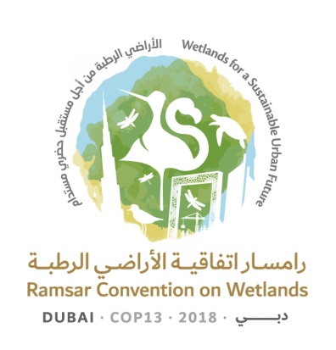
13th Meeting of the Conference of the Contracting Parties

to the Ramsar Convention on Wetlands

“Wetlands for a Sustainable Urban Future”

Dubai, United Arab Emirates, 21-29 October 2018

Resolution XIII.1

World Wetlands Day

1. RECALLING the International Conference on the Conservation of Wetlands and Waterfowl, hosted by the Game and Fish Department of the Government of Iran from 2 to 3 February 1971, in Ramsar, Islamic Republic of Iran, where the “Convention on Wetlands of International Importance especially as Waterfowl Habitat” was adopted by representatives of 18 States on 2 February 1971;

2. FURTHER RECALLING that the Convention was signed in Ramsar on 3 February 1971;

3. AWARE of the comprehensive nature of the Convention Programme on communication, capacity building, education, participation and awareness (CEPA) established by Resolution XII.9 for the period 2016-2024;

4. RECALLING that Resolution XII.9 recognizes the growing celebration of World Wetlands Day in a large number of countries, and urges Contracting Parties to continue or to begin to use this occasion to bring attention to their achievements and continuing challenges in wetland conservation and wise use; and

5. CONGRATULATING all Contracting Parties celebrating World Wetlands Days;

THE CONFERENCE OF THE CONTRACTING PARTIES

6. WELCOMES the celebration of World Wetlands Day in a growing number of countries;

7. INVITES the United Nations General Assembly to recognize 2 February of each year, the date of adoption of the Convention on Wetlands, as World Wetlands Day; and

8. INVITES Contracting Parties, the Secretariat, the United Nations Environment Programme and international organizations and non-governmental organizations with an interest in wetlands to facilitate cooperation and information exchange in support of 2 February as World Wetlands Day.

